**Fwunny Magnets**

**By: Mohammed Al-Shalchy;** [alshalchym2@montclair.edu](mailto:alshalchym2@montclair.edu)

**By:** [Britnie Gonzalez-Moodie](mailto:gonzalezmob1@montclair.edu)**;** [gonzalezmob1@montclair.edu](mailto:gonzalezmob1@montclair.edu)

**Different View Usernames and Passwords:**

**Customer:**

* **Username:** alshalm2_Client
* **Password:** do{hOUWX9z+i

**Business Owner:**

* **Username:** alshalm2_BusinessOwner
* **Password:** n^4vUG_mi4V]

**Database Admin:**

* **Username:** alshalm2_DatabaseAdmin
* **Password:** &]PU0WEKX2#W

**Employee:**

* **Username:** alshalm2_Employee
* **Password:** iMp]_%MCU6n}

**Executive Summary of the Problem:**

Creating a website is no easy task and requires a ton of work and manpower. Before the website is even created, there needs to be some form of database with tables to be interacted with to even begin creating a website of this magnitude. Once that database is created, there needs to be certain views created so that the database interactions can actually occur. Once all of this is done, the coding for the website starts. The website needs to be able to interact with the database to either enter new information, check information, or delete information in the appropriate tables of the database.

All of these issues can be solved with utilizing databases in CPanel. CPanel is a web-hosting platform where we can implement both our code as well as create databases. We utilize the “MySQL Databases” file to create the initial database as well as the users that interact with the database. Once the database is created, we utilize “phpMyAdmin” to begin creating the tables necessary for the website to function. Next, comes the actual coding of the website. We utilize HTML and PHP languages in the “File Manager” tab to be able to code as well as connect the PHP to the MySQL database tables to be able to do all the necessary work for each different view. For example, a customer is able to insert their username and passwords into the database to sign up, a business owner should be able to insert new products, and database admin can modify or delete certain products. Once all of that is done, we have to connect all of these links together to make a coherent, functioning website.

**Analysis of Client and His or Her needs:**

The Client wants a very niche website that serves a specific niche audience. The niche audience must be an audience that wants an appropriate product, specifically, 30 G-rated products divided into 5 separate categories. The client is extra focused on how the database interacts with the website. The client wants this website to have security via a log-in page, where someone is able to log-in to be able to access the products so that not anyone is simply going in and accessing the products and making changes in the product database without this minimal security. The client also wants this website to contain images that are copyright free so that we don’t risk a lawsuit. Finally, the client makes it explicitly clear that the website must not take in any payment information, simply records it in the database.

**Business plan And Purpose:**

* List participants (Group members, types of users, if their is a client that you are working with)
  + **Britnie Gonzalez-Moodie (Client, Developer)**
  + **Mohammed Al-Salchy (Client, Developer)**
  + **Professor Herbert-Berger (Client, Supervisor)**
  + **Business Owner (BusinessOwner)**
  + **Database Admin (DatabaseAdmin)**
  + **Employee (Employee)**
* Define your Business and its practices
  + Who is your client and how did you find this client?  
    **Our clients are ourselves.**
  + What is the contact information for your client:  
    **Brintie Gonzalez-Moodie (**[**gonzalezmob1@montclair.edu**](mailto:gonzalezmob1@montclair.edu) **)**

**Mohammed Al-Sachy (**[**alshalchym2@montclair.edu**](mailto:alshalchym2@montclair.edu) **)**

* + Why does this client want this website?  
    **This website is intended to complete a CSIT course requirement as well as to sell art merchandise.**
  + What are your products?  
    **The products for this website are magnets of different illustrations.**
  + Who do you expect your customer to be (the person who buys stuff from your website)? **Parents and children as drawings on magnets will be geared towards children**.
  + What access your various users should have to your product – define your four user groups and discuss in high level English what access they should have
* **Database Admins: Logging in, searching, modifying and deleting products from catalogues, and searching in the Employee database**
* **Employee: Logging in, searching in the Customer database to assist customers with info.**
* **Business Owner: Logging in, searching and inserting new products into the database**
* **Users: Logging in, viewing the current catalogue, searching, cart functions, purchasing products, and viewing orders**
* Basic plan of implementation – groups
  + Who is in the group?  
    **Brintie Gonzalez-Moodie and Mohammed Al-Salchy**
  + Who is doing what? – discuss how you have delegated work so far  
    **Britnie Gonzalez-Moodie : Cart, catalogue, Ordering functions, Data modeling , Illustration and Product design, Receipt**  
    **Mohammed Al-Salchy : Log-ins, searching, inserting, and deleting items from databases, Data modeling, acquiring merchandise**
  + Everyone must code
  + Everyone must participate in the data model
* How are you collecting requirements and information about your miniverse.  
  **Requirements are collected via a combination of observing in-class notes, industry examples , and brainstorming as a group.**
* What are your sources?  
  - <https://www.w3schools.com/php/DEFAULT.asp> (learning PHP)
* <https://www.amazon.com/Adhesive-Magnetic-Quantity-Premium-Flexible/dp/B079G4SKHK/ref=asc_df_B079G4SKHK/?tag=hyprod-20&linkCode=df0&hvadid=416807555731&hvpos=&hvnetw=g&hvrand=7243121334219859692&hvpone=&hvptwo=&hvqmt=&hvdev=c&hvdvcmdl=&hvlocint=&hvlocphy=9003483&hvtargid=pla-872201515345&psc=1&tag=&ref=&adgrpid=99283606932&hvpone=&hvptwo=&hvadid=416807555731&hvpos=&hvnetw=g&hvrand=7243121334219859692&hvqmt=&hvdev=c&hvdvcmdl=&hvlocint=&hvlocphy=9003483&hvtargid=pla-872201515345> (cuttable magnets)  
  <https://founderu.selz.com/7-steps-creating-ecommerce-website-store-pro/>
* <https://www.codecademy.com/learn/learn-html> (learning HTML)
* <https://webflow.com/blog/ecommerce-website-development>

**Data Views Discussion:**

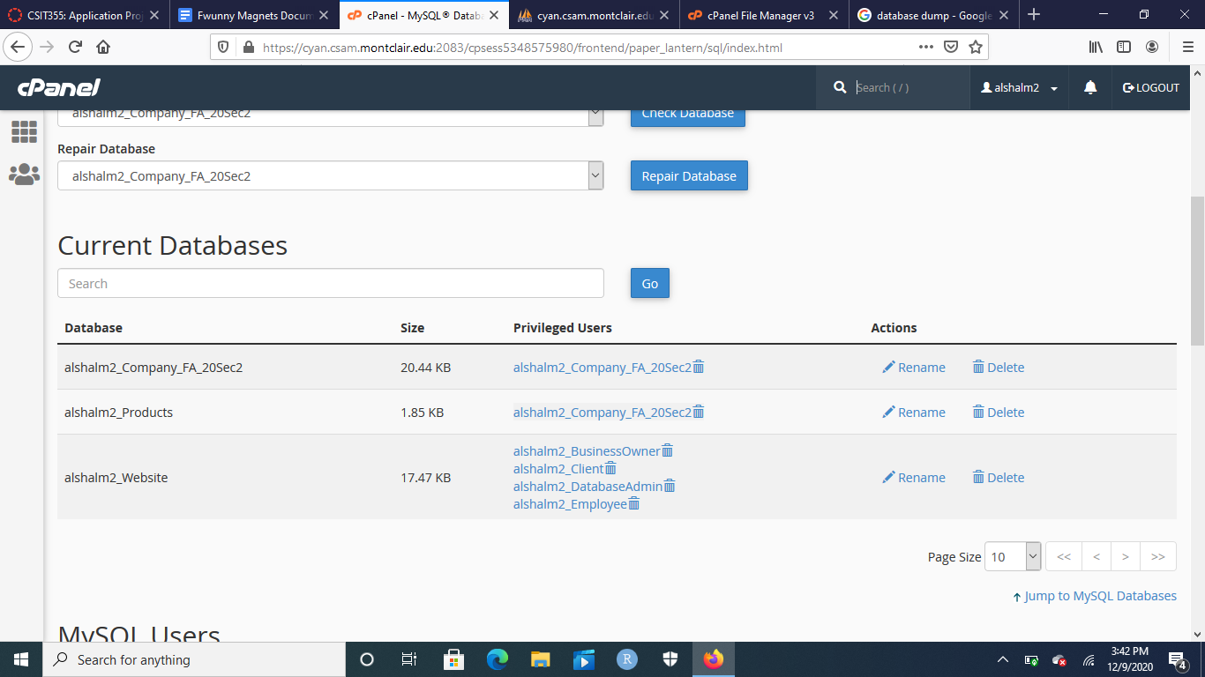

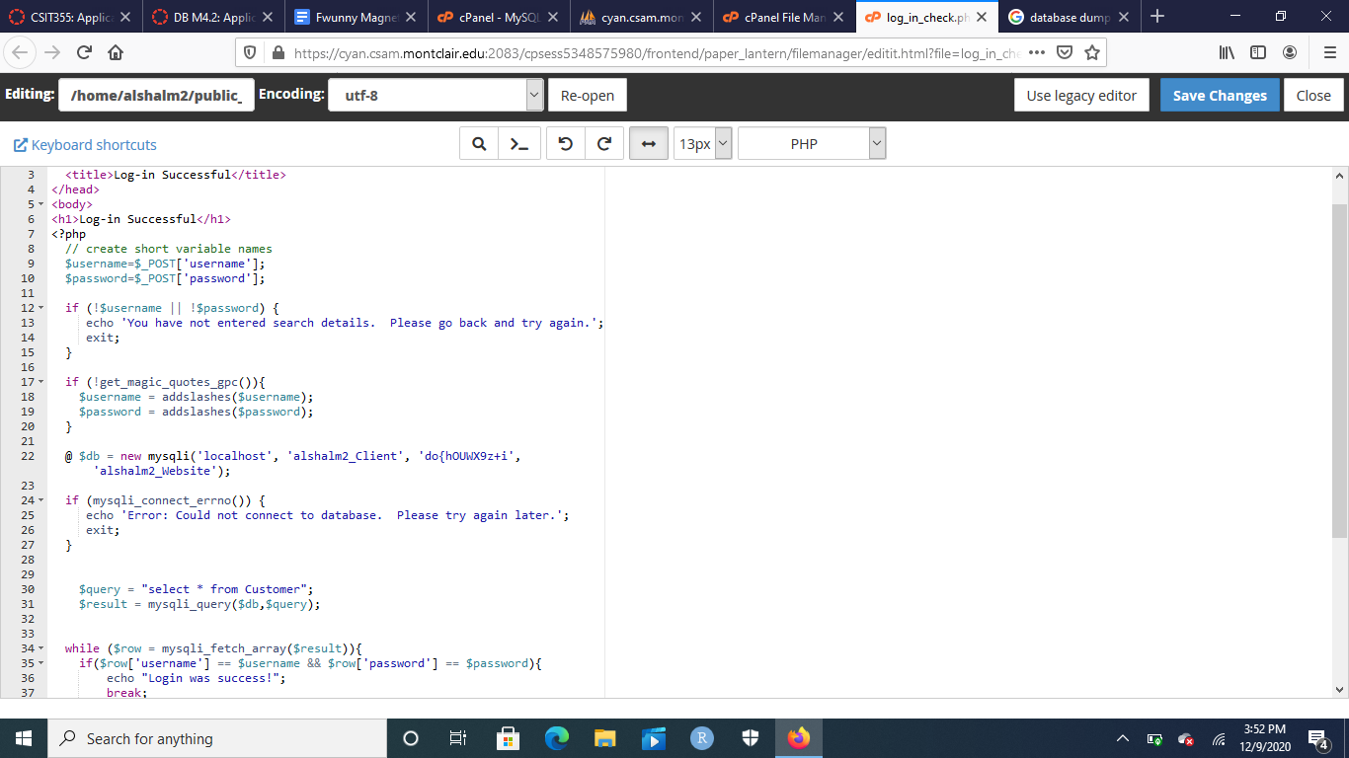

While the views in place are ordered alphabetically, the first view to look at is the alshalm2_Client view, or basically our customer. They basically have access to signing up, logging in, search mechanics, viewing the catalogue, cart mechanics, and ordering mechanics. The reason as to why this is the case is because a bulk of the work in the database has to do with products, as this is an E-commerce website, so they get the most views out of others when it comes to products, cart, and order form.

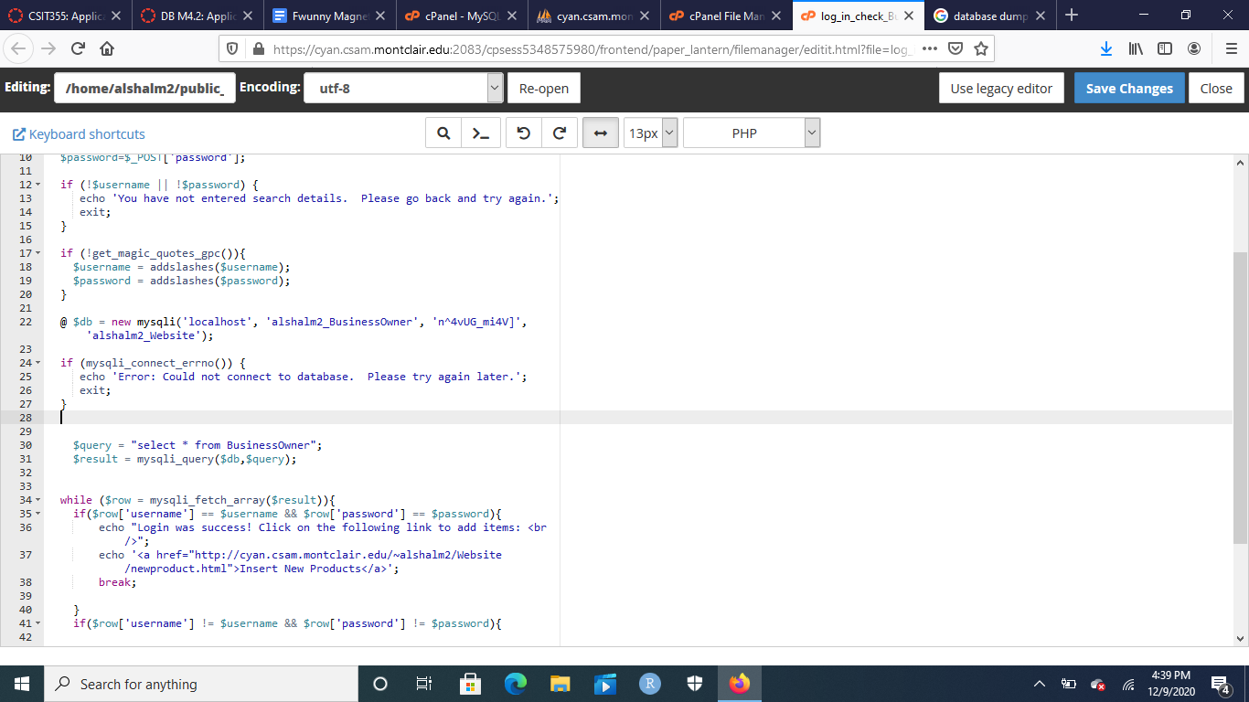

The second view to take a look at is the alshalm2_BusinessOwner view, or the business owner. The business owner can sign up, and once they sign up, can log into the website. Once those actions are executed, they can search through the catalogue, and insert new products into the Product table in the database. Business owner gets access to this view because they’re the one who owns the business, meaning they’re the one who has the right to come up with new products and introduce them into the Product table.

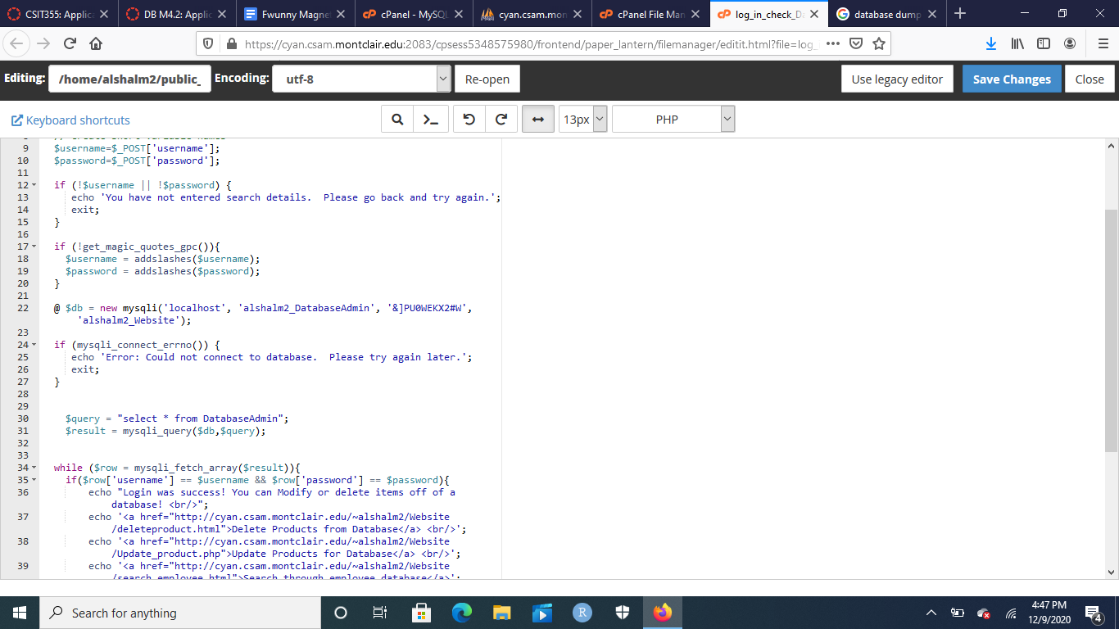

The third view to take a look at is the alshalm2_DatabaseAdmin view, or the database admin. The database admin can sign up, and once they sign up, they can log into the website to fulfill their roles. Once they’re logged in, they can search through the catalogue, they can search through employee records (as a small human resource job), update the Product table from the database, and delete items in the Product from the database. The database admin gets the modify and delete functionalities due to the fact that the business owner comes up with products, but the database admin is the one who refines everything, and takes out redundancy or mistakes that the business owner could’ve made. Furthermore, because it would be a conflict of interest to have the business owner or the employees be in charge of the human resource aspects, the database admin gets that role by searching through records of employees in the Employee table of the website database to assist employees in identifying them and their needs.

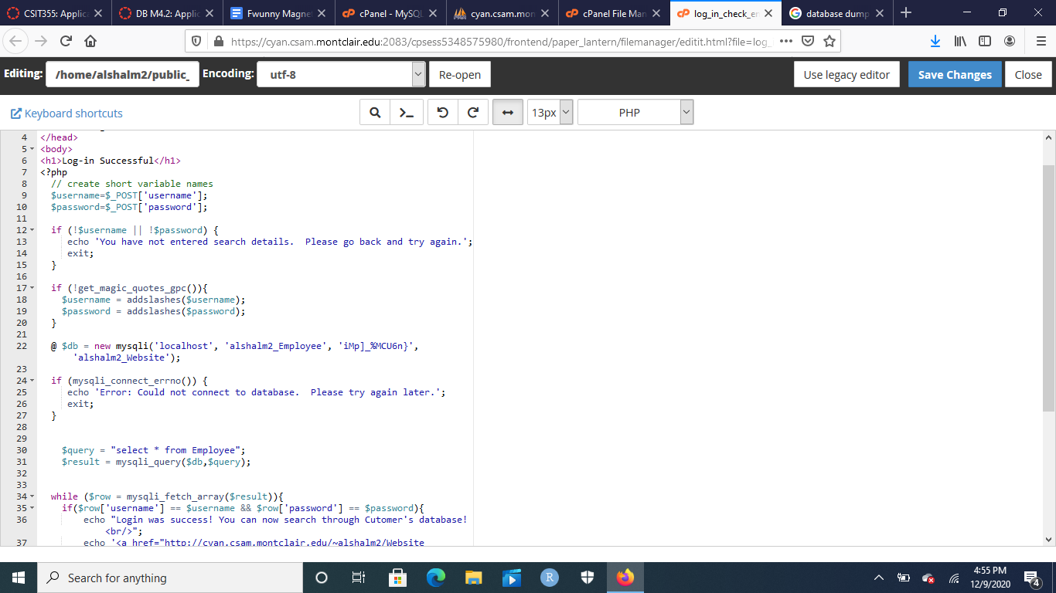

The fourth and final view to look at is the alshalm2_Employee view, or the employee view. The employee, like every other class, can sign up to the website, and once that occurs, they can log into the website to fulfill their role. Once logged in, they can do two tasks: search the catalogue and search the Customer table. These two tasks are done to assist the Customer in finding issues about a product as well as helping them with their log-in information.

**Data Model: Conceptual**

Original V1:

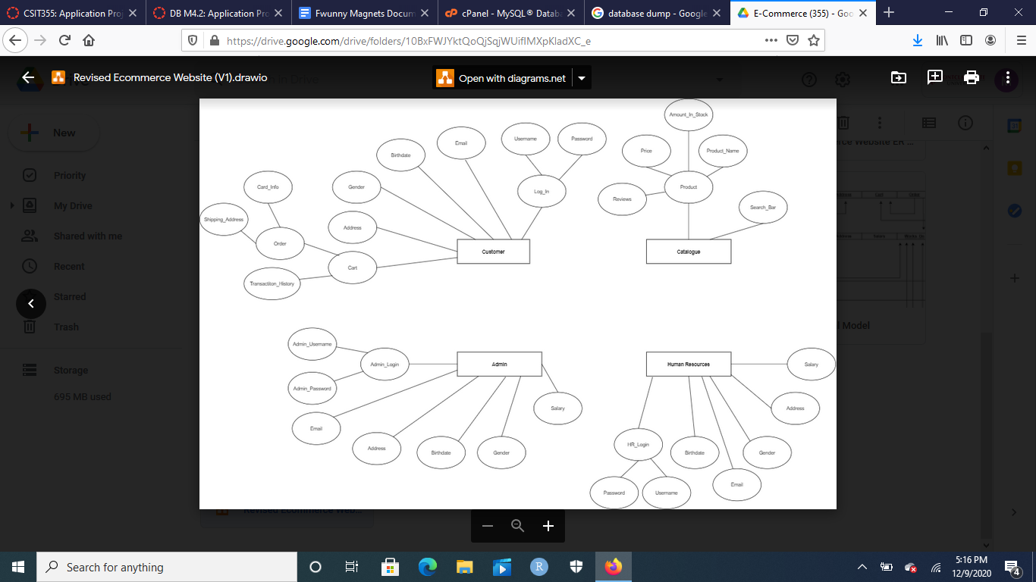

Final V1 for Discussion:

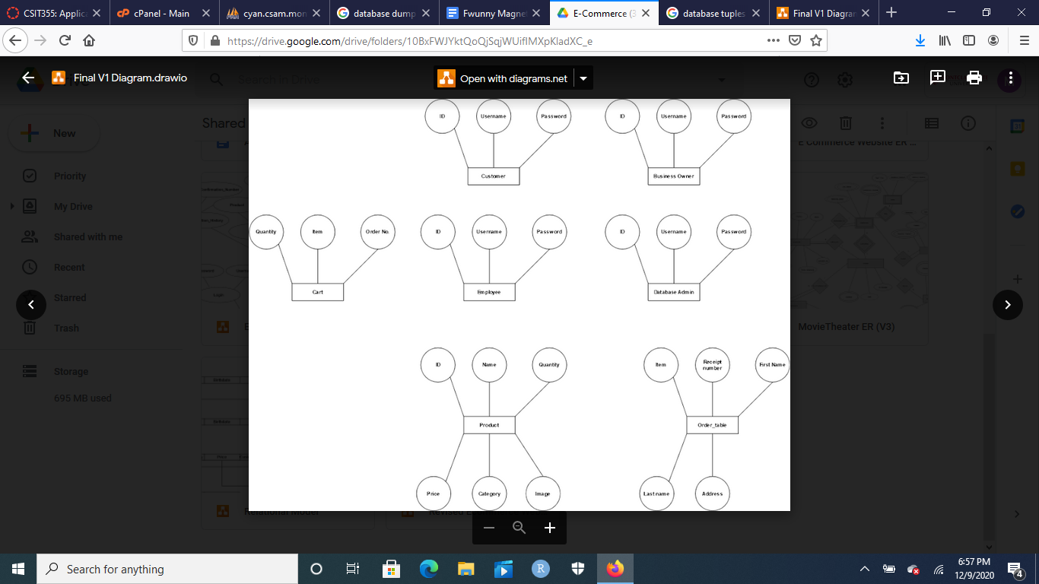

For our conceptual model, we wound up with 7 tables. Those tables being our first four views: Customer, BusinessOwner, Employee, and Database Admin, all contain the following variables: ID, username, and password. The other tables include Cart, Product, and Order_table. Cart has three variables, those being quantity, item, and order number. Product has six variables, those being ID, Name, Quantity, Price, Category, and Image. Finally, the Order_table has five variables, those being item, receipt number, first name, last name, and address.

Original V3 Diagram:

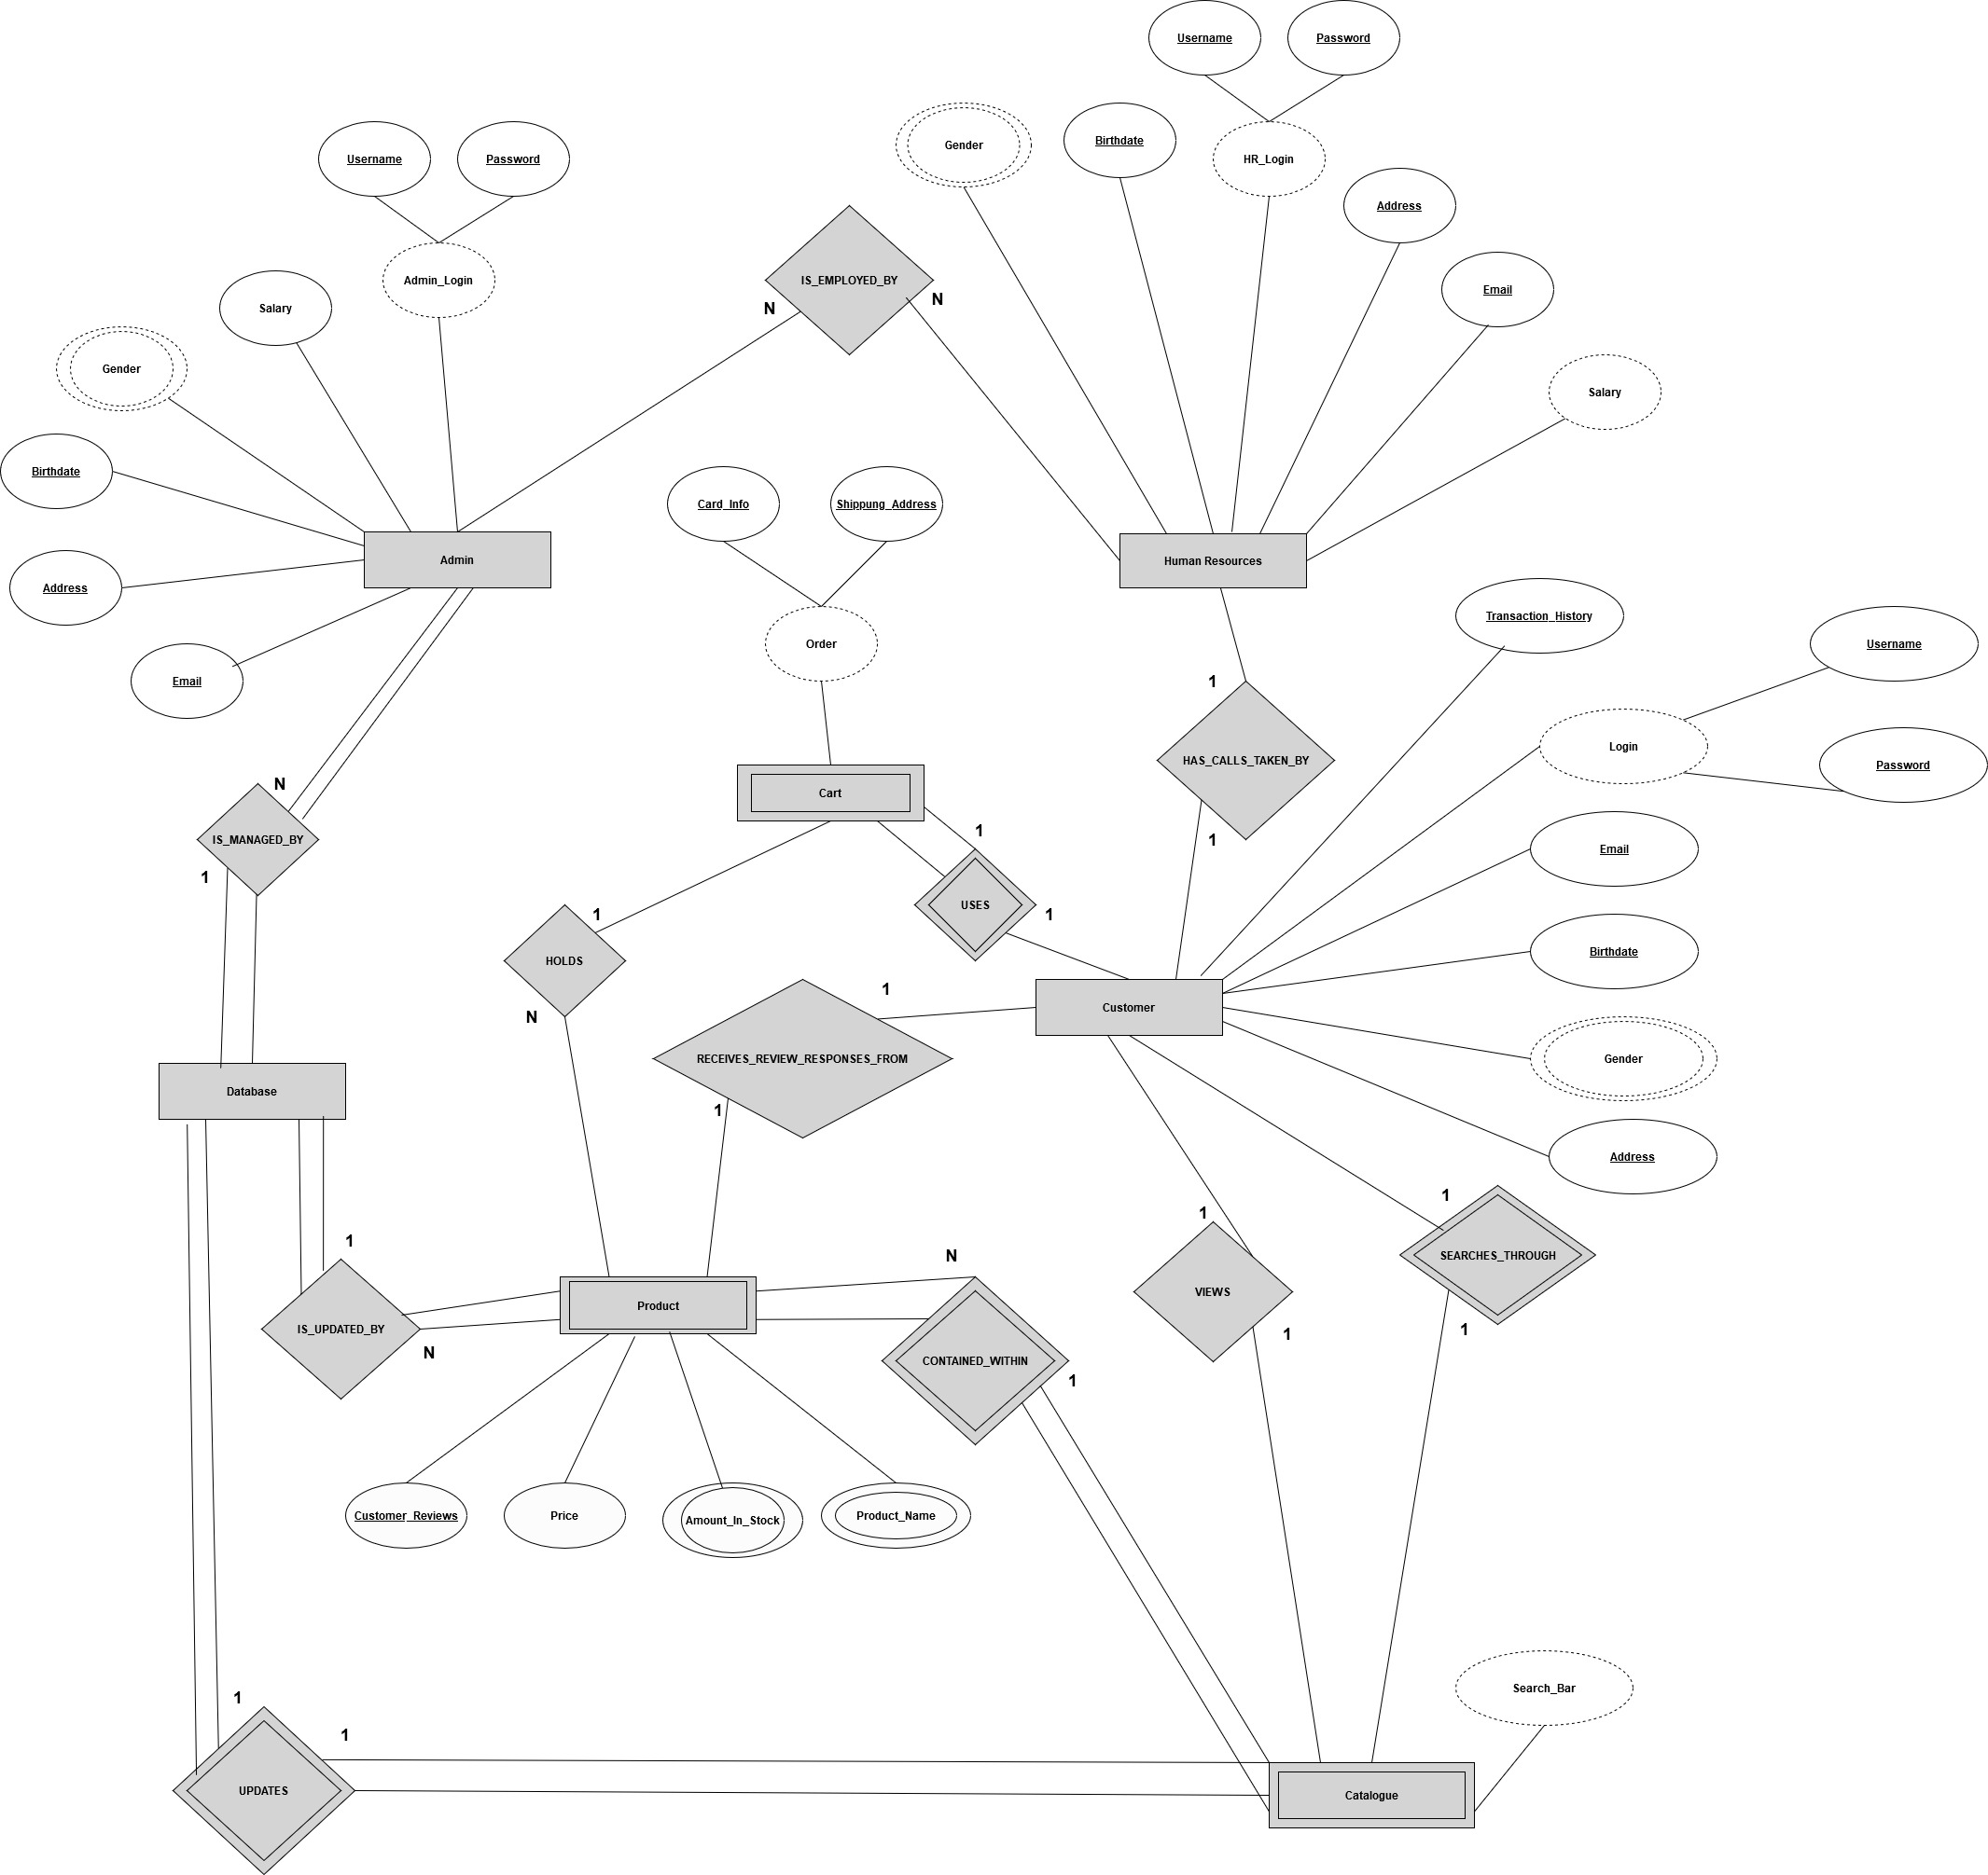

Final V3 Diagram:

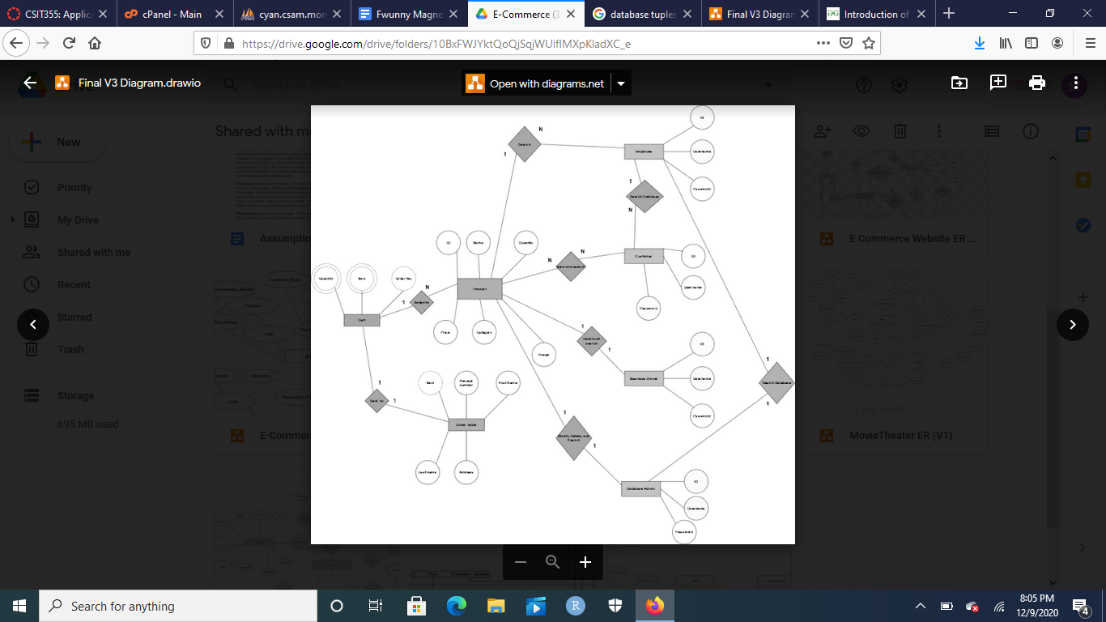

For the V3 of our conceptual model, the Customer looks through the products table which contain all of the products. Once the customer wants some products, they’re added to the cart table. The customer can choose to add more products into the cart table. In the cart, Quantity and item are both multivalued attributes since there can be multiple of them. Furthermore, all the values in the Cart table are derived attributes, as they all come from the Product table. Once the customer is done adding items to the cart, the items in the cart table are sent to the order table, which contains one derived attribute, item, and the rest being normal. Business Owner table gets to search and insert items into the Product table Database Admin gets to modify, delete, or search the Product table and search the Employee table. Finally, Employee searches both Product and Customer tables.

Original Relational Model:

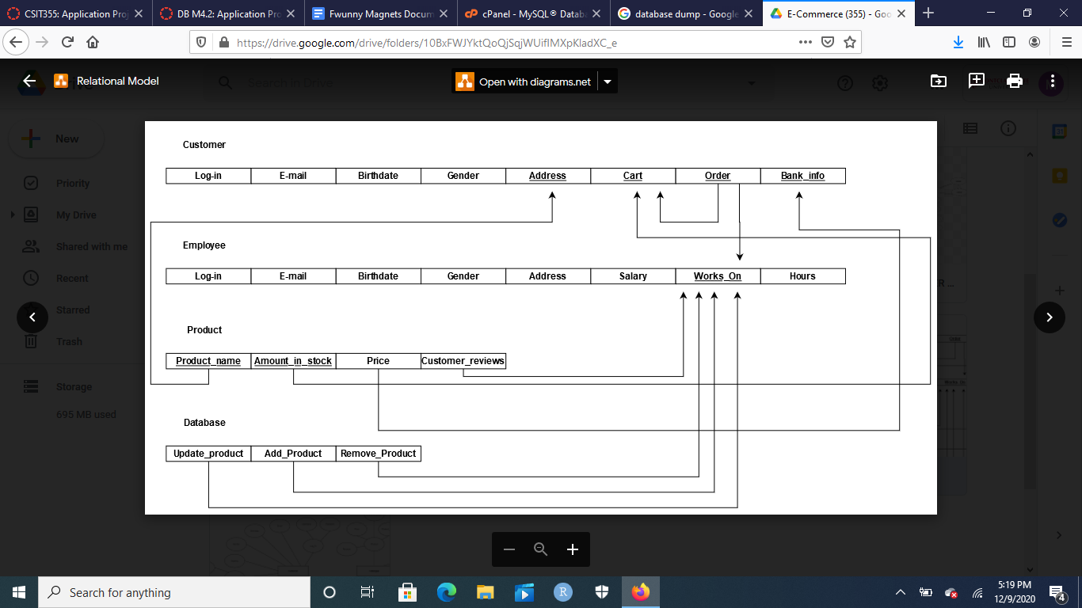

New Relational Model:

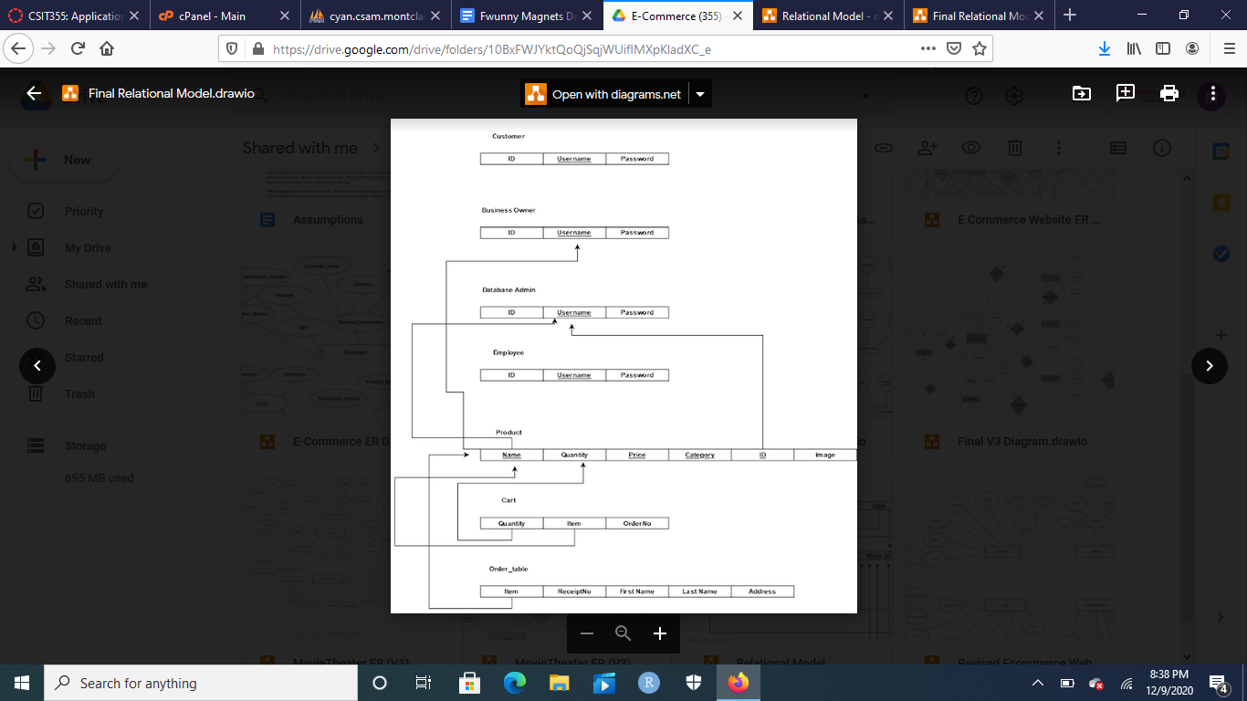

For the relational model, we decided to translate all of our tables into 7 relations. The four relations would be the Customer, Business Owner, Database Admin, and Employee, all of which have three attributes: ID, username, and password. The next relation as well as the biggest is Product, which contains eight attributes: Name, Quantity, Price, Category, ID, and Image. After that comes the Cart relation, which includes Quantity, Item, and Order Number. Final relation is Order_table, which includes Item, Receipt Number, First Name, Last Name, and Address. In the first four relations, the username is the key relation because password is encrypted, so we know by username who’s doing what. Item is a key relation because Item in both Order_table and Cart are both derived from another key relation, Name in the relation Product. Quantity in Cart is a key relation because it is derived from Quantity in Product, which is important to know how much of each product is being purchased. In Product, there are multiple key relations like Name, Price, Category, and ID, and they’re all key relationships because apart form basic searches, they’re required when imputing a new product (with name being most important), with a product being taken out, and with a product being modified (with ID being the most important).

Looking at the final product and the conceptual one, there were many clear problems. The big red flag for us was that we weren’t supposed to take in any payment. We originally looked at the 4.2 assignment, and because the hyperlink for “full documentation” didn’t work, we didn’t remember to check the original project requirements, which mentioned multiple times to not take in any payment information. So for the implementation, no payment info was or is ever taken. Furthermore, we decided to go with seven tables instead of four, one for each view (which we didn’t account for when making these diagrams), as well as a table for Cart, Order_table, and Product. It wasn’t good design to have the cart be part of the Customer table, and catalogue shouldn’t be a table, product should be. Finally, we made Customer orders its own table, as combining both the Cart and Order into a single table isn’t great design. We also removed a multitude of variables we wanted in our project, like customer reviews, emails, birth dates, gender, and salary, due to the fact that we were originally ambitious in our design and once the implementation occurred, these variables were hard to implement.

**Data Model: Implementation**

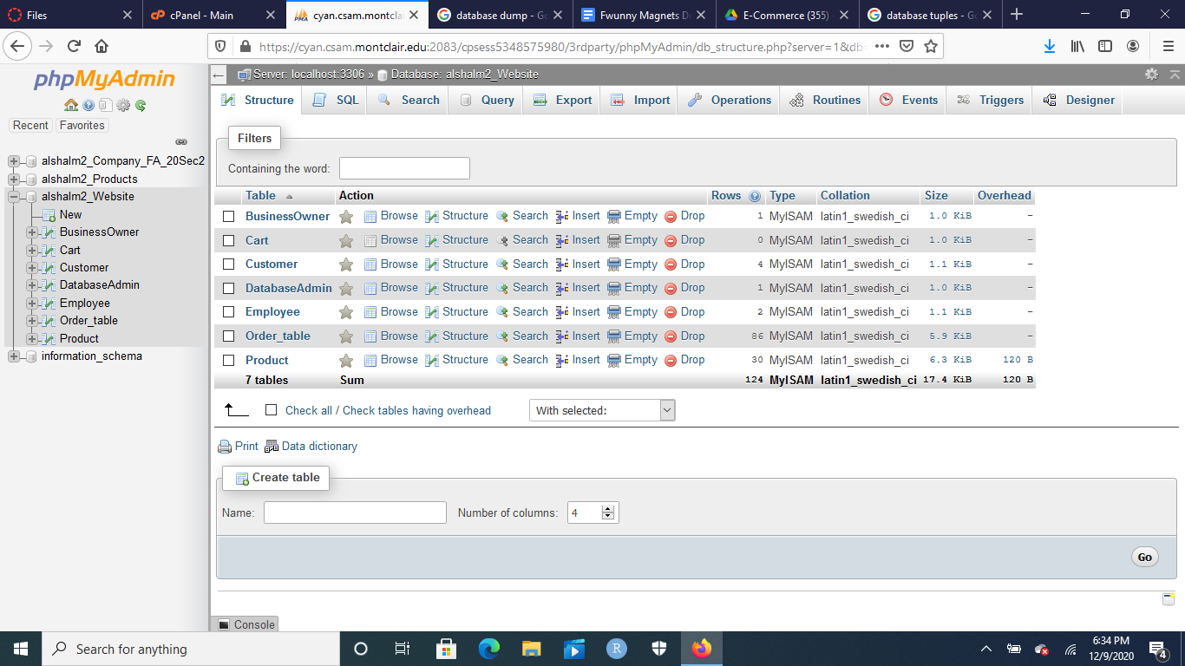

This is the entire database, which is named alshalchm2_Website. It includes 7 tables, labeled alphabetically. The table names are BusinessOwner, Cart, Customer, DatabaseAdmin, Employee, Order_table, and Product.

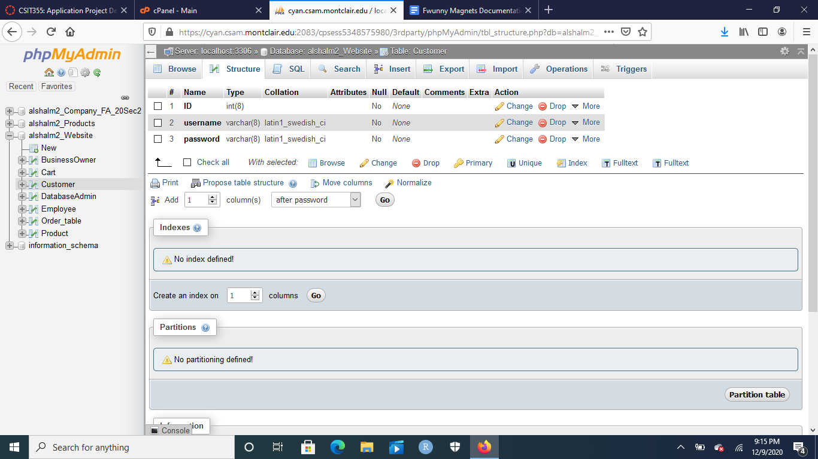

This is the Customer table form the alshalchm2_Website database. It has three columns: ID, username, and password, with ID being an integer of 8, and username and password being varchars of 8. This database is accessed by alshalm2_Client view to be able to sign up and log into the website. This database is also accessed by alshalm2_Employee to be able to search up Customer information by the employees.

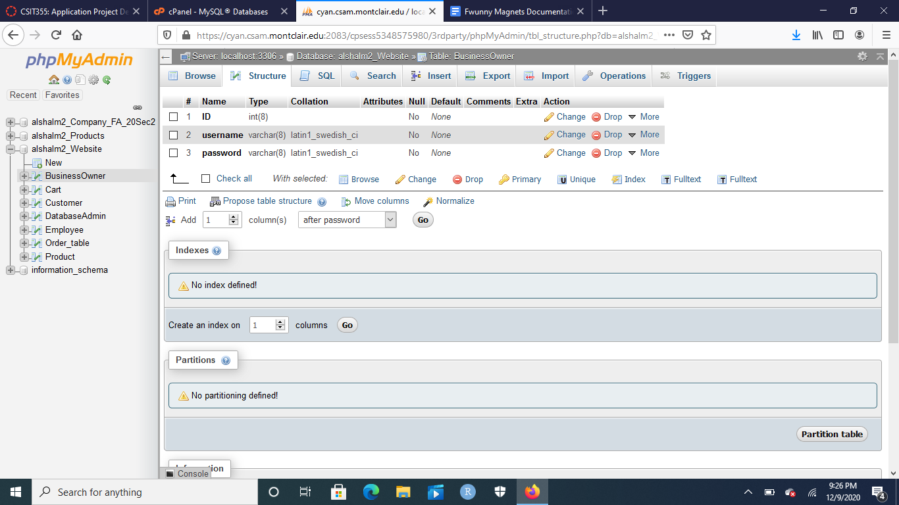

This is the BusinessOwner table form the alshalchm2_Website database. It has three columns: ID, username, and password, with ID being an integer of 8, and username and password being varchars of 8. This database is accessed by alshalm2_BusinessOwner view to be able to sign up and log into the website.

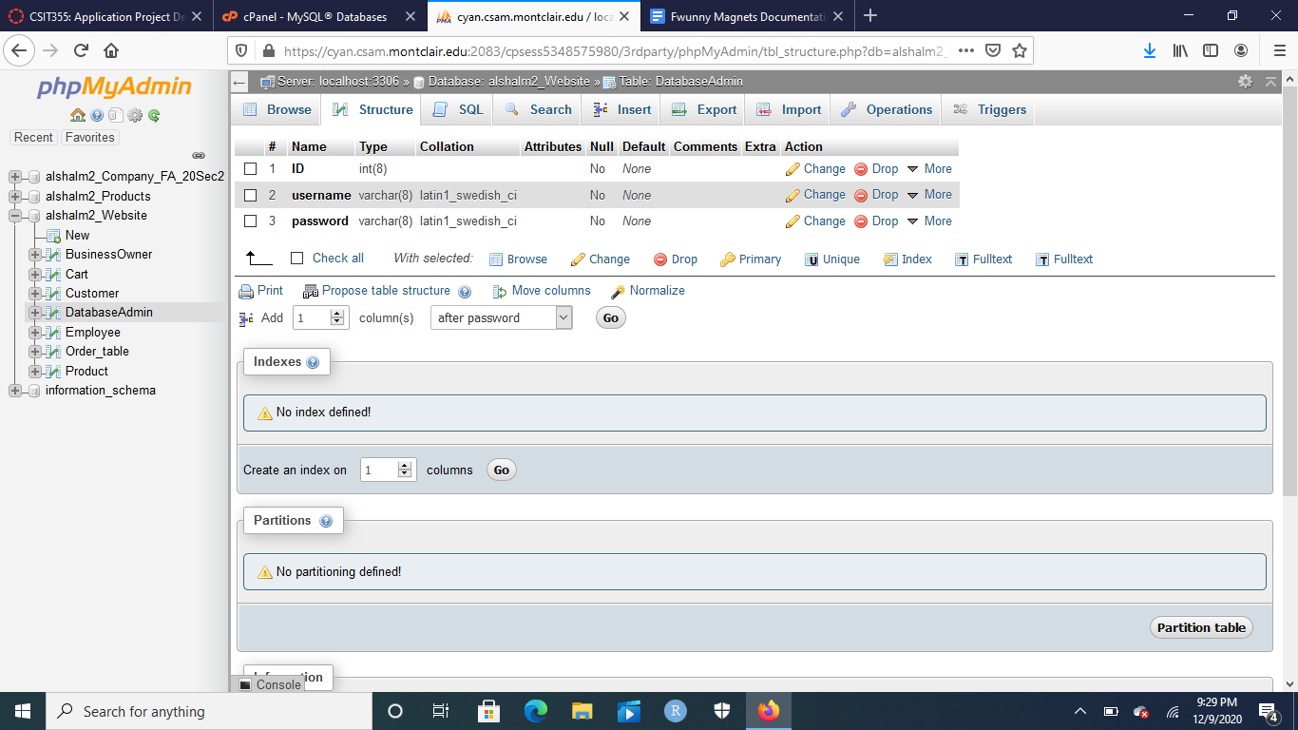

This is the DatabaseAdmin table form the alshalchm2_Website database. It has three columns: ID, username, and password, with ID being an integer of 8, and username and password being varchars of 8. This database is accessed by alshalm2_DatabaseAdmin view to be able to sign up and log into the website.

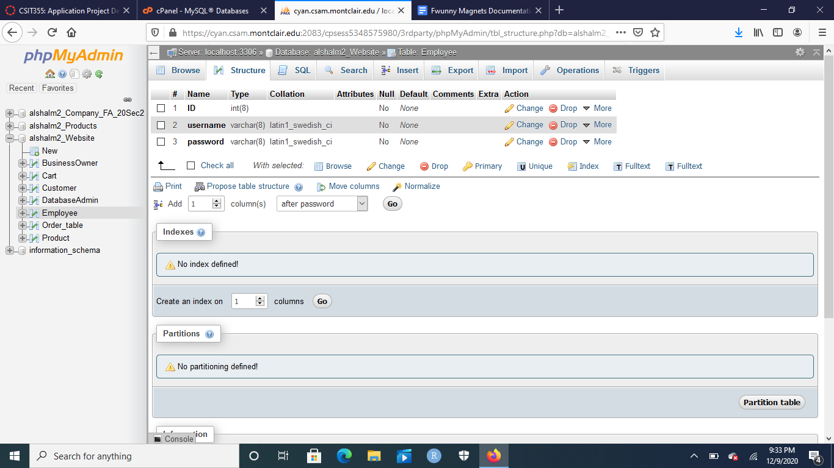

This is the Employee table form the alshalchm2_Website database. It has three columns: ID, username, and password, with ID being an integer of 8, and username and password being varchars of 8. This database is accessed by alshalm2_Employee view to be able to sign up and log into the website. This database is also accessed by alshalm2_DatabaseAdmin for the ability to search employee records for the small implementation of human resources.

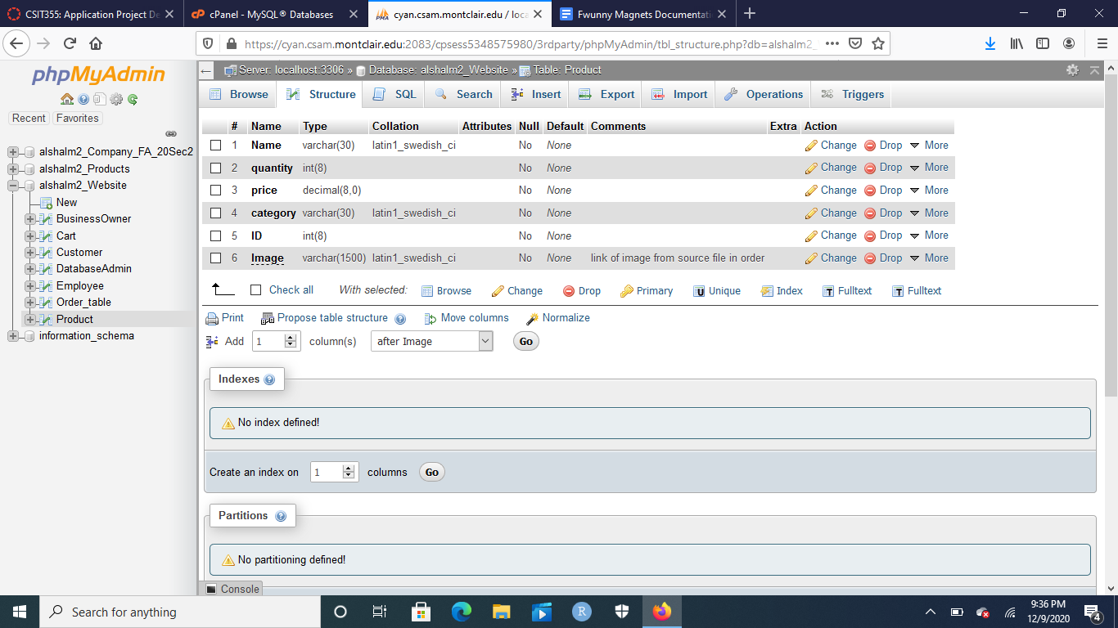

This is the Product table from alshalm2_Website database. It had 6 columns: Name (with a varchar of 30), quantity (with an int of 8), price (with a decimal of 8), category (with a varchar of 30), ID (with an int of 8), and Image (with a varchar of 1500). This table is accessed by every single view for the purpose of searching. For more specific actions, alshalm2_Client is able to view the products that are in the table, alshalm2_BusinessOwner is able to add more products into the table, and alshalm2_DatabaseAdmin is able to modify and delete products in this table.

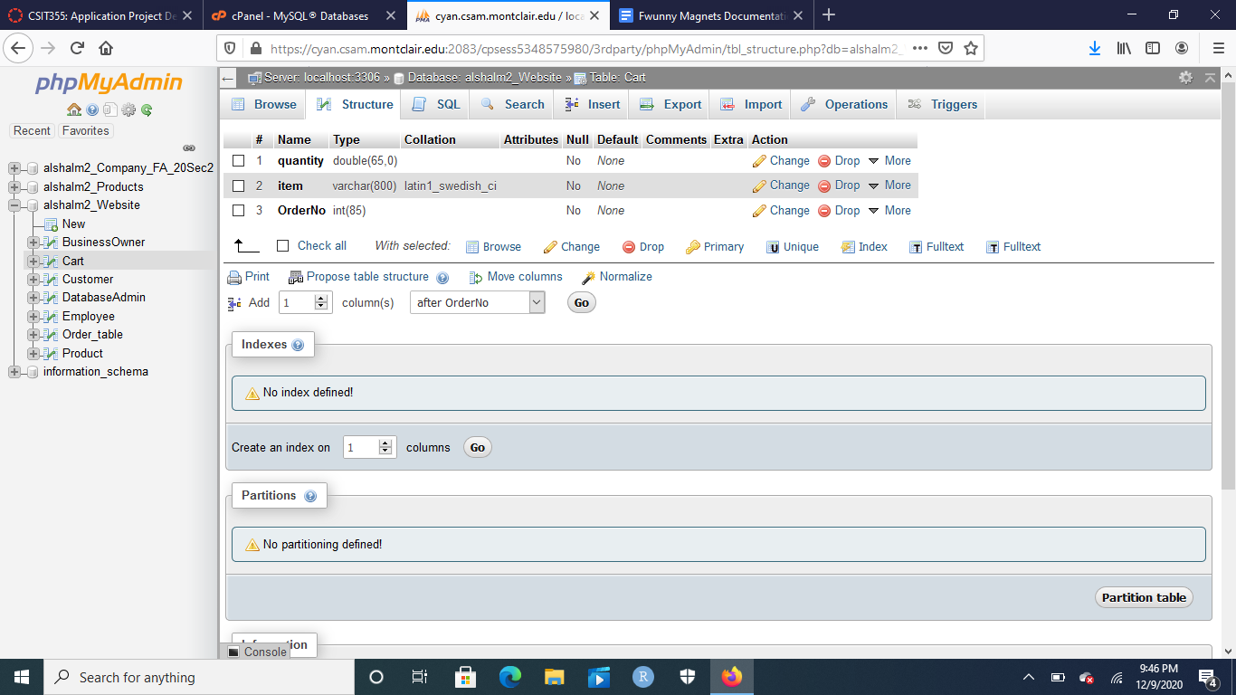

This is the Cart table from alshalm2_Website database. It has three columns: Quantity (with a double of 65), an item (with a varchar of 800 for the sake of adding more items), and OrderNo (with an int of 85). This table is accessed by alshalm2_Client view to be able to add the products in the products table into the Client table temporarily.

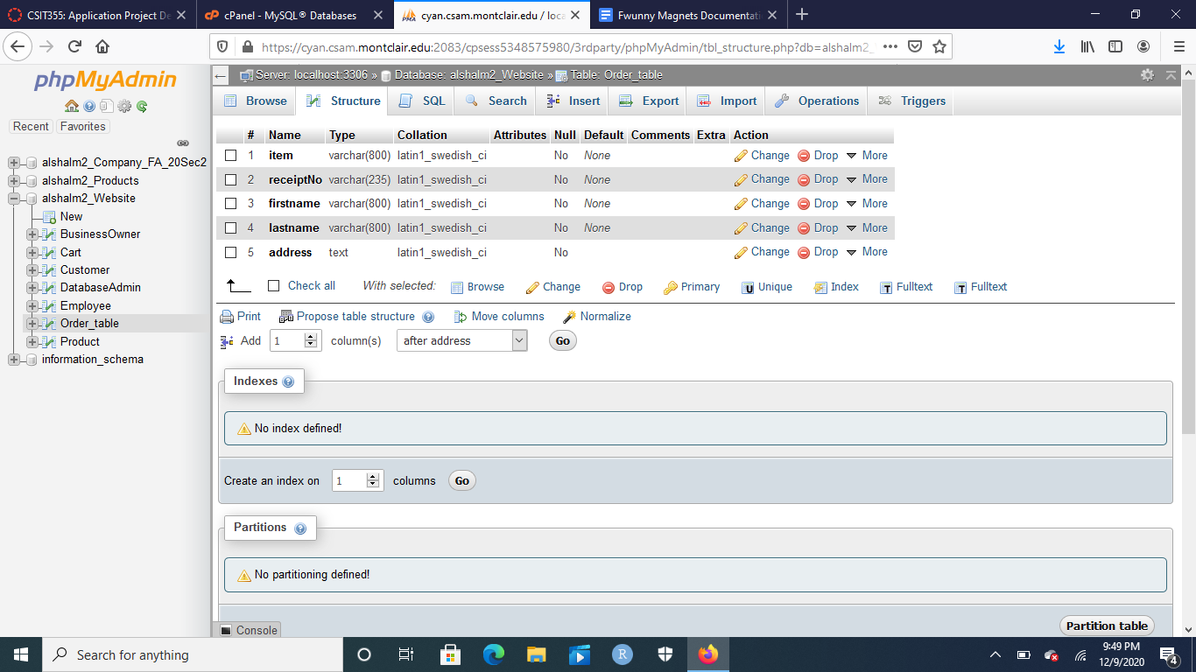

For the final table, this is the Order_table from the alshalm2_Website database. It contains 5 columns: Item (with a varchar of 800), recieptNo (with a varchar of 235), firstname (with a varchar of 8000, lastname (with a varchar of 800), and address (with a text option). It is utilized by the alshalm2_Client view to be able to process the order from the Cart table as well as enter the necessary information for shipment purposes.

**Website Implementation:**

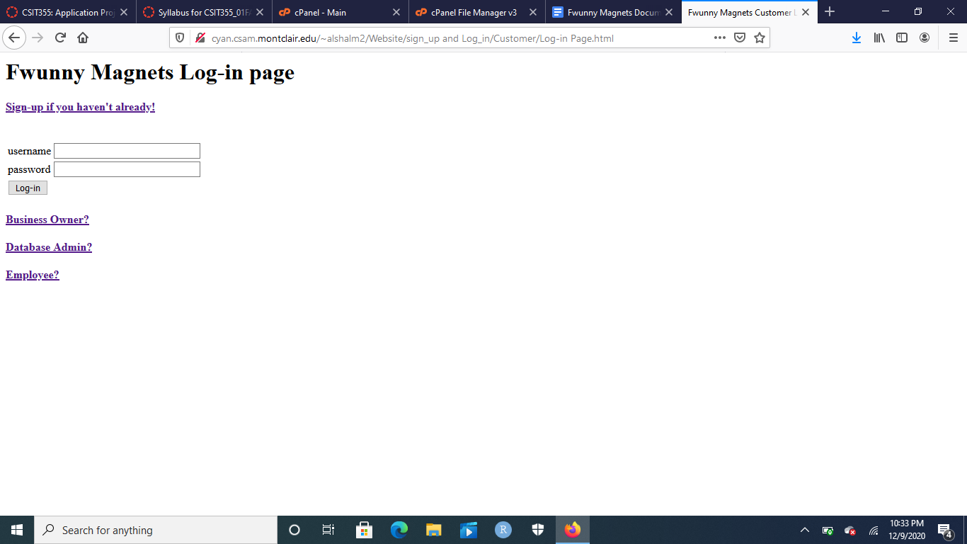

As the client wanted, the very first page of the website is met with a log-in page. Along the log-in page there are multiple hyperlinks, a sign up link, a link for business owner view, a link for the database admin view, and a link for the employee view. To continue with the website view, we log-in to be able to access the website.

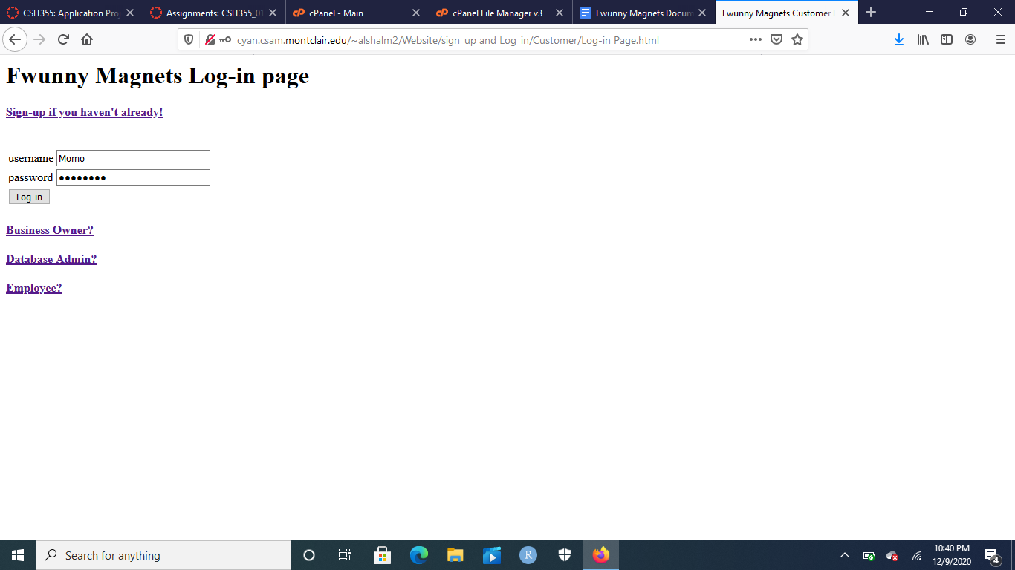

This is a username and a password that’s already signed up and registered into the database. Once the submit button is clicked, the PHP connects to the Customer database and checks whether the log-in info is registered or not in the database.

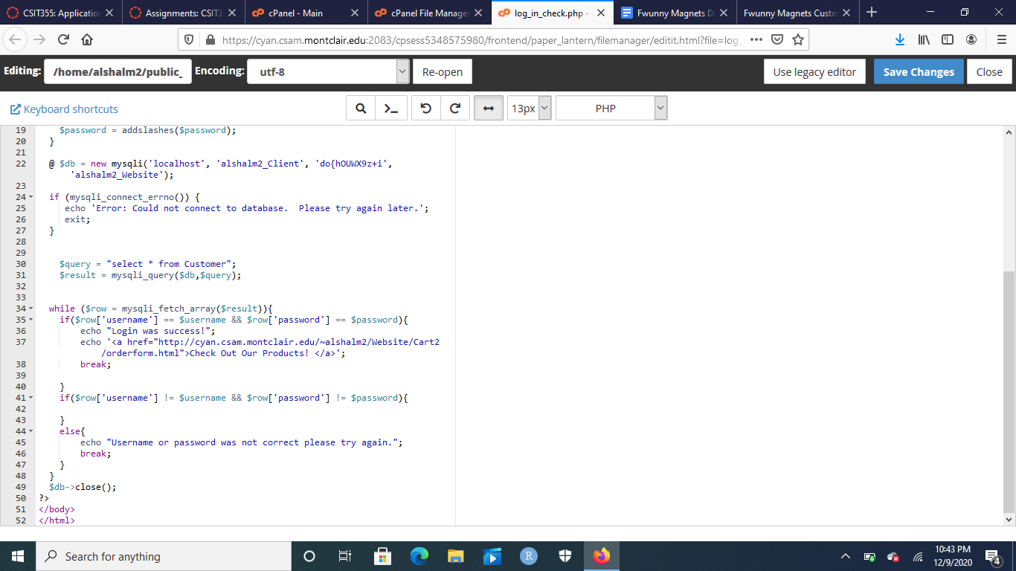

This is the PHP program that connects to the database. It selects * from the Customer table, and if the entered info is the same as the information in the database, it lets you log in. If not, then the website won’t allow you to log-in and browse the product catalogue.

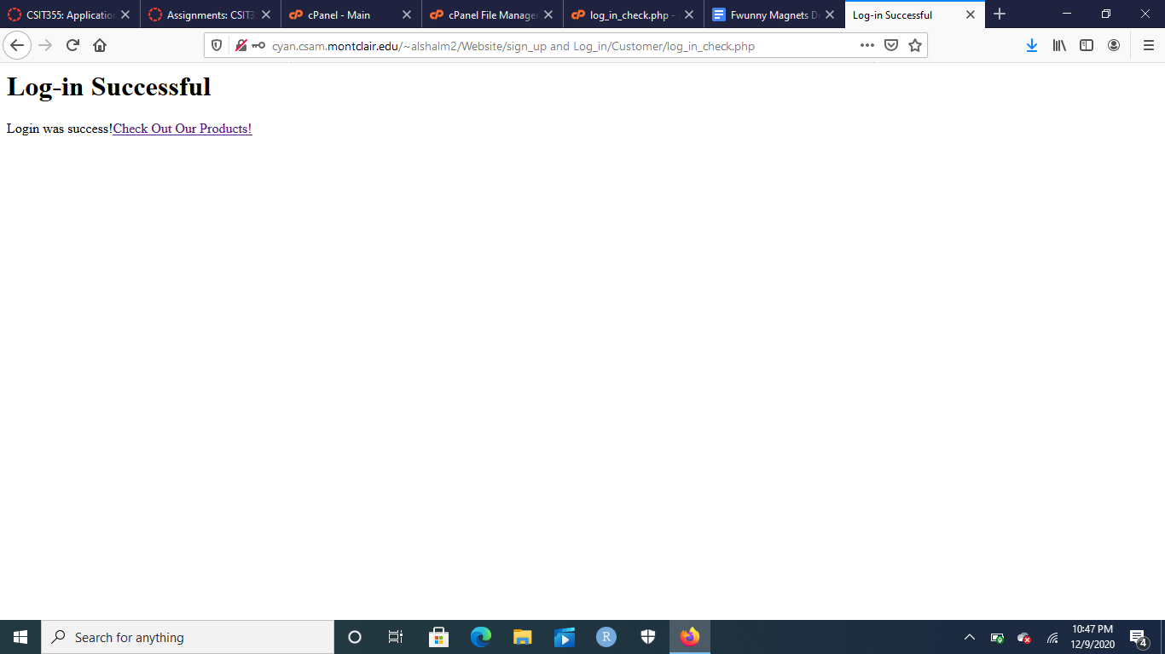

This is the view when the log-in is successful. You can then continue into the catalogue by clicking on the link labeled “Check Out Our Products!”

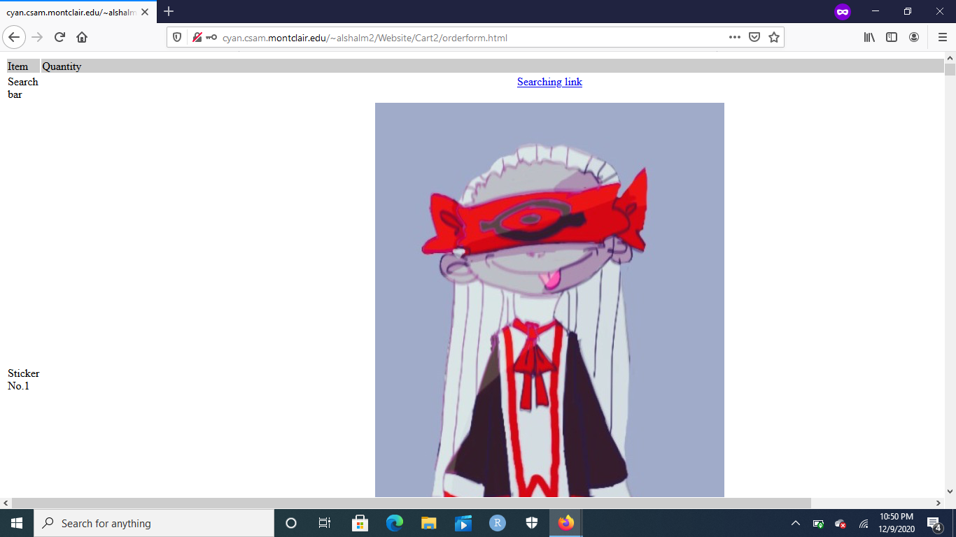

This is the website catalogue, which contains over 30 items divided into 5 categories: Unclean, Superhero, Character body, Color Scheme, and Full Image. This is elaborated further with the search bar mechanics (will be discussed later due to the fact that every view searches the products database.

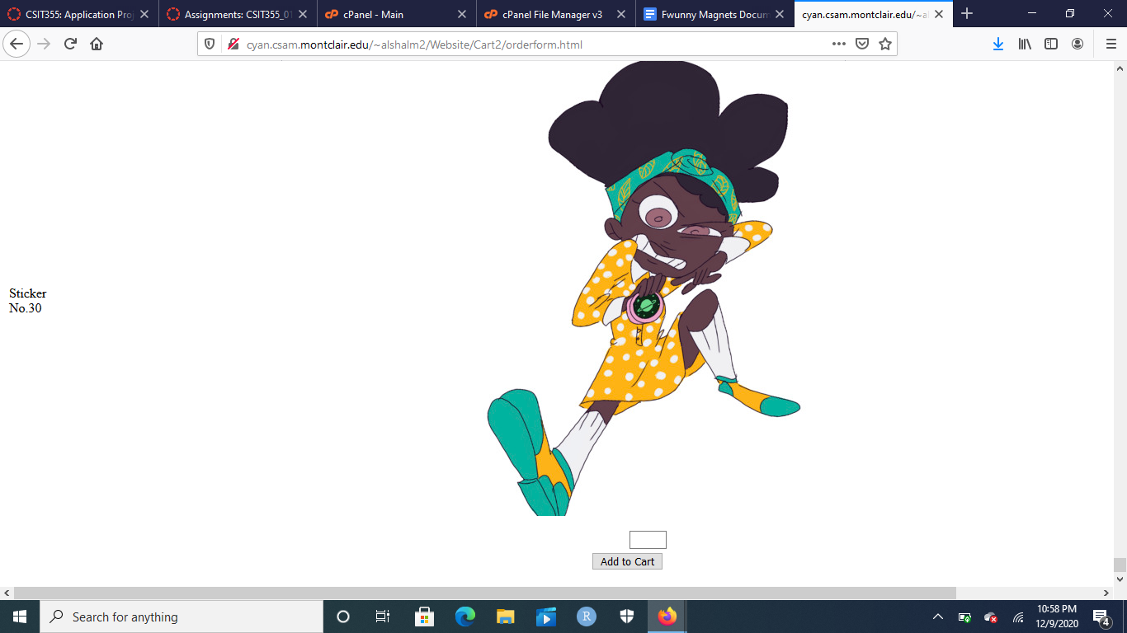

Once I decide to buy items, I input how many of each item I want and click “add to cart” at the bottom of the link. It will take me to the next link, which includes my cart as well as a request for information.

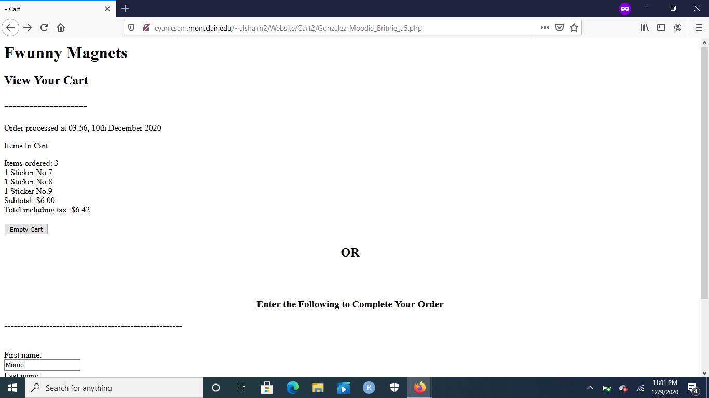

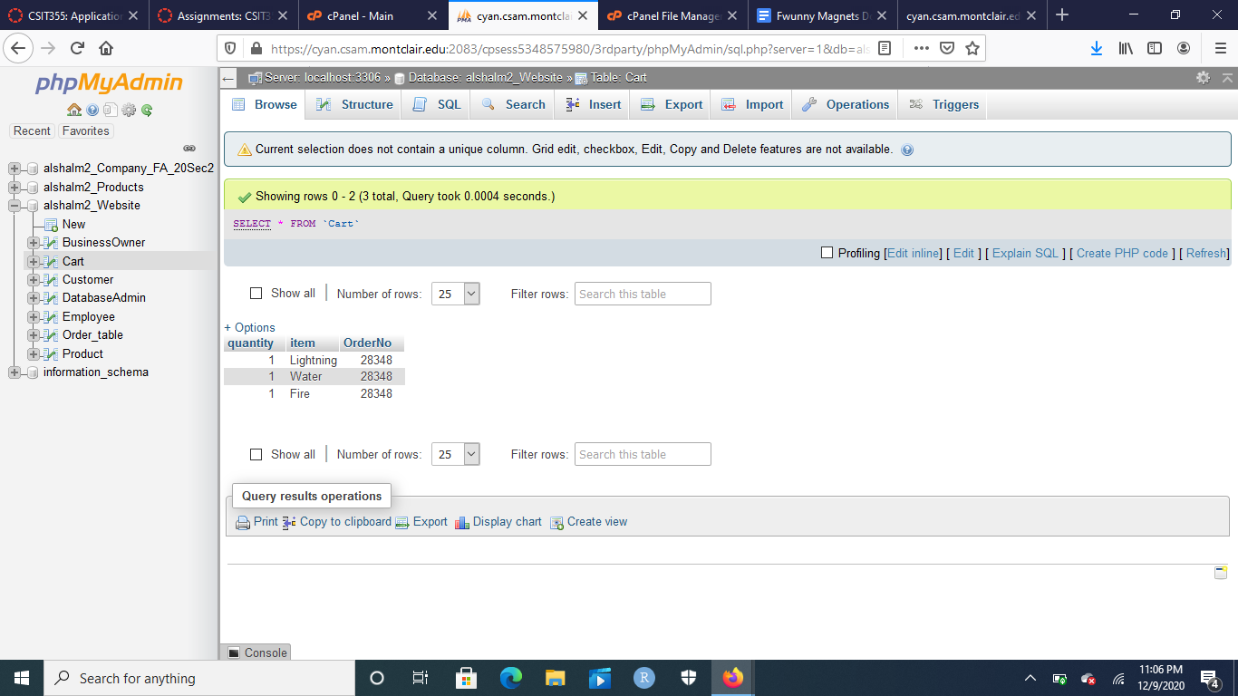

This is the cart of the user with all the products that they wanted. It shows that I have ordered Sticker number 7, sticker number 8, and sticker number 9, which are Lightning, Water, and Fire magnetic stickers, as recorded in the cart database once I click the add to cart button.

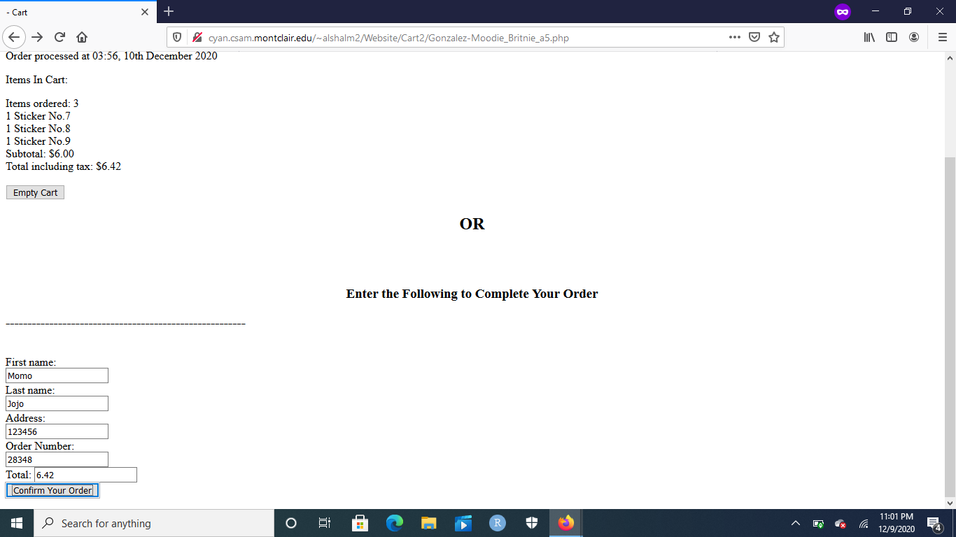

This is the bottom of the website from viewing the cart website. Over here is where the information is entered of the customer: First name, Last name, Address, Order Number (which is randomly generated), and Total (which is generated for you). Once “Confirm Your Order” is clicked, it takes you to the order completion page.

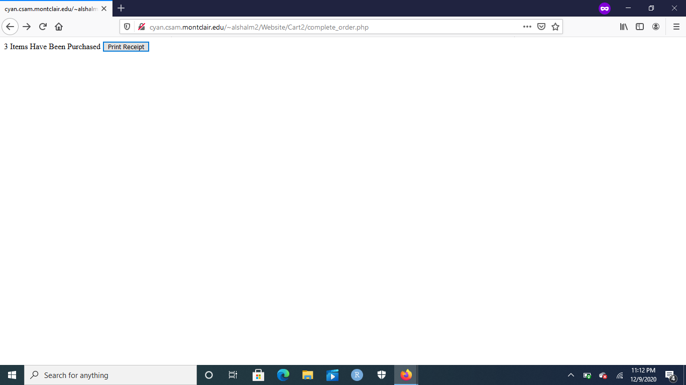

This is the order completion page. It showcases the items that have been “purchased” as well as a button to print the receipt, so that the client/customer can access their order and review it.

**(picture of receipt should be included here. Also include picture of the order database with the new information inserted there)**

Now that Customer views are over, the customer can go back to their cart view and click on the “clear cart” button, which clears the entire cart, and gets rid of it in the database. Now that all of the customer views have been exhausted, we can now jump into different views. First with the alshalm2_BusinessOwner view. Using the same log-in mechanics as the Customer log-in page, the Business Owner is able to log in by checking the table of BuisnessOwner and seeing if the username and password matches it.

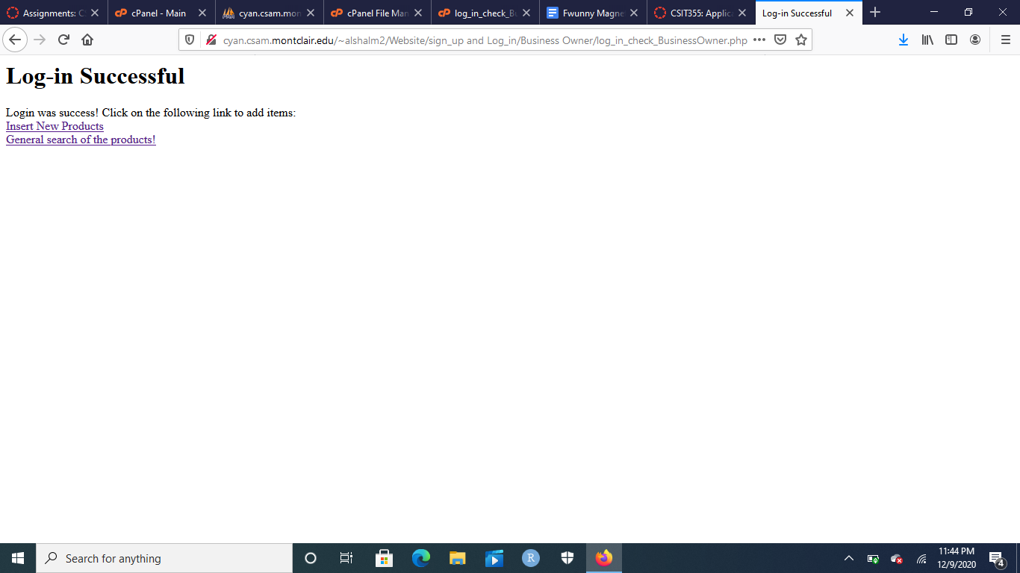

Once the business owner is logged in, they can access two things: general search of the products and the ability to insert new products. Once clicking on “Insert New Products” hyperlink, they’re taken to a page where they can start inserting the products that they desire to be inserted into the Product table of the database. The business owner has to enter the name, quantity, price, category, ID, and image of the product:

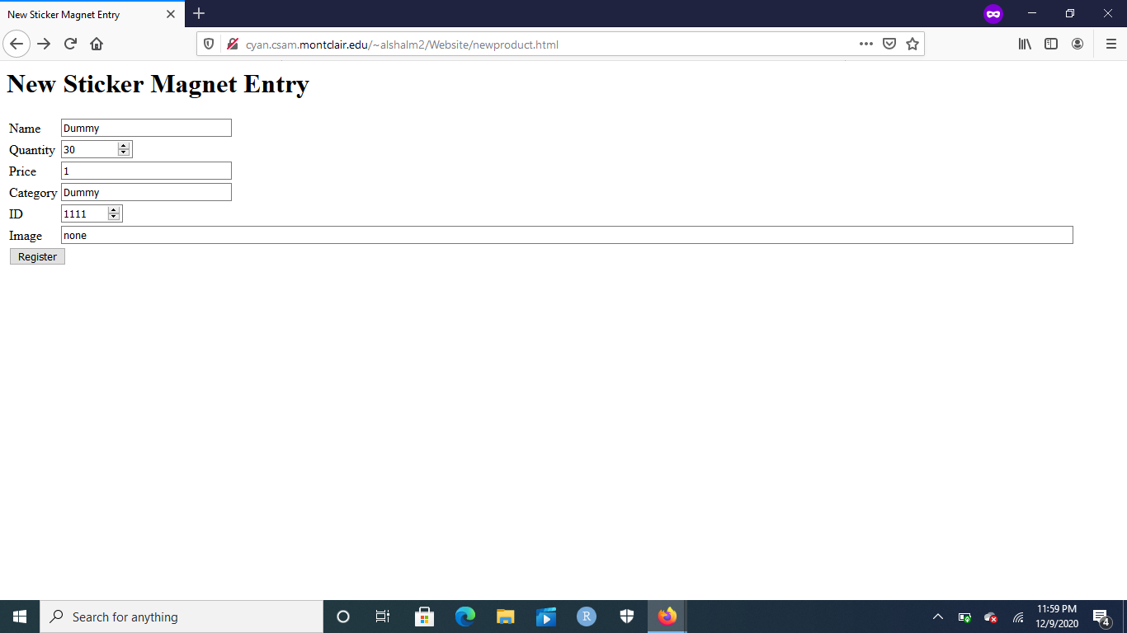

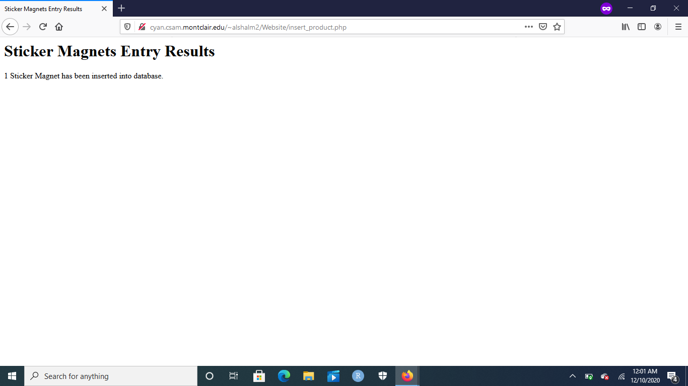

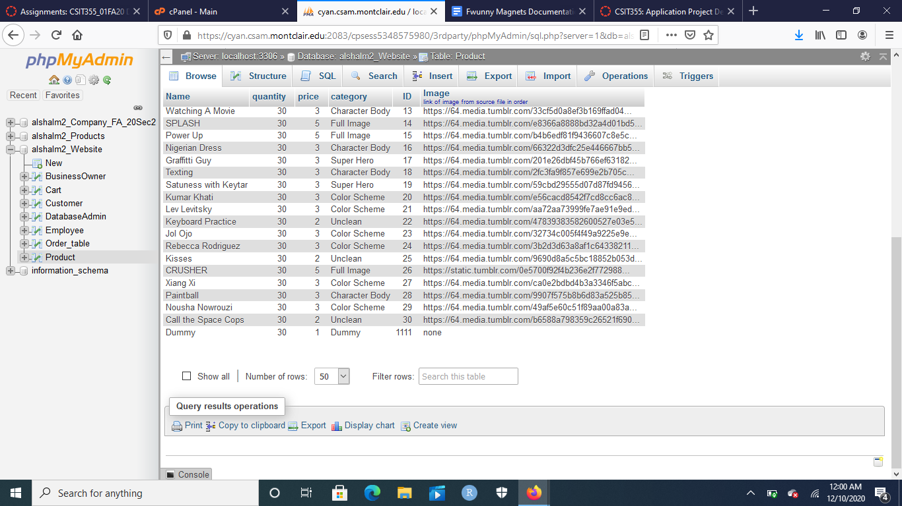

Once the business owner gets a product that they wanted inserted into the database, if the information that they entered is correct (matches the conditions of the code), they get a page which confirms that a sticker magnet has been added into the inventory. This is further backed up by the fact once the table is checked or when a product is searched for, the newly added product shows up in the table.

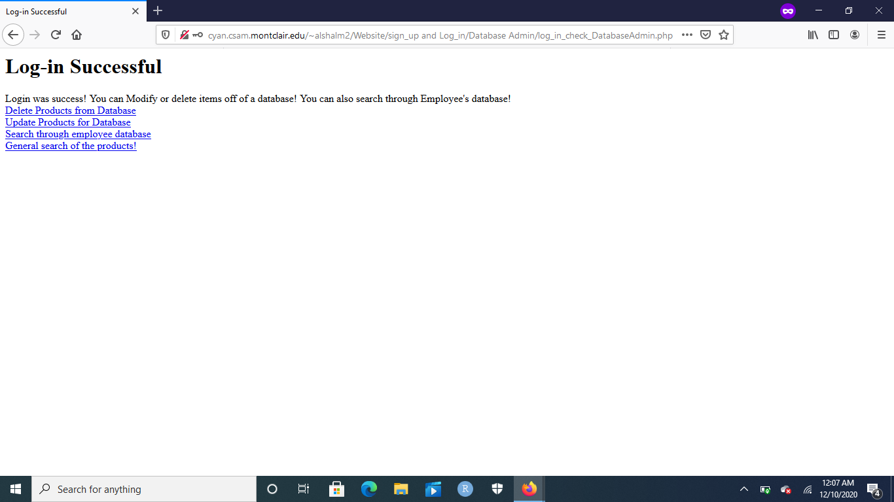

Just like the other views, once the log-in is successful from the alshalm2_DatabaseAdmin view, they can do three actions: update products in the database, delete products in the database, search through the Employee database, and perform a general search of the products.

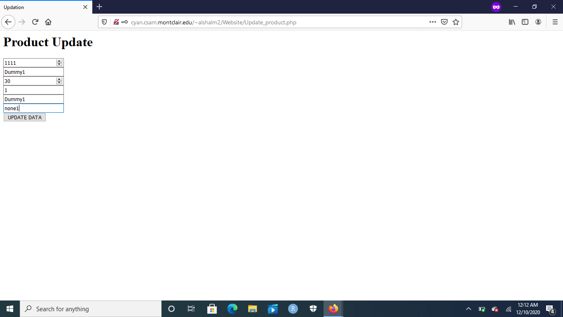

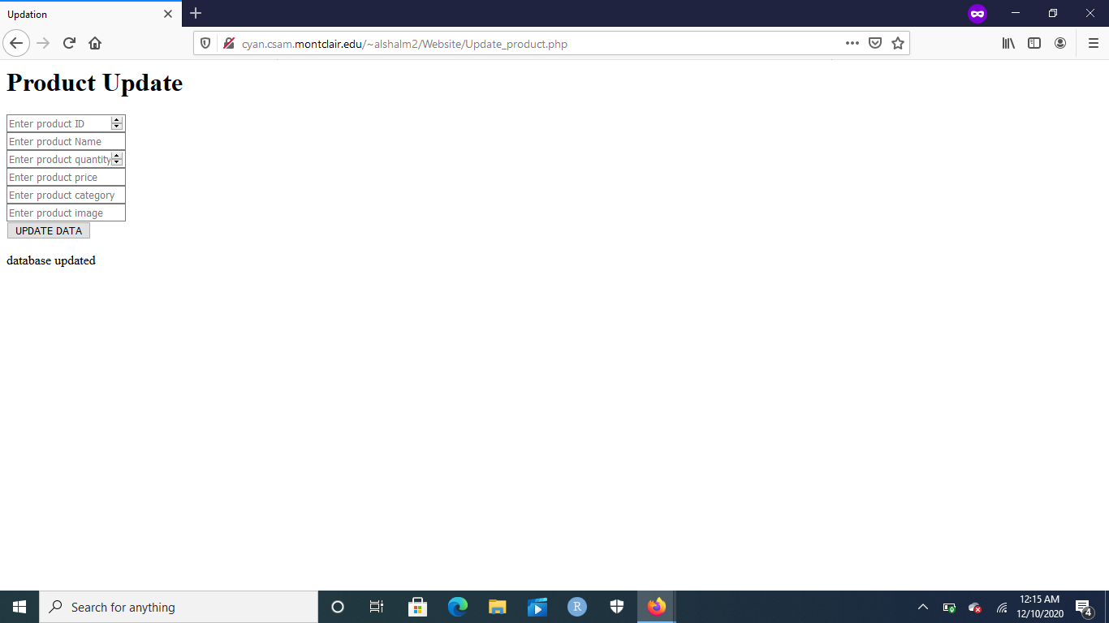

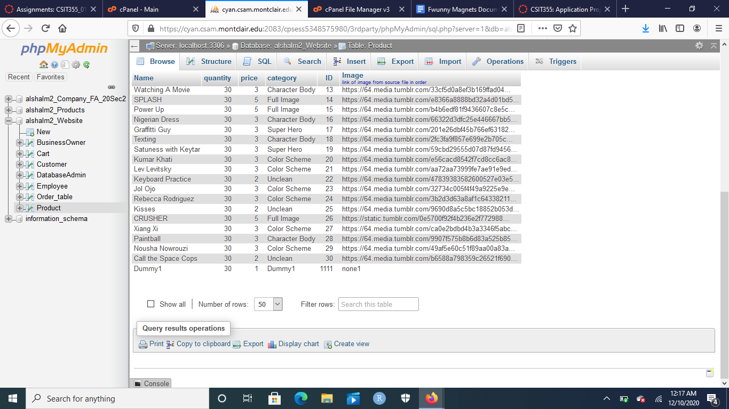

To update the Product table, the item has to be identified via the product ID so that a modification of the product can be made. In the following photos, the database admin enters the ID number of the product they want updated, enter the new details, and click the update data button. Once that button is clicked, the same page is updated with a new message “database updated”. This can be backed up by the fact that the product in the Product table is updated, which can also be searched for using the search mechanics.

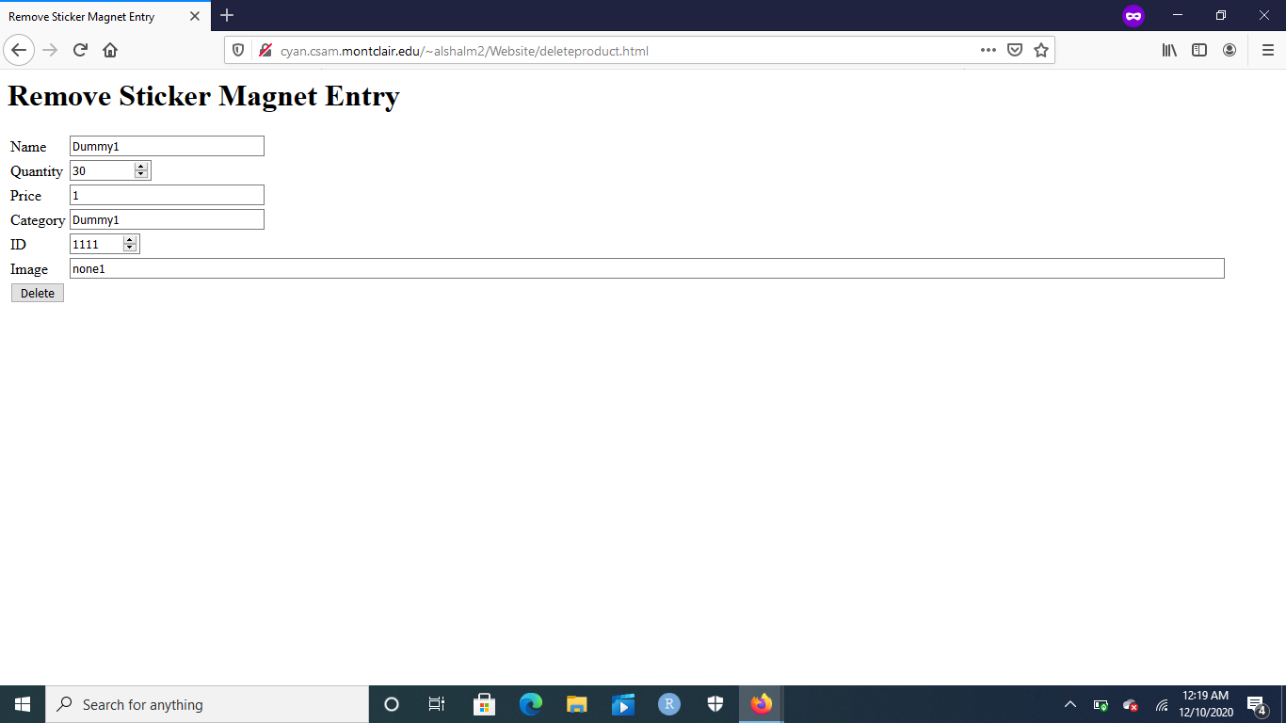

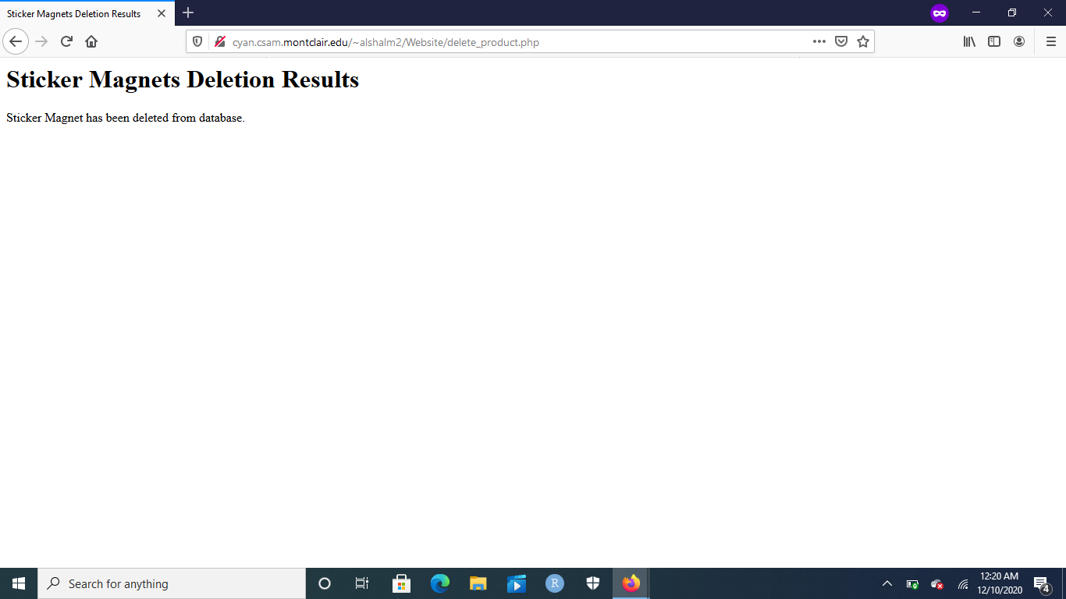

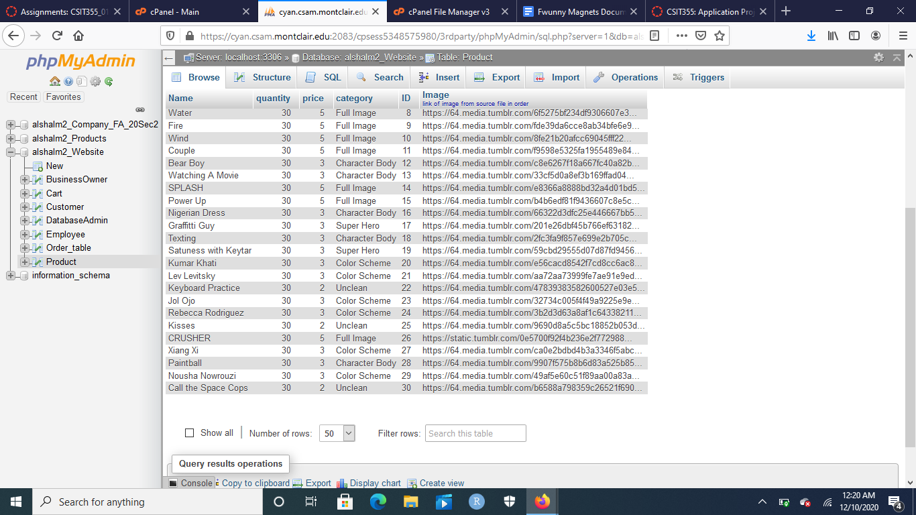

Next, the database admin can delete products from the Product table. They do this with a similar technique to inserting new products. The database admin enters the name, quantity, price, category, ID, and the images of the product that already exists in the database. If all the relevant information is correct, a page is showcased that lets the database admin know that the product has been deleted from the database. This is backed up by the fact that once looking into the database and searching for the product, the product is no longer present in the database.

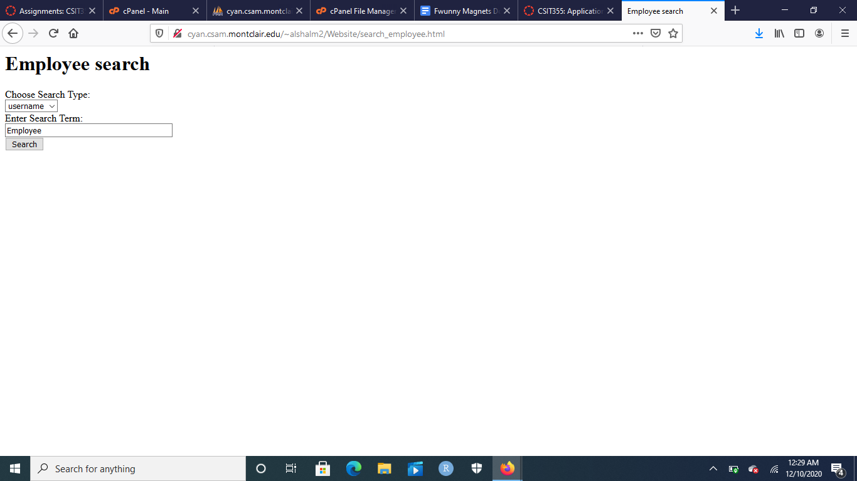

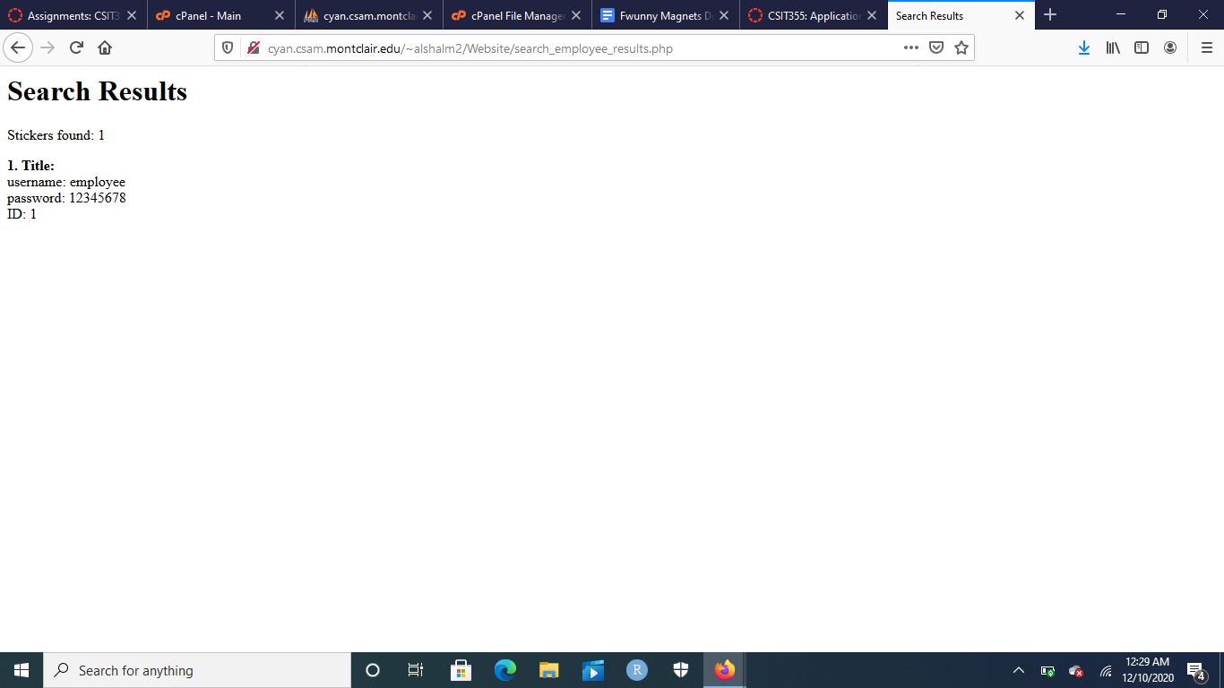

Finally, the Database Admin can search through the employee database for human resource management (this is the search mechanics that apply to the product searching as well). The database admin can pick any column to search with and enter appropriate details of that column. If something similar shows up, then the search result will be outputted from the appropriate table to be viewed.

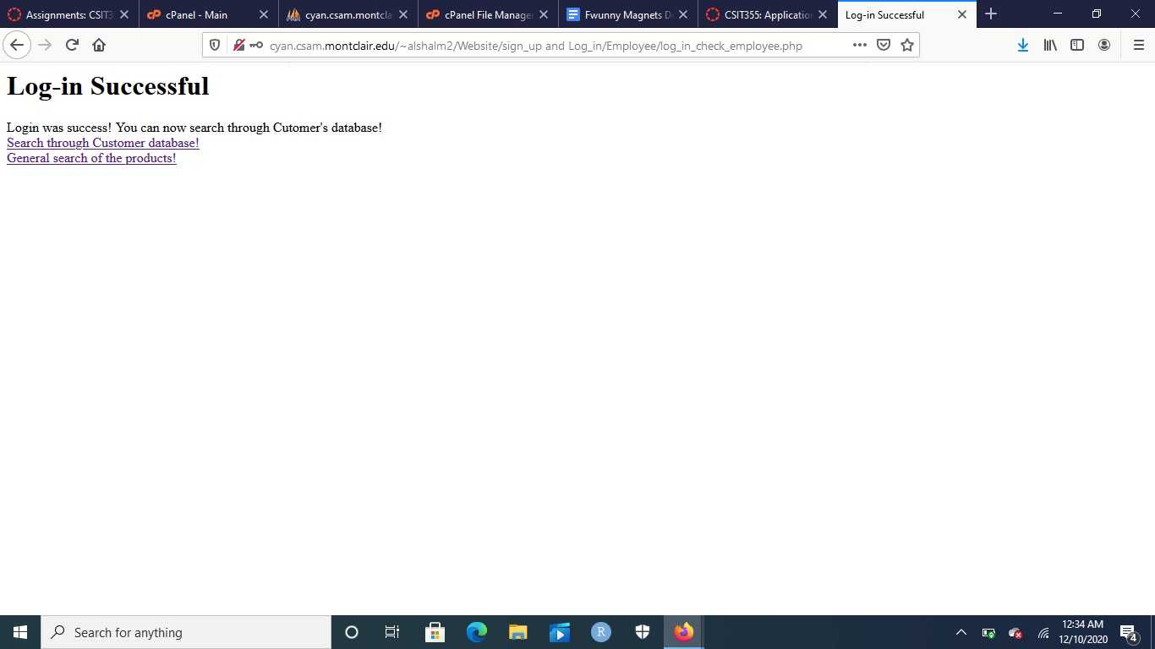

The final view is the alshalm2_Employee view, which gets to search the user table as well as the product table. Because the search mechanic has already been showcased, there is no need to go over it again, just showcase what the Employee has access to in their view.

**Analysis of the Database Issues:**

The database is generally formatted in 2nd normal form. This is the case when looking at the three tables that have to do with the process of “purchasing” a product: Product, Cart, and Order_table. The design is a bit unorthodox with the different views, as each view gets their own table with the exact same variables, which is a little redundant in design. It would be hard to categorize them as any normalization, but they’re closest to 2nd normal form when it comes to functionality.



For a first look at the Product table, there are seven columns named Name, quantity, price, category, ID, and Image. The foreign keys are Name and quantity because these are going to be the key values that will be used to fill the cart table. We decided it was crucial to go with the 2nd normal form for the product table because of the information necessary to be transferred into other tables, those being Name and quantity. Price is calculated in the code alongside a “tax” showcased in the cart, so that wasn’t a foreign key.



For the second table of normalization, which is Cart, there are three columns named quantity, item, and OrderNo. The foreign keys are item and OrderNo because they’re the information that’s going to be transferred and used in the Order_table table. We decided it was crucial to use Item and quantity as the foreign keys because item is necessary to derive from the product table and OrderNo is used as the receipt in the Order_table table to be able to finalize the order for someone.



For the third table of normalization, which is Order_table, there are five columns named Item, receiptNo, firstname, lastname, and address. The foreign keys are item and receiptNo, which are derived from the item and orderNo from the Cart table. We decided that it was crucial to make this table a 2nd form normalization and use these keys to be able to give the customer their ordered items as well as order number so that they can look back to it when they want to. Furthermore, information like item has been utilized since the product table as “Name”, so it’s important for item to be a foreign key, which is why this table has to be in 2nd normalization form.



For the fourth table to look at, it is the Customer table with three columns: ID, username, and password. This table is only used for the purposes of signing up and “purchasing” of products; it is a security measure to make sure that not anyone can access our website products. The table is also utilized by the employee class so that they can look up customer information, which in that case, every variable would be a foreign key since it’s being searched by another view. We decided to use this type of unorthodox form to be able to let a customer sign up, log-in, and then view products.



For the fifth table to look at, it is the BusinessOwner table with three columns: ID, username, and password. This table is used by the business owner for the purposes of signing up, logging into the website, and inserting new products into the database. We decided to use this type of unorthodox form to be able to let a business owner sign up, log-in, and then start inserting the products that they want to insert. 

For the sixth table to look at, it is the DatabaseAdmin table with three columns: ID, username, and password. This table is only used for the purposes of having the database admin sign up, modify or delete products in the Product table, and search in the Employee table. We decided to use this type of unorthodox form to be able to let the database admin sign up, log-in, and then start modifying/deleting products as well as searching the employee database.



For the final table to look at, it is the Employee table with three columns: ID, username, and password. This table is used for the purposes of signing up, logging in, and searching the customer database. The table is also utilized by the database admin class so that they can look up employee information, which in that case, every variable would be a foreign key since it’s being searched by another view. We decided to use this type of unorthodox form to be able to let an employee sign up, log in, and search the user’s database.

**Work Plan Discussion For Partners:**

[Mohammed Al-Shalchy](mailto:alshalchym2@montclair.edu):

I personally worked on the sign-up interfaces, log-in interfaces, searching mechanics, inserting mechanics, updating mechanics, and deleting mechanics in the code.

For the sign-up interfaces, I had one HTML document for the signing up to the website, which allowed the user to enter a username, a password, and a desired ID number (the ID number is for utilization purposes for the searching done by both alshalm2_Employee and alshalm2_DatabaseAdmin).

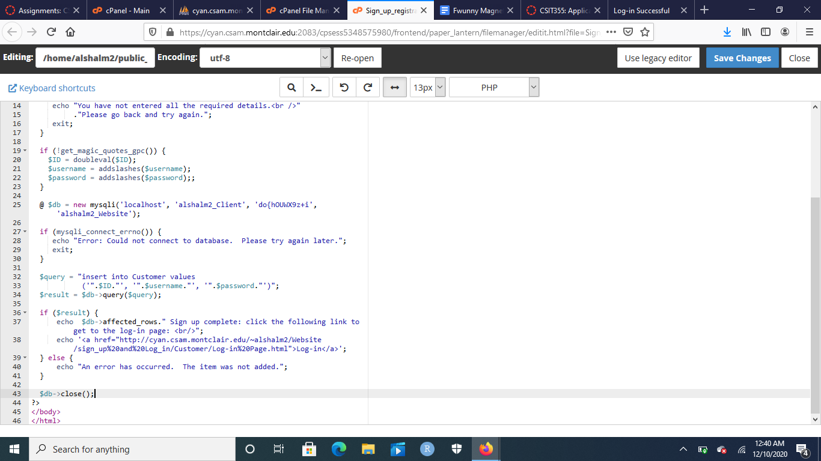

The code above is similar to every other sign up for every other view, they just access different tables for the different user views. I also got this code from assignment 5.3 and changed it from interesting products into signing users up to the website. Once the sign up is complete, a message will be showcased to show that a sign up was successful, and then a hyperlink will take the person to the appropriate log-in page.

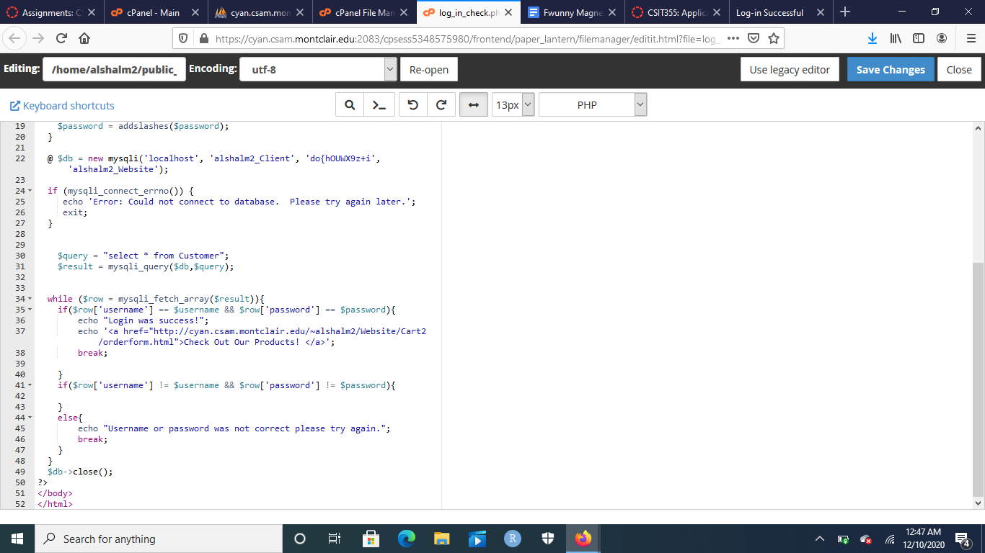

For the log-in page, there’s an HTML document that asks the user of different views to log into their appropriate page. I’ve implemented a while loop which fetches an array of the $result query and an if statement that checks for conditions of the username and password and see if they match the username and passwords in the database. Once the condition is met, the user is allowed to enter the website.

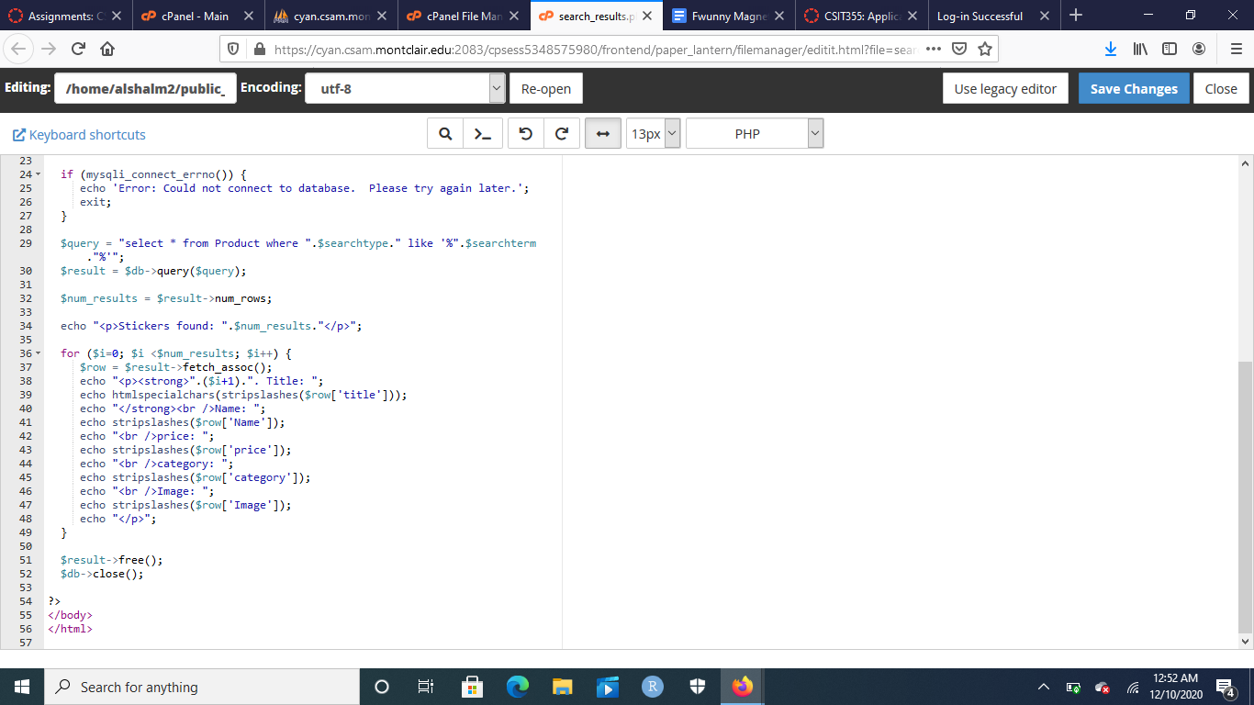

For the searching mechanics of the website, I first made an HTML document which takes in search inputs from the user by different categories. Then, using similar code to assignment 5.3, I query the results and display them based on certain columns that I believe are important to showcase. This is the same method for creating the searching methods of Customers and Employees that are utilized by alshalm2_Employee and alshalm2_DatabaseAdmin, just different tables and columns are used.

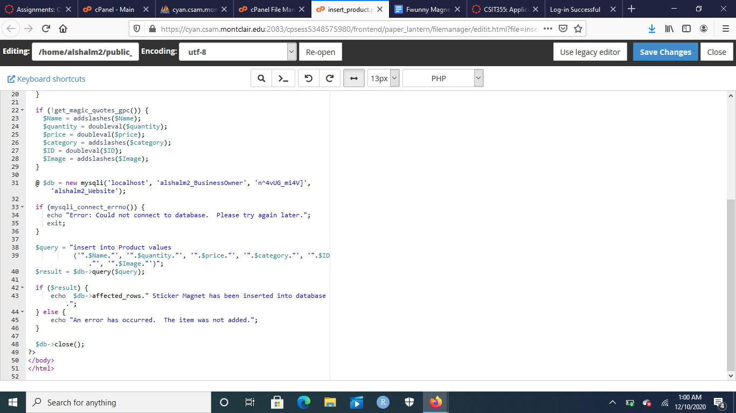

For inserting products into the database, I utilize the same code for inserting products from assignment 5.3 and make minimal changes to it. I make sure that I can connect to the database and then query the results, and run an if statement to make sure if the results are queried, then whatever the alsham2_BusinessOwner inserts from the HTML document/website gets inserted into the Product table.

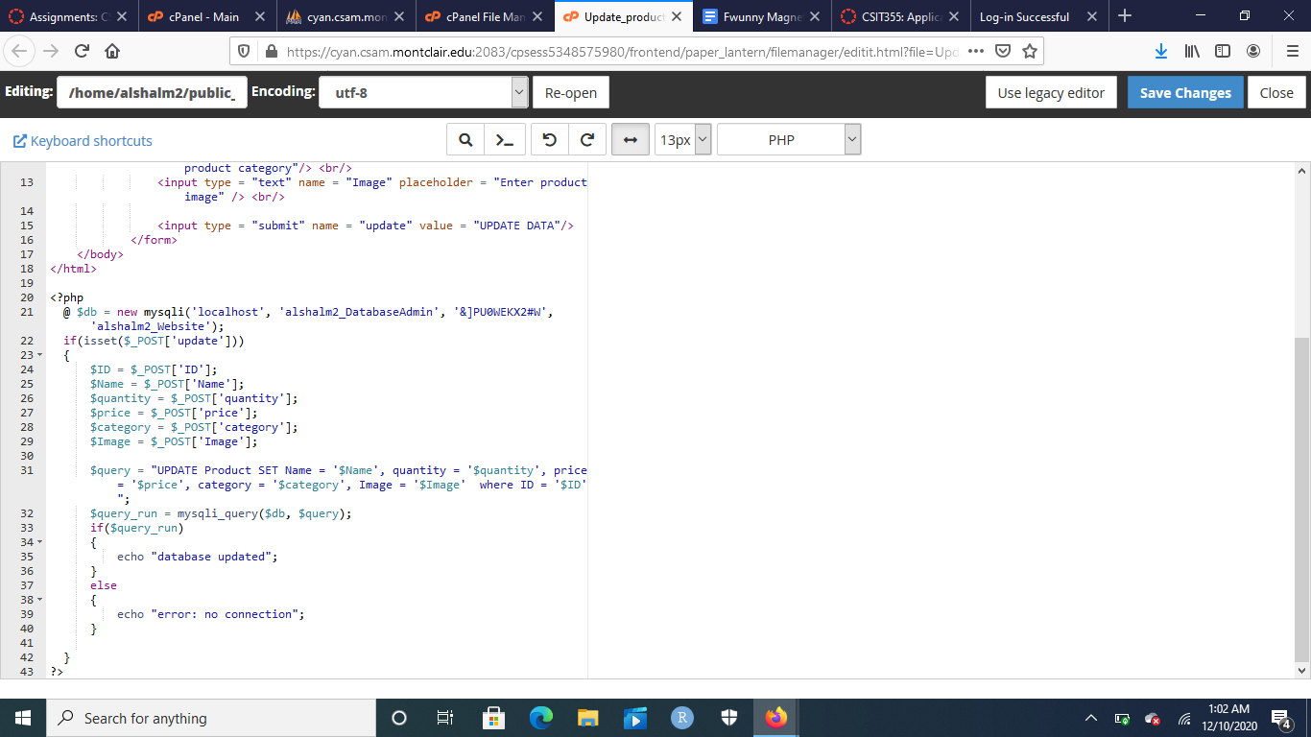

For updating the products in the database, I struggled since I didn’t have a good reference point to update data in tables. I knew insert from the assignment, I knew deletion from knowing some SQL, but updating was tough for me. I decided to utilize the following YouTube video to help me create the code behind updating the database: <https://youtu.be/8aEznmj40sc> . The way it works is once the database admin clicks update data, an if statement is run, which generates all of the functions for the product table and runs a query, which updates all of the columns in a table when the ID is entered for that item. If the run is successful, then the database is updated. Otherwise, no update is initiated.

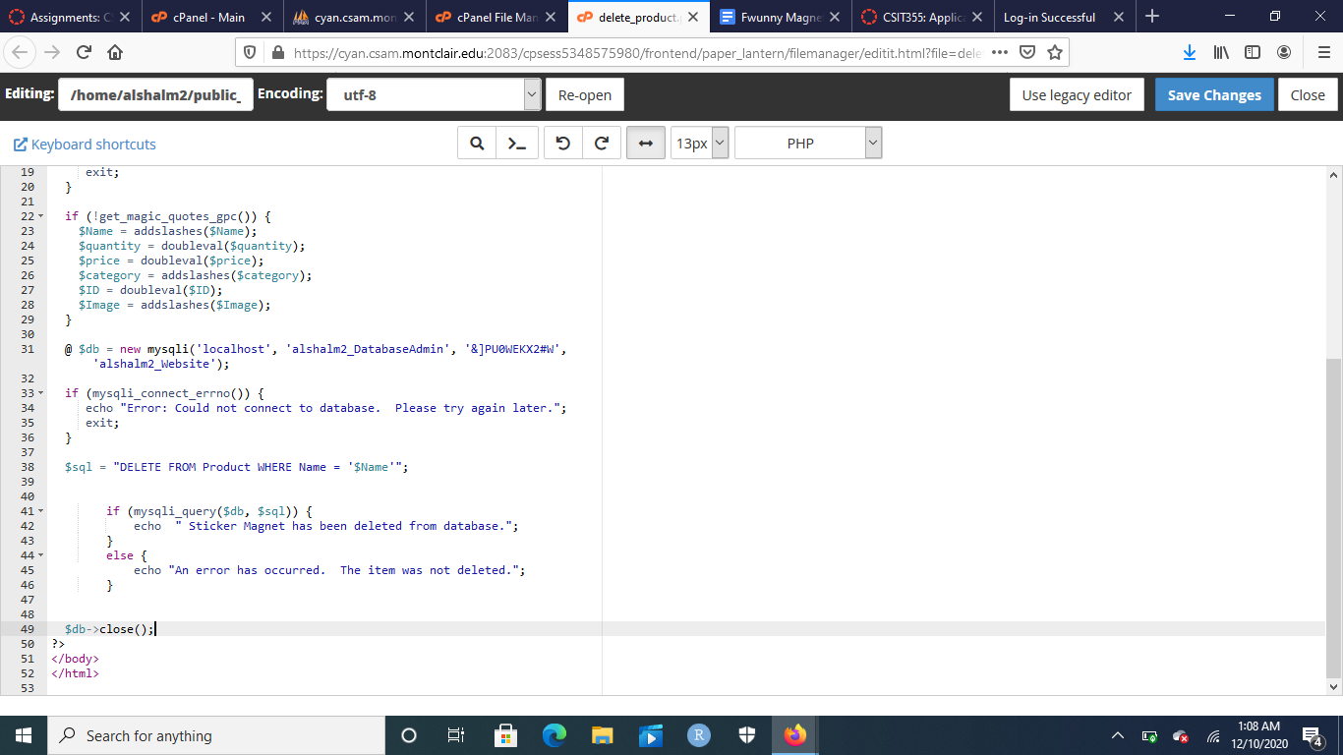

The final portion of my work on the website is deleting the items from the database, which is done by utilizing the inserting code from inserting products and assignment 5.3. The way that his code works is by defining an SQL function where it deletes from the product column where Name = $Name, meaning that the user still has to enter all of the information in the HTML document/web page for deleting product, but the main one that this program revolves around is the input of the Name. Once the input occurs, the if statement executes a query and deletes the item from the Product table.

**Britnie Gonzalez-Moodie:**

For the project I mainly worked on the cart functionalities and designing the data tables themselves along with the catalogue as well as creating all of the products that are associated with the website.

As the data modeling has already been covered earlier in the project, here I will cover the catalogue and its functionalities as well as a thorough explanation of the code , utilizing snippets of both php.

Lets’ return to the database containing the products:

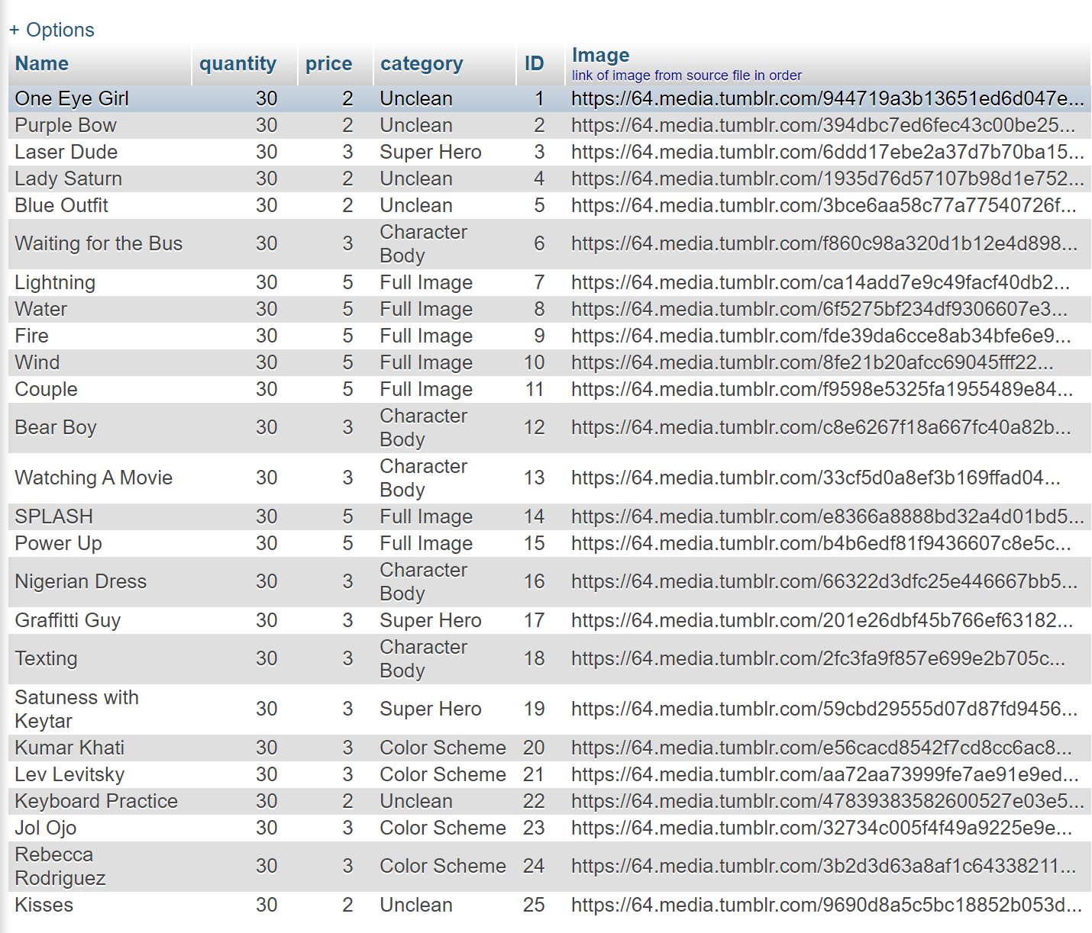

Each product name and image corresponds to one of the images that a customer may preview on the main catalogue page. These images were initially uploaded into a google drive, however, due to the restrictions to file access regarding direct hyperlinks, it was more viable to upload these images to a public domain so that when the catagalogue is actually pulled up by customers, they could view the image instead of a broken html image replacement. The image hyperlinks are pulled from my own personal tumblr page, where I uploaded them prior to coding the actual html catalogue site.

<https://tmblr.co/Z7Ud0wZMbmwcKW00>

<https://tmblr.co/Z7Ud0wZMblY8Wu00>

<https://tmblr.co/Z7Ud0wZMbjYw8m00>

At the start I had to initalize a table in CPanel that would containing columns that would act as a temporary holding place for the cart items that the user could add to their cart and worked with the user associated view to allow them to clear all items in their cart before confirming their order in case of any mistake or if they simply changed their mind before purchase.

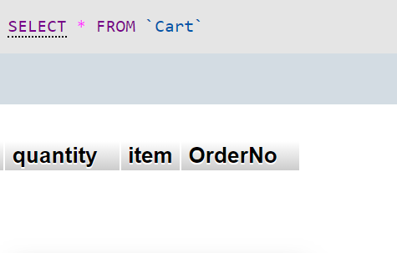

Quantity specified here would be updated with the the quantity variables of each magnet that a user could add to their cart using the input field in the html website , the item would be retrieved from the ‘name’ html attribute and its associated $name variable in the php file linked from the “add to cart submission. ” Quantity is a double value along with OrderNo (Order number) and item is of type varchar. Order number is populated with a randomly generated number that is produced whenever a user adds at least one item to their cart, this order number plays a role in retrieving their receipt.

This take us to the catalogue itself. I worked with six different implementations over time

**Orderform.html**

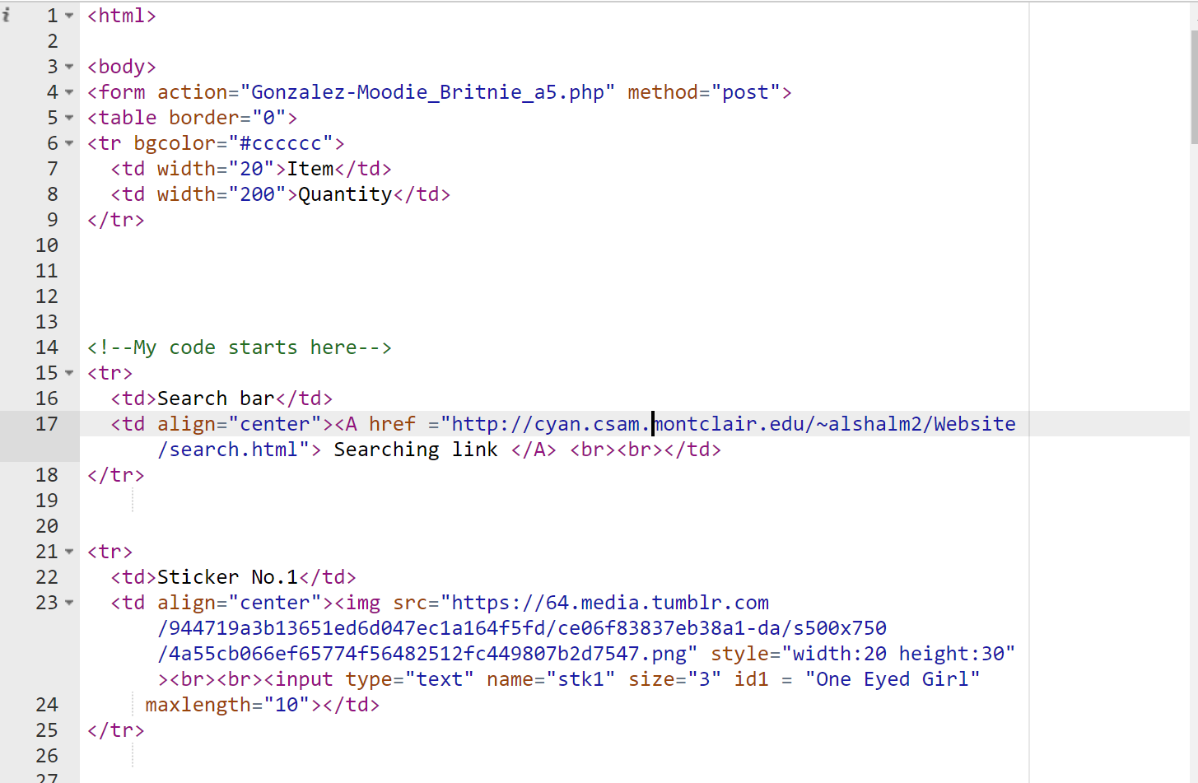

Orderform.html is essentially our catalogue and the main page that customers associated with the user view will be directly interacting with. It contains every product in the same order as displayed in product table along with the corresponding image preview of that product and an input field below each specifying the quantity of each product the user intends to add to their cart. All of this is encased in an html <form> object that on submission calls Gonzalez-Moodie_Britnie_a5.php through its action attribute using the method “post” which will update their cart based on the “name”, and “id” attributes of the products that the user entered a quantity under.

**Gonzalez-Moodie_Britnie_a5.php**

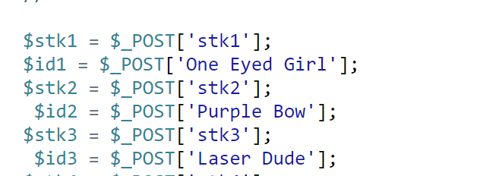

At the top of the page , the associated quantity variables and id variables from the previous page are linked using $_POST and the random number associated with their cart and later may serve as their order number are generated using the line below.



Beneath it a variable that quanitifies the total items in that user’s cart.

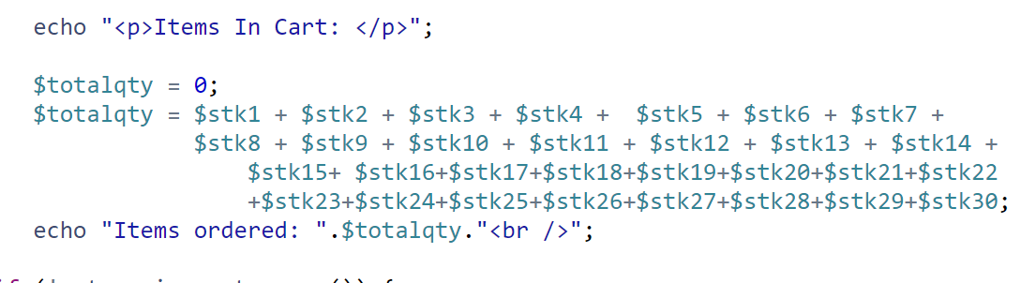

As well as an if statement that will allow the quantities of these items to be added to the cart table based on individual queries that will will only be triggered if the user adds at least one of the corresponding items to their cart.

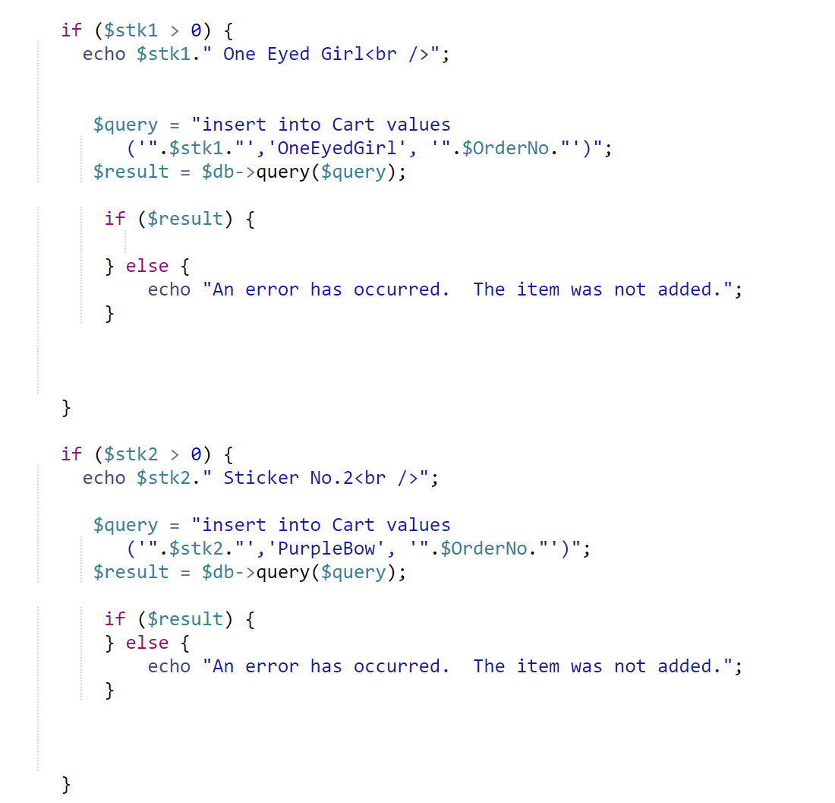

This makes up a bulk of the code, following it are two more things however

First is the totalamount variable that quanitifies the price and includes NJ’s 7% tax rate in giving the user what their final order amount will be should they chose to purchase all of the items in their cart.

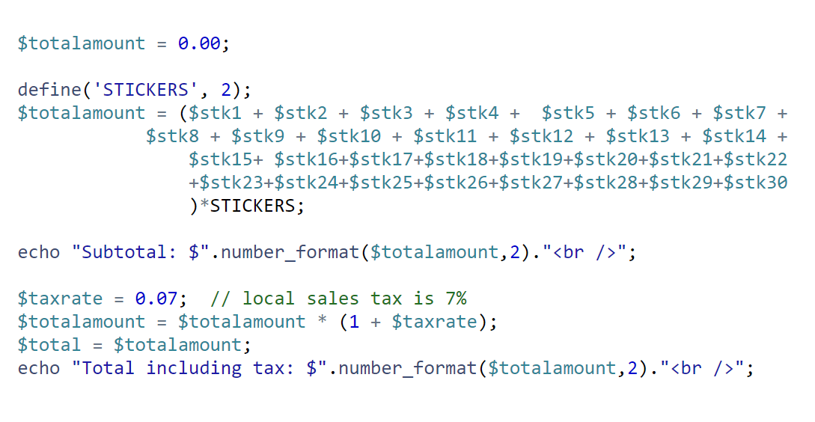

After this I include a form that specifies if the user wants to purchase all of the items in their cart that they may enter their first and last name, as well as address with the total amount field and order number being populated by their already given value from earlier in the code. Above the order confirmation form, there is also a button that the user can use to to delete all of the items in their cart which links to clearcart.php.

**Clearcart.php**

Should the user decide to click the “clear cart” button below their cart, the cart table containing the attributes of their cart before order will be completely cleared allowing the user to return back to the catalogue and add different items to their cart. It does this by linking to the database and deleting all rows of cart using a sql query, telling the user how many items have been removed

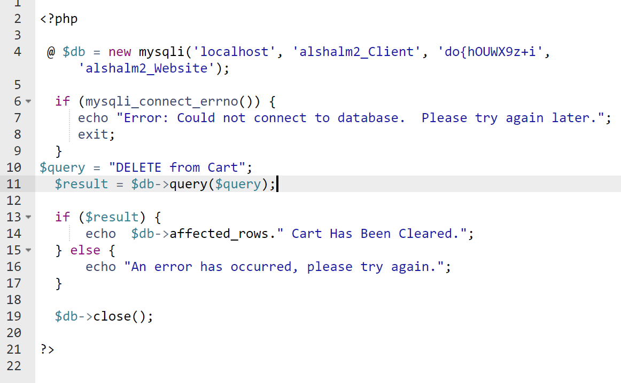

**Order table**

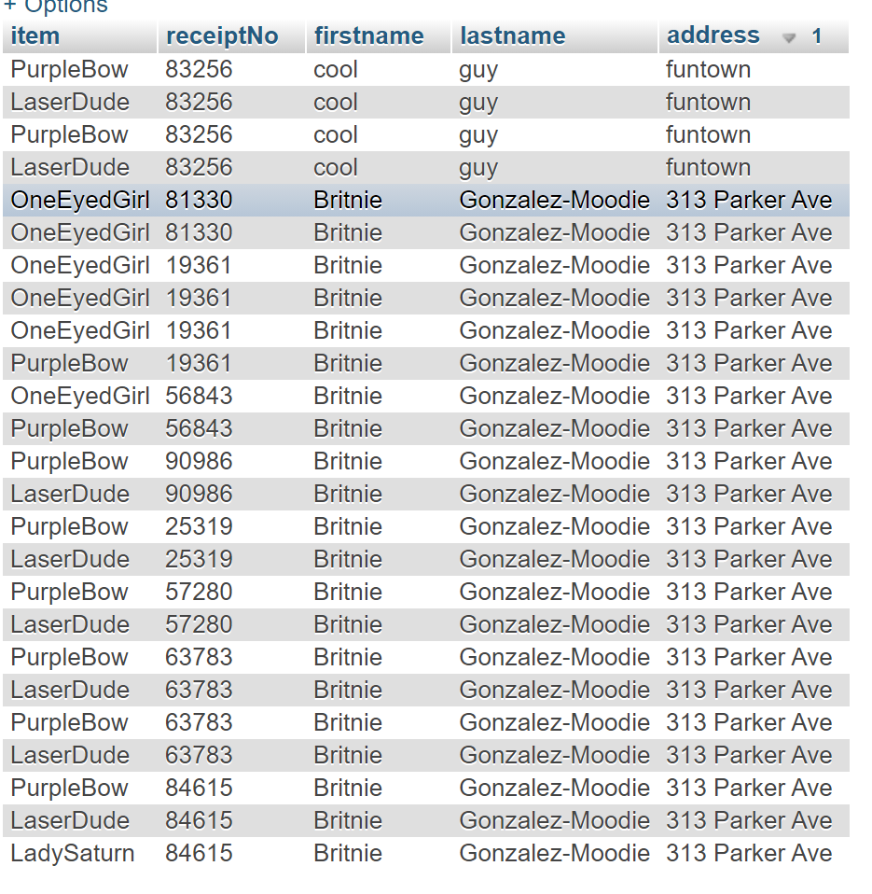

If the user should choose to complete their order . then upon pressing the complete order button below their cart and giving their first and last name, as well as address , the Order table will be updated with the information concerning their order and the corresponding order number generated from that specific cart.

**Confirm_order.php**

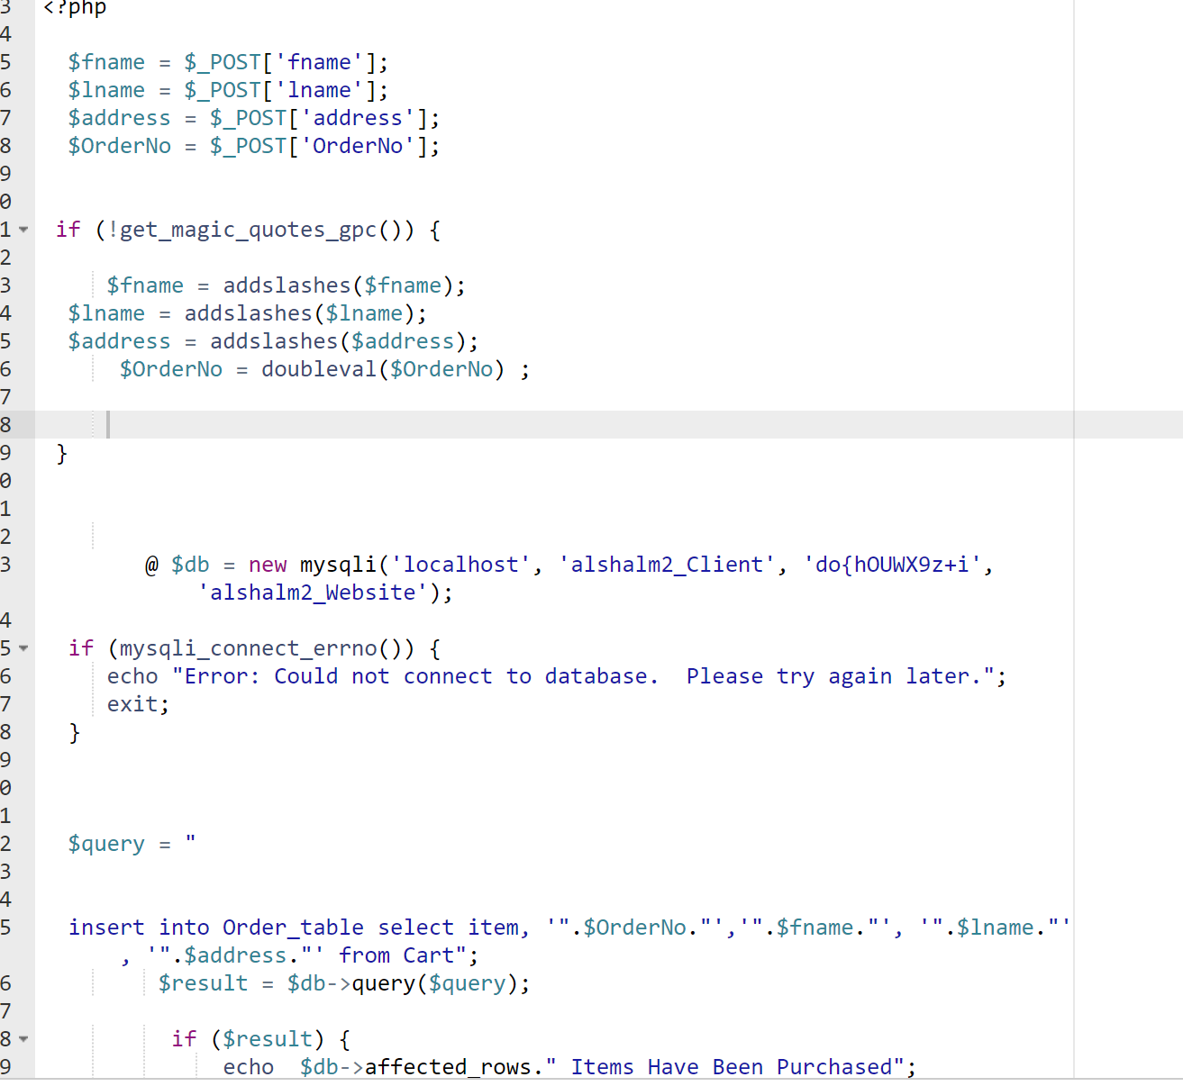

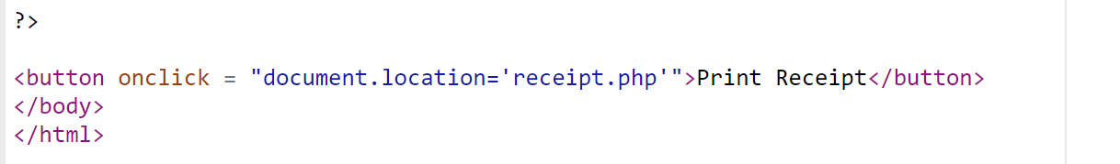

When the user clicks to confirm order , the complete_order.php class is summoned and the form information from the cart page is transferred using the “post” method. This class in turn will connect to the database and insert their first name, lastname , order number, and address into the order_table table. Should they choose to view their receipt, they may click a button titled “Print receipt” which will generate the details from their last order.

**Receipt**

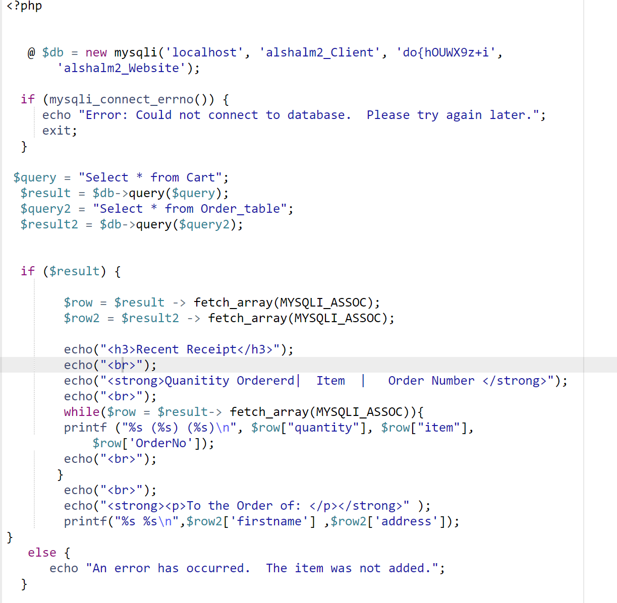

When the user clicks the “print receipt” button after confirming their order , the receipt.php class is called which connects to the database and generates an associative array producing credentials that correspond to the user’s order by querying to both the Cart and Order_table tables. It will show them a page containing that order’s Order Number, the items ordered, and the name and address details they entered when confirming.

**Security Discussion:**

Regarding the security we have implemented on our e-commerce website, we have taken into consideration both log in and sign up security having to deal with the four views we implemented : the Business Owner, Customer, Database Admin, and Employee. Each of these views is implemented using a secluded folder path within the Website coding structure. Each of these folders has its own sign in and log-in classes that link to a separate login table depending on the user in question in the database. This ensures that none of the login information is in any way accessible across different views of the website or even within the database.

1. **Login In Landing Pad** 
   1. Regardless of the view, when the user gets to the login-in landing page of our website , it shows them the same html structured page. When the user enters there credentials a php script is triggered that checks either the Business Owner, Database Admin, Customer, or Employee sign up tables and checks to see if the username and password are contained within the corresponding table and if that same username and password combination are associated with the same row of the table.
2. **Implementation of Secure Passwords** 
   1. Each password and username within the tables “Employee”, “DatabaseAdmin”, “Customer”, “Employee”, and “BusinessOwner” tables within the website database is populated using the sign-up html pages associated with each table. When the user signs up, a sign_up_registration php script runs that contains an insertion query that inserts the lines from the username and password fields in the html form into those fields in the corresponding table. Another parameter “ID” is populated with a unique identifier number in the ID column of the table that corresponds to their sign up. This ID is used to match wether or not this username and password combination has been entered into the table prior by checking if the ID value already exists in the correlated table. When the user attempts to login on the landing page associated with their given view, if their credentials do not match any of the entries in the table populated from the sign up database they cannot pass through to view any of the website’s contents that are restricted based on their view. For example , if the the database admin view fails to log in correctly they are incapable of accessing the page that allows them to update the product table in the database.   
      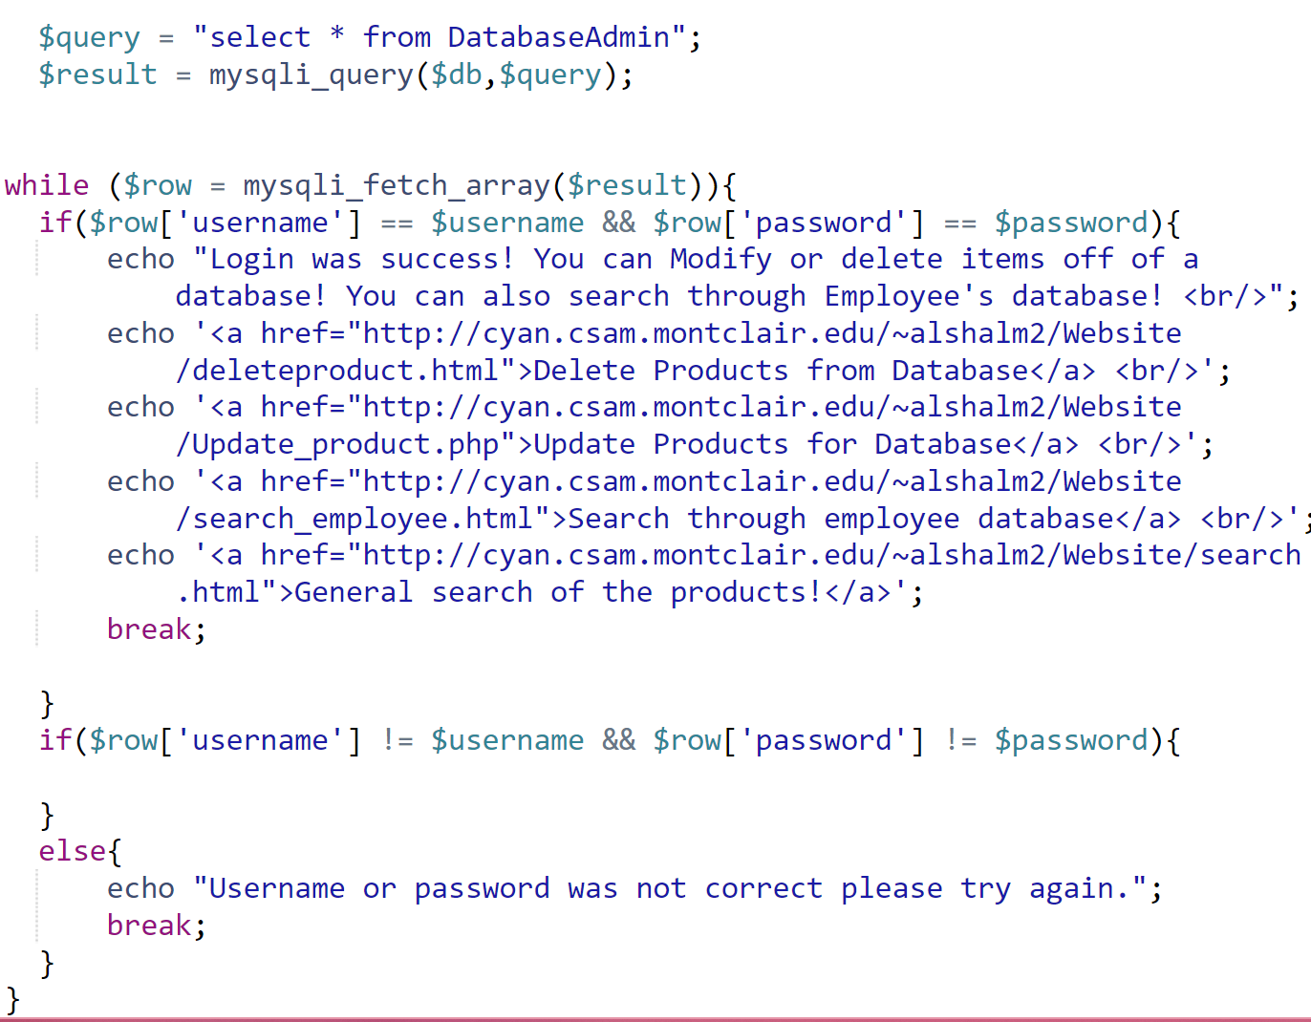

*The above photo shows a screenshot from the DatabaseAdmin login in php file, we utilized row functions several times throughout the coding for the project , in this instance the class returns a different hyperlink address based on the login shownin the iff statement if their login information is found within in table containing the login information for Database Administrators. If the login credentials don't match, the loop breaks and instead prompts the user to enter their credentials again.*

**Conclusion and Discussion on if we had more time:**

Throughout working on the project both me and Mohammed did learn some pretty valuable lessons regarding time constraints versus vision constraints, as mentioned earlier, the database itself was very much a large point of where most of our struggles came form. My initial design for the database was far too elaborate for what we were capable of achieving by the end of this class and even then, how the tables of the database were structured became heavily subject to change as the coding continued. Many of the other struggles came with querying directly into the database using php, I am more familiar with sql than Mohammed before this class but only regarding java and javascript connecting to databases and many of the places we turned to try to help with examples in laying out information like associative arrays and the getmagic function were pretty new and loosely comprehended initially.

On the advent of time , leading up to the submission, time was very much working against us. We had some initially, far more stylized view and a far closer implementation of the database in tandem with our code than what we ended up accomplishing. Specifically I had created around 6 different versions of cart and the main catalogue that had a more user-friendly “add to cart” and “remove from cart” functionality and would connect more to the product database. At this point cart functioned like an array with the contents only being add to the “Order_table” table if the user confirmed their order. However this was was of much issue because I was using sql instead of mysqli and this did not implement a cart table and had to be changed to fit these project requirements. For Mohammed it was much of an issue with the redundancy in the contents of the table , if more time was allotted on as to how to transfer variable information between classes then the views may have fit together far more organically and utilized far less files.

**Appendix of all code:**

1. Database Dump

-- phpMyAdmin SQL Dump

-- version 4.9.4

-- https://www.phpmyadmin.net/

--

-- Host: localhost:3306

-- Generation Time: Dec 10, 2020 at 09:13 AM

-- Server version: 5.7.32

-- PHP Version: 7.3.6

SET SQL_MODE = "NO_AUTO_VALUE_ON_ZERO";

SET AUTOCOMMIT = 0;

START TRANSACTION;

SET time_zone = "+00:00";

/*!40101 SET @OLD_CHARACTER_SET_CLIENT=@@CHARACTER_SET_CLIENT */;

/*!40101 SET @OLD_CHARACTER_SET_RESULTS=@@CHARACTER_SET_RESULTS */;

/*!40101 SET @OLD_COLLATION_CONNECTION=@@COLLATION_CONNECTION */;

/*!40101 SET NAMES utf8mb4 */;

--

-- Database: `alshalm2_Website`

--

-- --------------------------------------------------------

--

-- Table structure for table `BusinessOwner`

--

CREATE TABLE `BusinessOwner` (

`ID` int(8) NOT NULL,

`username` varchar(8) NOT NULL,

`password` varchar(8) NOT NULL

) ENGINE=MyISAM DEFAULT CHARSET=latin1;

--

-- Dumping data for table `BusinessOwner`

--

INSERT INTO `BusinessOwner` (`ID`, `username`, `password`) VALUES

(1, 'owner', '12345678');

-- --------------------------------------------------------

--

-- Table structure for table `Cart`

--

CREATE TABLE `Cart` (

`quantity` double(65,0) NOT NULL,

`item` varchar(800) NOT NULL,

`OrderNo` int(85) NOT NULL

) ENGINE=MyISAM DEFAULT CHARSET=latin1;

-- --------------------------------------------------------

--

-- Table structure for table `Customer`

--

CREATE TABLE `Customer` (

`ID` int(8) NOT NULL,

`username` varchar(8) NOT NULL,

`password` varchar(8) NOT NULL

) ENGINE=MyISAM DEFAULT CHARSET=latin1;

--

-- Dumping data for table `Customer`

--

INSERT INTO `Customer` (`ID`, `username`, `password`) VALUES

(1, 'MomoMomo', '12345678'),

(2, 'Momo', '87654321'),

(1, 'owner', '12345678'),

(3, 'koko', '123');

-- --------------------------------------------------------

--

-- Table structure for table `DatabaseAdmin`

--

CREATE TABLE `DatabaseAdmin` (

`ID` int(8) NOT NULL,

`username` varchar(8) NOT NULL,

`password` varchar(8) NOT NULL

) ENGINE=MyISAM DEFAULT CHARSET=latin1;

--

-- Dumping data for table `DatabaseAdmin`

--

INSERT INTO `DatabaseAdmin` (`ID`, `username`, `password`) VALUES

(1, 'Database', '12345678');

-- --------------------------------------------------------

--

-- Table structure for table `Employee`

--

CREATE TABLE `Employee` (

`ID` int(8) NOT NULL,

`username` varchar(8) NOT NULL,

`password` varchar(8) NOT NULL

) ENGINE=MyISAM DEFAULT CHARSET=latin1;

--

-- Dumping data for table `Employee`

--

INSERT INTO `Employee` (`ID`, `username`, `password`) VALUES

(1, 'employee', '12345678'),

(2, 'Emp', '87654321');

-- --------------------------------------------------------

--

-- Table structure for table `Order_table`

--

CREATE TABLE `Order_table` (

`item` varchar(800) NOT NULL,

`receiptNo` varchar(235) NOT NULL,

`firstname` varchar(800) NOT NULL,

`lastname` varchar(800) NOT NULL,

`address` text NOT NULL

) ENGINE=MyISAM DEFAULT CHARSET=latin1;

--

-- Dumping data for table `Order_table`

--

INSERT INTO `Order_table` (`item`, `receiptNo`, `firstname`, `lastname`, `address`) VALUES

('OneEyedGirl', '81330', 'Britnie', 'Gonzalez-Moodie', '313 Parker Ave'),

('OneEyedGirl', '81330', 'Britnie', 'Gonzalez-Moodie', '313 Parker Ave'),

('OneEyedGirl', '19361', 'Britnie', 'Gonzalez-Moodie', '313 Parker Ave'),

('OneEyedGirl', '19361', 'Britnie', 'Gonzalez-Moodie', '313 Parker Ave'),

('OneEyedGirl', '19361', 'Britnie', 'Gonzalez-Moodie', '313 Parker Ave'),

('PurpleBow', '19361', 'Britnie', 'Gonzalez-Moodie', '313 Parker Ave'),

('OneEyedGirl', '56843', 'Britnie', 'Gonzalez-Moodie', '313 Parker Ave'),

('PurpleBow', '56843', 'Britnie', 'Gonzalez-Moodie', '313 Parker Ave'),

('PurpleBow', '90986', 'Britnie', 'Gonzalez-Moodie', '313 Parker Ave'),

('LaserDude', '90986', 'Britnie', 'Gonzalez-Moodie', '313 Parker Ave'),

('PurpleBow', '83256', 'cool', 'guy', 'funtown'),

('LaserDude', '83256', 'cool', 'guy', 'funtown'),

('PurpleBow', '83256', 'cool', 'guy', 'funtown'),

('LaserDude', '83256', 'cool', 'guy', 'funtown'),

('PurpleBow', '25319', 'Britnie', 'Gonzalez-Moodie', '313 Parker Ave'),

('LaserDude', '25319', 'Britnie', 'Gonzalez-Moodie', '313 Parker Ave'),

('PurpleBow', '0', '', '', ''),

('LaserDude', '0', '', '', ''),

('PurpleBow', '57280', 'Britnie', 'Gonzalez-Moodie', '313 Parker Ave'),

('LaserDude', '57280', 'Britnie', 'Gonzalez-Moodie', '313 Parker Ave'),

('PurpleBow', '63783', '', '', ''),

('LaserDude', '63783', '', '', ''),

('PurpleBow', '63783', '', '', ''),

('LaserDude', '63783', '', '', ''),

('PurpleBow', '63783', 'Britnie', 'Gonzalez-Moodie', '313 Parker Ave'),

('LaserDude', '63783', 'Britnie', 'Gonzalez-Moodie', '313 Parker Ave'),

('PurpleBow', '63783', 'Britnie', 'Gonzalez-Moodie', '313 Parker Ave'),

('LaserDude', '63783', 'Britnie', 'Gonzalez-Moodie', '313 Parker Ave'),

('PurpleBow', '84615', 'Britnie', 'Gonzalez-Moodie', '313 Parker Ave'),

('LaserDude', '84615', 'Britnie', 'Gonzalez-Moodie', '313 Parker Ave'),

('LadySaturn', '84615', 'Britnie', 'Gonzalez-Moodie', '313 Parker Ave'),

('PurpleBow', '85671', 'Britnie', 'Gonzalez-Moodie', '313 Parker Ave'),

('LaserDude', '85671', 'Britnie', 'Gonzalez-Moodie', '313 Parker Ave'),

('LadySaturn', '85671', 'Britnie', 'Gonzalez-Moodie', '313 Parker Ave'),

('PurpleBow', '85671', 'Britnie', 'Gonzalez-Moodie', '313 Parker Ave'),

('LaserDude', '85671', 'Britnie', 'Gonzalez-Moodie', '313 Parker Ave'),

('LadySaturn', '85671', 'Britnie', 'Gonzalez-Moodie', '313 Parker Ave'),

('PurpleBow', '85671', 'Britnie', 'Gonzalez-Moodie', '313 Parker Ave'),

('LaserDude', '85671', 'Britnie', 'Gonzalez-Moodie', '313 Parker Ave'),

('LadySaturn', '85671', 'Britnie', 'Gonzalez-Moodie', '313 Parker Ave'),

('PurpleBow', '78447', 'Britnie', 'Gonzalez-Moodie', '313 Parker Ave'),

('LaserDude', '78447', 'Britnie', 'Gonzalez-Moodie', '313 Parker Ave'),

('LadySaturn', '78447', 'Britnie', 'Gonzalez-Moodie', '313 Parker Ave'),

('PurpleBow', '43846', 'Britnie', 'Gonzalez-Moodie', '313 Parker Ave'),

('LaserDude', '43846', 'Britnie', 'Gonzalez-Moodie', '313 Parker Ave'),

('LadySaturn', '43846', 'Britnie', 'Gonzalez-Moodie', '313 Parker Ave'),

('OneEyedGirl', '43846', 'Britnie', 'Gonzalez-Moodie', '313 Parker Ave'),

('PurpleBow', '43846', 'Britnie', 'Gonzalez-Moodie', '313 Parker Ave'),

('LaserDude', '43846', 'Britnie', 'Gonzalez-Moodie', '313 Parker Ave'),

('LadySaturn', '43846', 'Britnie', 'Gonzalez-Moodie', '313 Parker Ave'),

('OneEyedGirl', '43846', 'Britnie', 'Gonzalez-Moodie', '313 Parker Ave'),

('PurpleBow', '86236', 'Britnie', 'Gonzalez-Moodie', '313 Parker Ave'),

('LaserDude', '86236', 'Britnie', 'Gonzalez-Moodie', '313 Parker Ave'),

('LadySaturn', '86236', 'Britnie', 'Gonzalez-Moodie', '313 Parker Ave'),

('OneEyedGirl', '86236', 'Britnie', 'Gonzalez-Moodie', '313 Parker Ave'),

('OneEyedGirl', '86236', 'Britnie', 'Gonzalez-Moodie', '313 Parker Ave'),

('PurpleBow', '59378', 'Britnie', 'Gonzalez-Moodie', '313 Parker Ave'),

('LaserDude', '59378', 'Britnie', 'Gonzalez-Moodie', '313 Parker Ave'),

('LadySaturn', '59378', 'Britnie', 'Gonzalez-Moodie', '313 Parker Ave'),

('OneEyedGirl', '59378', 'Britnie', 'Gonzalez-Moodie', '313 Parker Ave'),

('OneEyedGirl', '59378', 'Britnie', 'Gonzalez-Moodie', '313 Parker Ave'),

('OneEyedGirl', '59378', 'Britnie', 'Gonzalez-Moodie', '313 Parker Ave'),

('PurpleBow', '59378', 'Britnie', 'Gonzalez-Moodie', '313 Parker Ave'),

('LaserDude', '59378', 'Britnie', 'Gonzalez-Moodie', '313 Parker Ave'),

('LadySaturn', '59378', 'Britnie', 'Gonzalez-Moodie', '313 Parker Ave'),

('OneEyedGirl', '59378', 'Britnie', 'Gonzalez-Moodie', '313 Parker Ave'),

('OneEyedGirl', '59378', 'Britnie', 'Gonzalez-Moodie', '313 Parker Ave'),

('OneEyedGirl', '59378', 'Britnie', 'Gonzalez-Moodie', '313 Parker Ave'),

('PurpleBow', '41897', 'Britnie', 'Gonzalez-Moodie', '313 Parker Ave'),

('LaserDude', '41897', 'Britnie', 'Gonzalez-Moodie', '313 Parker Ave'),

('LadySaturn', '41897', 'Britnie', 'Gonzalez-Moodie', '313 Parker Ave'),

('OneEyedGirl', '41897', 'Britnie', 'Gonzalez-Moodie', '313 Parker Ave'),

('OneEyedGirl', '41897', 'Britnie', 'Gonzalez-Moodie', '313 Parker Ave'),

('OneEyedGirl', '41897', 'Britnie', 'Gonzalez-Moodie', '313 Parker Ave'),

('OneEyedGirl', '41897', 'Britnie', 'Gonzalez-Moodie', '313 Parker Ave'),

('OneEyedGirl', '20921', 'Britnie', 'Gonzalez-Moodie', '313 Parker Ave'),

('OneEyedGirl', '66686', 'Britnie', 'Gonzalez-Moodie', '313 Parker Ave'),

('OneEyedGirl', '66686', 'Britnie', 'Gonzalez-Moodie', '313 Parker Ave'),

('OneEyedGirl', '65558', 'Britnie', 'Gonzalez-Moodie', '313 Parker Ave'),

('OneEyedGirl', '65558', 'Britnie', 'Gonzalez-Moodie', '313 Parker Ave'),

('OneEyedGirl', '65558', 'Britnie', 'Gonzalez-Moodie', '313 Parker Ave'),

('PurpleBow', '65558', 'Britnie', 'Gonzalez-Moodie', '313 Parker Ave'),

('OneEyedGirl', '65558', 'Britnie', 'Gonzalez-Moodie', '313 Parker Ave'),

('OneEyedGirl', '65558', 'Britnie', 'Gonzalez-Moodie', '313 Parker Ave'),

('OneEyedGirl', '65558', 'Britnie', 'Gonzalez-Moodie', '313 Parker Ave'),

('PurpleBow', '65558', 'Britnie', 'Gonzalez-Moodie', '313 Parker Ave'),

('OneEyedGirl', '32169', 'Momo', 'Jojo', '1234'),

('Lightning', '28348', 'Momo', 'Jojo', '123456'),

('Water', '28348', 'Momo', 'Jojo', '123456'),

('Fire', '28348', 'Momo', 'Jojo', '123456'),

('CalltheSpaceCops', '39062', 'Britnie', 'Gonzalez-Moodie', '313 Parker Ave');

-- --------------------------------------------------------

--

-- Table structure for table `Product`

--

CREATE TABLE `Product` (

`Name` varchar(30) NOT NULL,

`quantity` int(8) NOT NULL,

`price` decimal(8,0) NOT NULL,

`category` varchar(30) NOT NULL,

`ID` int(8) NOT NULL,

`Image` varchar(1500) NOT NULL COMMENT 'link of image from source file in order'

) ENGINE=MyISAM DEFAULT CHARSET=latin1;

--

-- Dumping data for table `Product`

--

INSERT INTO `Product` (`Name`, `quantity`, `price`, `category`, `ID`, `Image`) VALUES

('One Eye Girl', 30, 2, 'Unclean', 1, 'https://64.media.tumblr.com/944719a3b13651ed6d047ec1a164f5fd/ce06f83837eb38a1-da/s500x750/4a55cb066ef65774f56482512fc449807b2d7547.png'),

('Purple Bow', 30, 2, 'Unclean', 2, 'https://64.media.tumblr.com/394dbc7ed6fec43c00be25c2e55fdceb/ce06f83837eb38a1-d1/s2048x3072/95c2741546ab08f93d90295c0ab9653f80b3a061.png'),

('Laser Dude', 30, 3, 'Super Hero', 3, 'https://64.media.tumblr.com/6ddd17ebe2a37d7b70ba15a93e4257e8/ce06f83837eb38a1-7f/s2048x3072/382c6c8e2f717498644dc7c8360a920093dc4044.png'),

('Lady Saturn', 30, 2, 'Unclean', 4, 'https://64.media.tumblr.com/1935d76d57107b98d1e752c35b921ace/ce06f83837eb38a1-5e/s2048x3072/fcb8bc0cbda3f844030e3aee8224d865fb059b43.png'),

('Blue Outfit', 30, 2, 'Unclean', 5, 'https://64.media.tumblr.com/3bce6aa58c77a77540726fb18998d3b3/ce06f83837eb38a1-0d/s2048x3072/17e8a76456ba59e5ce6f1ea963066854df42a6bc.png'),

('Waiting for the Bus', 30, 3, 'Character Body', 6, 'https://64.media.tumblr.com/f860c98a320d1b12e4d8987dcd3e0a8a/ce06f83837eb38a1-38/s2048x3072/1106ebbad87da080feb5b0f718aabe3926276d52.png'),

('Lightning', 30, 5, 'Full Image', 7, 'https://64.media.tumblr.com/ca14add7e9c49facf40db21009be2cf3/0864108deb6eecd1-c5/s500x750/aaec8875583cd3502dfffba6233dd4c2b98294e4.png'),

('Water', 30, 5, 'Full Image', 8, 'https://64.media.tumblr.com/6f5275bf234df9306607e3bcd450e088/0864108deb6eecd1-8e/s500x750/866fa7532de0db87380fa58acc5f958865c08529.png'),

('Fire', 30, 5, 'Full Image', 9, 'https://64.media.tumblr.com/fde39da6cce8ab34bfe6e9d0e472f5f4/0864108deb6eecd1-54/s500x750/12c5aa6bce2a7cd5d8a5e75cdf8c5259cbe327b5.png'),

('Wind', 30, 5, 'Full Image', 10, 'https://64.media.tumblr.com/8fe21b20afcc69045fff22f8e01c7b08/0864108deb6eecd1-24/s400x600/4d6d82c94cc15ca1c4f9ec445c90cf9f28f5a84d.png'),

('Couple', 30, 5, 'Full Image', 11, 'https://64.media.tumblr.com/f9598e5325fa1955489e84e0ea7d6032/0864108deb6eecd1-d5/s400x600/8b1d4f45b4d825c6a7faa80b8ad4f37b33d665fb.jpg'),

('Bear Boy', 30, 3, 'Character Body', 12, 'https://64.media.tumblr.com/c8e6267f18a667fc40a82b817da8c42a/0864108deb6eecd1-42/s400x600/e08af4bef3b9e285f629f13c068aa91b89017f9b.jpg'),

('Watching A Movie', 30, 3, 'Character Body', 13, 'https://64.media.tumblr.com/33cf5d0a8ef3b169ffad04af14174504/0864108deb6eecd1-ca/s540x810/bc5be764923755f421917ebfd13e2a72f28956ac.jpg'),

('SPLASH', 30, 5, 'Full Image', 14, 'https://64.media.tumblr.com/e8366a8888bd32a4d01bd5fd7fa2fe0b/0864108deb6eecd1-1e/s540x810/122056d6254193e4e67dc226b362eb2e38b334cc.png'),

('Power Up', 30, 5, 'Full Image', 15, 'https://64.media.tumblr.com/b4b6edf81f9436607c8e5c05585c3fb7/7e0299b940521857-cb/s1280x1920/56b8d3ddf9e80322824a4ea5fdc3917167c95d64.jpg'),

('Nigerian Dress', 30, 3, 'Character Body', 16, 'https://64.media.tumblr.com/66322d3dfc25e446667bb5312c8a9da5/7e0299b940521857-f4/s1280x1920/6abb75626345a51247940b1378d46b47424aa6cb.jpg'),

('Graffitti Guy', 30, 3, 'Super Hero', 17, 'https://64.media.tumblr.com/201e26dbf45b766ef6318202ab96ffdc/7e0299b940521857-af/s1280x1920/beee87bd921789909c8f1f226ab2ba17ace48860.jpg'),

('Texting', 30, 3, 'Character Body', 18, 'https://64.media.tumblr.com/2fc3fa9f857e699e2b705c699ab68589/7e0299b940521857-1b/s1280x1920/8434e8d0cb0caa0e62b3db378fbe90025fd7af5a.jpg'),

('Satuness with Keytar', 30, 3, 'Super Hero', 19, 'https://64.media.tumblr.com/59cbd29555d07d87fd94566cf66bd98d/7e0299b940521857-e2/s1280x1920/6fb3844bde8a43ce5020e3b3027be45e21a98231.jpg'),

('Kumar Khati', 30, 3, 'Color Scheme', 20, 'https://64.media.tumblr.com/e56cacd8542f7cd8cc6ac8f830b9063b/f76b3fc6dd06ae40-51/s1280x1920/b6bd0b0656bd8f083db939aad251c929fc0a2240.jpg'),

('Lev Levitsky', 30, 3, 'Color Scheme', 21, 'https://64.media.tumblr.com/aa72aa73999fe7ae91e9edba0090c449/f76b3fc6dd06ae40-9c/s540x810/b6bc195b843f4aa0e428a702c1b087a4945a89f5.jpg'),

('Keyboard Practice', 30, 2, 'Unclean', 22, 'https://64.media.tumblr.com/47839383582600527e03e5cd0cd2bb30/f76b3fc6dd06ae40-8d/s640x960/70792ffff22d7b48a216c998cf97ec8da25f7168.jpg'),

('Jol Ojo', 30, 3, 'Color Scheme', 23, 'https://64.media.tumblr.com/32734c005f4f49a9225e9e76407ab370/f76b3fc6dd06ae40-b8/s540x810/e70d644c54faf75a6210ffefdf936781ce09b086.jpg'),

('Rebecca Rodriguez', 30, 3, 'Color Scheme', 24, 'https://64.media.tumblr.com/3b2d3d63a8af1c643382119e4857db5e/f76b3fc6dd06ae40-73/s540x810/ae14fde7bcc9ffce42f567fd34399c13bb9da7a7.jpg'),

('Kisses', 30, 2, 'Unclean', 25, 'https://64.media.tumblr.com/9690d8a5c5bc18852b053dac8c757898/f76b3fc6dd06ae40-69/s540x810/6a5c9a4924c95ef528bc514fd8374d7a5c07bcf2.jpg'),

('CRUSHER', 30, 5, 'Full Image', 26, 'https://static.tumblr.com/0e5700f92f4b236e2f7729882ada6fb2/r7is2wv/ZoVoufz3b/tumblr_static_tumblr_static__focused_v3.png'),

('Xiang Xi', 30, 3, 'Color Scheme', 27, 'https://64.media.tumblr.com/ca0e2bdbd4b3a3346f5abc6a9b134ad5/f76b3fc6dd06ae40-1e/s540x810/cca524bddf83b735f3afdfe23de3e0457e16a5d2.jpg'),

('Paintball', 30, 3, 'Character Body', 28, 'https://64.media.tumblr.com/9907f575b8b6d83a525b859bd2e745c8/f76b3fc6dd06ae40-b7/s400x600/d7445274b8b08c16148f59ac66cf7b769fa7f3c2.png'),

('Nousha Nowrouzi', 30, 3, 'Color Scheme', 29, 'https://64.media.tumblr.com/49af5e60c51f89aa00a83a9bb9f8233e/f76b3fc6dd06ae40-9e/s400x600/bec9063381e1de453523533ff8a8820bbcffe661.jpg'),

('Call the Space Cops', 30, 2, 'Unclean', 30, 'https://64.media.tumblr.com/b6588a798359c26521f69080c252ba9c/f76b3fc6dd06ae40-72/s400x600/ee37b83e2bc490056562999bf5a4f94063b46962.jpg');

COMMIT;

/*!40101 SET CHARACTER_SET_CLIENT=@OLD_CHARACTER_SET_CLIENT */;

/*!40101 SET CHARACTER_SET_RESULTS=@OLD_CHARACTER_SET_RESULTS */;

/*!40101 SET COLLATION_CONNECTION=@OLD_COLLATION_CONNECTION */;

1. Delete_product.php

<html>

<head>

<title>Sticker Magnets Deletion Results</title>

</head>

<body>

<h1>Sticker Magnets Deletion Results</h1>

<?php

// create short variable names

$Name=$_POST['Name'];

$quantity=$_POST['quantity'];

$price=$_POST['price'];

$category=$_POST['category'];

$ID = $_POST['ID'];

$Image = $_POST['Image'];

if (!$Name || !$quantity || !$price || !$category || !$ID || !$Image) {

echo "You have not entered all the required details.<br />"

."Please go back and try again.";

exit;

}

if (!get_magic_quotes_gpc()) {

$Name = addslashes($Name);

$quantity = doubleval($quantity);

$price = doubleval($price);

$category = addslashes($category);

$ID = doubleval($ID);

$Image = addslashes($Image);

}

@ $db = new mysqli('localhost', 'alshalm2_DatabaseAdmin', '&]PU0WEKX2#W', 'alshalm2_Website');

if (mysqli_connect_errno()) {

echo "Error: Could not connect to database. Please try again later.";

exit;

}

$sql = "DELETE FROM Product WHERE Name = '$Name'";

if (mysqli_query($db, $sql)) {

echo " Sticker Magnet has been deleted from database.";

}

else {

echo "An error has occurred. The item was not deleted.";

}

$db->close();

?>

</body>

</html>

1. Deleteproduct.htm

<html>

<head>

<title>Remove Sticker Magnet Entry</title>

</head>

<body>

<h1>Remove Sticker Magnet Entry</h1>

<form action="delete_product.php" method="post">

<table border="0">

<tr>

<td>Name</td>

<td><input type="text" name="Name" maxlength="30" size="30"></td>

</tr>

<tr>

<td>Quantity</td>

<td> <input type="number" name="quantity" maxlength="30" size="10"></td>

</tr>

<tr>

<td>Price</td>

<td> <input type="decimal" name="price" maxlength="235" size="30"></td>

</tr>

<tr>

<td>Category</td>

<td><input type="text" name="category" maxlength="30" size="30"></td>

</tr>

<tr>

<td>ID</td>

<td><input type="number" name="ID" maxlength="8" size="8"></td>

</tr>

<tr>

<td>Image</td>

<td><input type="text" name="Image" maxlength="1500" size="200"></td>

</tr>

<tr>

<td colspan="2"><input type="submit" value="Delete"></td>

</tr>

</table>

</form>

</body>

</html>

1. Insert_product.php

<html>

<head>

<title>Sticker Magnets Entry Results</title>

</head>

<body>

<h1>Sticker Magnets Entry Results</h1>

<?php

// create short variable names

$Name=$_POST['Name'];

$quantity=$_POST['quantity'];

$price=$_POST['price'];

$category=$_POST['category'];

$ID = $_POST['ID'];

$Image = $_POST['Image'];

if (!$Name || !$quantity || !$price || !$category || !$ID || !$Image) {

echo "You have not entered all the required details.<br />"

."Please go back and try again.";

exit;

}

if (!get_magic_quotes_gpc()) {

$Name = addslashes($Name);

$quantity = doubleval($quantity);

$price = doubleval($price);

$category = addslashes($category);

$ID = doubleval($ID);

$Image = addslashes($Image);

}

@ $db = new mysqli('localhost', 'alshalm2_BusinessOwner', 'n^4vUG_mi4V]', 'alshalm2_Website');

if (mysqli_connect_errno()) {

echo "Error: Could not connect to database. Please try again later.";

exit;

}

$query = "insert into Product values

('".$Name."', '".$quantity."', '".$price."', '".$category."', '".$ID."', '".$Image."')";

$result = $db->query($query);

if ($result) {

echo $db->affected_rows." Sticker Magnet has been inserted into database.";

} else {

echo "An error has occurred. The item was not added.";

}

$db->close();

?>

</body>

</html>

1. Newproduct.html

<html>

<head>

<title>New Sticker Magnet Entry</title>

</head>

<body>

<h1>New Sticker Magnet Entry</h1>

<form action="insert_product.php" method="post">

<table border="0">

<tr>

<td>Name</td>

<td><input type="text" name="Name" maxlength="30" size="30"></td>

</tr>

<tr>

<td>Quantity</td>

<td> <input type="number" name="quantity" maxlength="30" size="10"></td>

</tr>

<tr>

<td>Price</td>

<td> <input type="decimal" name="price" maxlength="235" size="30"></td>

</tr>

<tr>

<td>Category</td>

<td><input type="text" name="category" maxlength="30" size="30"></td>

</tr>

<tr>

<td>ID</td>

<td><input type="number" name="ID" maxlength="8" size="8"></td>

</tr>

<tr>

<td>Image</td>

<td><input type="text" name="Image" maxlength="1500" size="200"></td>

</tr>

<tr>

<td colspan="2"><input type="submit" value="Register"></td>

</tr>

</table>

</form>

</body>

</html>

1. Search.html

<html>

<head>

<title>Catalog Search</title>

</head>

<body>

<h1>Catalog Search</h1>

<form action="search_results.php" method="post">

Choose Search Type:<br />

<select name="searchtype">

<option value="Name">Name

<option value="price">price

<option value="category">category

<!-- <option value="isbn">ISBN -->

</select>

<br />

Enter Search Term:<br />

<input name="searchterm" type="text" size="40">

<br />

<input type="submit" name="submit" value="Search">

</form>

</body>

</html>

1. Serach_employee.html

<html>

<head>

<title>Employee search</title>

</head>

<body>

<h1>Employee search</h1>

<form action="search_employee_results.php" method="post">

Choose Search Type:<br />

<select name="searchtype">

<option value="username">username

<option value="password">password

<option value="ID">ID

<!-- <option value="isbn">ISBN -->

</select>

<br />

Enter Search Term:<br />

<input name="searchterm" type="text" size="40">

<br />

<input type="submit" name="submit" value="Search">

</form>

</body>

</html>

1. search_employee_results.php

<html>

<head>

<title>Search Results</title>

</head>

<body>

<h1>Search Results</h1>

<?php

// create short variable names

$searchtype=$_POST['searchtype'];

$searchterm=trim($_POST['searchterm']);

if (!$searchtype || !$searchterm) {

echo 'You have not entered search details. Please go back and try again.';

exit;

}

if (!get_magic_quotes_gpc()){

$searchtype = addslashes($searchtype);

$searchterm = addslashes($searchterm);

}

@ $db = new mysqli('localhost', 'alshalm2_DatabaseAdmin', '&]PU0WEKX2#W', 'alshalm2_Website');

if (mysqli_connect_errno()) {

echo 'Error: Could not connect to database. Please try again later.';

exit;

}

$query = "select * from Employee where ".$searchtype." like '%".$searchterm."%'";

$result = $db->query($query);

$num_results = $result->num_rows;

echo "<p>Stickers found: ".$num_results."</p>";

for ($i=0; $i <$num_results; $i++) {

$row = $result->fetch_assoc();

echo "<p><strong>".($i+1).". Title: ";

echo htmlspecialchars(stripslashes($row['title']));

echo "</strong><br />username: ";

echo stripslashes($row['username']);

echo "<br />password: ";

echo stripslashes($row['password']);

echo "<br />ID: ";

echo stripslashes($row['ID']);

echo "</p>";

}

$result->free();

$db->close();

?>

</body>

</html>

1. Search_results.php

<html>

<head>

<title>Search Results</title>

</head>

<body>

<h1>Search Results</h1>

<?php

// create short variable names

$searchtype=$_POST['searchtype'];

$searchterm=trim($_POST['searchterm']);

if (!$searchtype || !$searchterm) {

echo 'You have not entered search details. Please go back and try again.';

exit;

}

if (!get_magic_quotes_gpc()){

$searchtype = addslashes($searchtype);

$searchterm = addslashes($searchterm);

}

@ $db = new mysqli('localhost', 'alshalm2_Client', 'do{hOUWX9z+i', 'alshalm2_Website');

if (mysqli_connect_errno()) {

echo 'Error: Could not connect to database. Please try again later.';

exit;

}

$query = "select * from Product where ".$searchtype." like '%".$searchterm."%'";

$result = $db->query($query);

$num_results = $result->num_rows;

echo "<p>Stickers found: ".$num_results."</p>";

for ($i=0; $i <$num_results; $i++) {

$row = $result->fetch_assoc();

echo "<p><strong>".($i+1).". Title: ";

echo htmlspecialchars(stripslashes($row['title']));

echo "</strong><br />Name: ";

echo stripslashes($row['Name']);

echo "<br />price: ";

echo stripslashes($row['price']);

echo "<br />category: ";

echo stripslashes($row['category']);

echo "<br />Image: ";

echo stripslashes($row['Image']);

echo "</p>";

}

$result->free();

$db->close();

?>

</body>

</html>

1. Search_user.html

<html>

<head>

<title>User search</title>

</head>

<body>

<h1>User search</h1>

<form action="search_user_results.php" method="post">

Choose Search Type:<br />

<select name="searchtype">

<option value="username">username

<option value="password">password

<option value="ID">ID

<!-- <option value="isbn">ISBN -->

</select>

<br />

Enter Search Term:<br />

<input name="searchterm" type="text" size="40">

<br />

<input type="submit" name="submit" value="Search">

</form>

</body>

</html>

1. Serach_user_results.php

<html>

<head>

<title>Search Results</title>

</head>

<body>

<h1>Search Results</h1>

<?php

// create short variable names

$searchtype=$_POST['searchtype'];

$searchterm=trim($_POST['searchterm']);

if (!$searchtype || !$searchterm) {

echo 'You have not entered search details. Please go back and try again.';

exit;

}

if (!get_magic_quotes_gpc()){

$searchtype = addslashes($searchtype);

$searchterm = addslashes($searchterm);

}

@ $db = new mysqli('localhost', 'alshalm2_Employee', 'iMp]_%MCU6n}', 'alshalm2_Website');

if (mysqli_connect_errno()) {

echo 'Error: Could not connect to database. Please try again later.';

exit;

}

$query = "select * from Customer where ".$searchtype." like '%".$searchterm."%'";

$result = $db->query($query);

$num_results = $result->num_rows;

echo "<p>Stickers found: ".$num_results."</p>";

for ($i=0; $i <$num_results; $i++) {

$row = $result->fetch_assoc();

echo "<p><strong>".($i+1).". Title: ";

echo htmlspecialchars(stripslashes($row['title']));

echo "</strong><br />username: ";

echo stripslashes($row['username']);

echo "<br />password: ";

echo stripslashes($row['password']);

echo "<br />ID: ";

echo stripslashes($row['ID']);

echo "</p>";

}

$result->free();

$db->close();

?>

</body>

</html>

1. Update_product.php

<html>

<head>

<title> Updation</title>

</head>

<body>

<h1> Product Update</h1>

<form action=" " method = "POST">

<input type = "number" name = "ID" placeholder = "Enter product ID" /> <br/>

<input type = "text" name = "Name" placeholder = "Enter product Name" /> <br/>

<input type = "number" name = "quantity" placeholder = "Enter product quantity" /> <br/>

<input type = "decimal" name = "price" placeholder = "Enter product price" /> <br/>

<input type = "text" name = "category" placeholder = "Enter product category"/> <br/>

<input type = "text" name = "Image" placeholder = "Enter product image" /> <br/>

<input type = "submit" name = "update" value = "UPDATE DATA"/>

</form>

</body>

</html>

<?php

@ $db = new mysqli('localhost', 'alshalm2_DatabaseAdmin', '&]PU0WEKX2#W', 'alshalm2_Website');

if(isset($_POST['update']))

{

$ID = $_POST['ID'];

$Name = $_POST['Name'];

$quantity = $_POST['quantity'];

$price = $_POST['price'];

$category = $_POST['category'];

$Image = $_POST['Image'];

$query = "UPDATE Product SET Name = '$Name', quantity = '$quantity', price = '$price', category = '$category', Image = '$Image' where ID = '$ID' ";

$query_run = mysqli_query($db, $query);

if($query_run)

{

echo "database updated";

}

else

{

echo "error: no connection";

}

}

?>

1. Business owner
   1. **BusinessOwner.html**

<div class="header">

<h1>Business Owner</h1>

</div>

<h1> <A HREF = "http://cyan.csam.montclair.edu/~alshalm2/Website/sign_up%20and%20Log_in/Business%20Owner/sign_up_BusinessOwner.html">Sign-up</A> </h1> <br/>

<h1> <A HREF = "http://cyan.csam.montclair.edu/~alshalm2/Website/sign_up%20and%20Log_in/Business%20Owner/Log-in%20BusinessOwner.html">Log-in</A> </h1> <br/>

* 1. **Log-in BusinessOwner.html**

<html>

<head>

<title>Log-in Owner</title>

</head>

<body>

<h1>Log-in Owner</h1>

<form action="log_in_check_BusinessOwner.php" method="post">

<table border="0">

<tr>

<td>username</td>

<td> <input type="text" name="username" maxlength="8" size="30"></td>

</tr>

<tr>

<td>password</td>

<td> <input type="password" name="password" maxlength="235" size="30"></td>

</tr>

<tr>

<td colspan="2"><input type="submit" value="Log-in"></td>

</tr>

</table>

</form>

</body>

</html>

* 1. **log_in_check_BusinessOwner**

<html>

<head>

<title>Log-in Successful</title>

</head>

<body>

<h1>Log-in Successful</h1>

<?php

// create short variable names

$username=$_POST['username'];

$password=$_POST['password'];

if (!$username || !$password) {

echo 'You have not entered search details. Please go back and try again.';

exit;

}

if (!get_magic_quotes_gpc()){

$username = addslashes($username);

$password = addslashes($password);

}

@ $db = new mysqli('localhost', 'alshalm2_BusinessOwner', 'n^4vUG_mi4V]', 'alshalm2_Website');

if (mysqli_connect_errno()) {

echo 'Error: Could not connect to database. Please try again later.';

exit;

}

$query = "select * from BusinessOwner";

$result = mysqli_query($db,$query);

while ($row = mysqli_fetch_array($result)){

if($row['username'] == $username && $row['password'] == $password){

echo "Login was success! Click on the following link to add items: <br/>";

echo '<a href="http://cyan.csam.montclair.edu/~alshalm2/Website/newproduct.html">Insert New Products</a> <br/>';

echo '<a href="http://cyan.csam.montclair.edu/~alshalm2/Website/search.html">General search of the products!</a>';

break;

}

if($row['username'] != $username && $row['password'] != $password){

}

else{

echo "Username or password was not correct please try again.";

break;

}

}

$db->close();

?>

</body>

</html>

* 1. **sign_up_BusinessOwner.html**

<html>

<head>

<title>New Owner Sign-up</title>

</head>

<body>

<h1>New Owner Sign-up</h1>

<form action="sign_up_registration_BusinessOwner.php" method="post">

<table border="0">

<tr>

<td>ID</td>

<td><input type="text" name="ID" maxlength="30" size="30"></td>

</tr>

<tr>

<td>username</td>

<td> <input type="text" name="username" maxlength="8" size="30"></td>

</tr>

<tr>

<td>password</td>

<td> <input type="password" name="password" maxlength="235" size="30"></td>

</tr>

<tr>

<td colspan="2"><input type="submit" value="Register"></td>

</tr>

</table>

</form>

</body>

</html>

* 1. **sign_up_registration_BusinessOwner.php**

<html>

<head>

<title>Sign up</title>

</head>

<body>

<h1>Sign Up Page</h1>

<?php

// create short variable names

$ID=$_POST['ID'];

$username=$_POST['username'];

$password=$_POST['password'];

if (!$ID || !$username || !$password) {

echo "You have not entered all the required details.<br />"

."Please go back and try again.";

exit;

}

if (!get_magic_quotes_gpc()) {

$ID = doubleval($ID);

$username = addslashes($username);

$password = addslashes($password);;

}

@ $db = new mysqli('localhost', 'alshalm2_BusinessOwner', 'n^4vUG_mi4V]', 'alshalm2_Website');

if (mysqli_connect_errno()) {

echo "Error: Could not connect to database. Please try again later.";

exit;

}

$query = "insert into BusinessOwner values

('".$ID."', '".$username."', '".$password."')";

$result = $db->query($query);

if ($result) {

echo $db->affected_rows." Sign up complete: click the following link to get to the log-in page: <br/>";

echo '<a href="http://cyan.csam.montclair.edu/~alshalm2/Website/sign_up%20and%20Log_in/Business%20Owner/Log-in%20BusinessOwner.html">Log-in</a>';

} else {

echo "An error has occurred. The item was not added.";

}

$db->close();

?>

</body>

</html>

1. Customer
   1. Customer.html

<div class="header">

<h1>Customer</h1>

</div>

<h1> <A HREF = "http://cyan.csam.montclair.edu/~alshalm2/Website/sign_up%20and%20Log_in/Customer/sign_up.html">Sign-up</A> </h1> <br/>

<h1> <A HREF = "http://cyan.csam.montclair.edu/~alshalm2/Website/sign_up%20and%20Log_in/Customer/Log-in%20Page.html">Log-in</A> </h1> <br/>

* 1. Login-Page.html

<html>

<head>

<title>Fwunny Magnets Customer Log-in page</title>

</head>

<body>

<h1>Fwunny Magnets Log-in page</h1>

<h4> <A HREF = "http://cyan.csam.montclair.edu/~alshalm2/Website/sign_up%20and%20Log_in/Customer/sign_up.html">Sign-up if you haven't already!</A> </h4> <br/>

<form action="log_in_check.php" method="post">

<table border="0">

<tr>

<td>username</td>

<td> <input type="text" name="username" maxlength="8" size="30"></td>

</tr>

<tr>

<td>password</td>

<td> <input type="password" name="password" maxlength="235" size="30"></td>

</tr>

<tr>

<td colspan="2"><input type="submit" value="Log-in"></td>

</tr>

</table>

<h4><A HREF = "http://cyan.csam.montclair.edu/~alshalm2/Website/sign_up%20and%20Log_in/Business%20Owner/BusinessOwner.html">Business Owner?</A></h4>

<h4><A HREF = "http://cyan.csam.montclair.edu/~alshalm2/Website/sign_up%20and%20Log_in/Database%20Admin/DatabaseAdmin.html">Database Admin?</A></h4>

<h4><A HREF = "http://cyan.csam.montclair.edu/~alshalm2/Website/sign_up%20and%20Log_in/Employee/Employee.html">Employee?</A></h4>

</form>

</body>

</html>

* 1. Log_in_check.php

<html>

<head>

<title>Log-in Successful</title>

</head>

<body>

<h1>Log-in Successful</h1>

<?php

// create short variable names

$username=$_POST['username'];

$password=$_POST['password'];

if (!$username || !$password) {

echo 'You have not entered search details. Please go back and try again.';

exit;

}

if (!get_magic_quotes_gpc()){

$username = addslashes($username);

$password = addslashes($password);

}

@ $db = new mysqli('localhost', 'alshalm2_Client', 'do{hOUWX9z+i', 'alshalm2_Website');

if (mysqli_connect_errno()) {

echo 'Error: Could not connect to database. Please try again later.';

exit;

}

$query = "select * from Customer";

$result = mysqli_query($db,$query);

while ($row = mysqli_fetch_array($result)){

if($row['username'] == $username && $row['password'] == $password){

echo "Login was success!";

echo '<a href="http://cyan.csam.montclair.edu/~alshalm2/Website/Cart2/orderform.html">Check Out Our Products! </a>';

break;

}

if($row['username'] != $username && $row['password'] != $password){

}

else{

echo "Username or password was not correct please try again.";

break;

}

}

$db->close();

?>

</body>

</html>

* 1. Sign_up.html

<html>

<head>

<title>New Customer Sign Up</title>

</head>

<body>

<h1>New Customer Sign Up</h1>

<form action="Sign_up_registration.php" method="post">

<table border="0">

<tr>

<td>ID</td>

<td><input type="text" name="ID" maxlength="30" size="30"></td>

</tr>

<tr>

<td>username</td>

<td> <input type="text" name="username" maxlength="8" size="30"></td>

</tr>

<tr>

<td>password</td>

<td> <input type="password" name="password" maxlength="235" size="30"></td>

</tr>

<tr>

<td colspan="2"><input type="submit" value="Register"></td>

</tr>

</table>

</form>

</body>

</html>

* 1. Sign_up_registration.php

<html>

<head>

<title>Sign up</title>

</head>

<body>

<h1>Sign Up Page</h1>

<?php

// create short variable names

$ID=$_POST['ID'];

$username=$_POST['username'];

$password=$_POST['password'];

if (!$ID || !$username || !$password) {

echo "You have not entered all the required details.<br />"

."Please go back and try again.";

exit;

}

if (!get_magic_quotes_gpc()) {

$ID = doubleval($ID);

$username = addslashes($username);

$password = addslashes($password);;

}

@ $db = new mysqli('localhost', 'alshalm2_Client', 'do{hOUWX9z+i', 'alshalm2_Website');

if (mysqli_connect_errno()) {

echo "Error: Could not connect to database. Please try again later.";

exit;

}

$query = "insert into Customer values

('".$ID."', '".$username."', '".$password."')";

$result = $db->query($query);

if ($result) {

echo $db->affected_rows." Sign up complete: click the following link to get to the log-in page: <br/>";

echo '<a href="http://cyan.csam.montclair.edu/~alshalm2/Website/sign_up%20and%20Log_in/Customer/Log-in%20Page.html">Log-in</a>';

} else {

echo "An error has occurred. The item was not added.";

}

$db->close();

?>

</body>

</html>

1. Database Admin
   1. DatabaseAdmin.html

<div class="header">

<h1>Admin</h1>

</div>

<h1> <A HREF = "http://cyan.csam.montclair.edu/~alshalm2/Website/sign_up%20and%20Log_in/Database%20Admin/sign_up_DatabaseAdmin.html">Sign-up</A> </h1> <br/>

<h1> <A HREF = "http://cyan.csam.montclair.edu/~alshalm2/Website/sign_up%20and%20Log_in/Database%20Admin/Log-in%20DatabaseAdmin.html">Log-in</A> </h1> <br/>

* 1. Log-in DatabaseADmin.html

<html>

<head>

<title>Log-in Database Admin</title>

</head>

<body>

<h1>Log-in Database Admin</h1>

<form action="log_in_check_DatabaseAdmin.php" method="post">

<table border="0">

<tr>

<td>username</td>

<td> <input type="text" name="username" maxlength="8" size="30"></td>

</tr>

<tr>

<td>password</td>

<td> <input type="password" name="password" maxlength="235" size="30"></td>

</tr>

<tr>

<td colspan="2"><input type="submit" value="Log-in"></td>

</tr>

</table>

</form>

</body>

</html>

* 1. log_in_check_DatabaseAdmin.php

<html>

<head>

<title>Log-in Successful</title>

</head>

<body>

<h1>Log-in Successful</h1>

<?php

// create short variable names

$username=$_POST['username'];

$password=$_POST['password'];

if (!$username || !$password) {

echo 'You have not entered search details. Please go back and try again.';

exit;

}

if (!get_magic_quotes_gpc()){

$username = addslashes($username);

$password = addslashes($password);

}

@ $db = new mysqli('localhost', 'alshalm2_DatabaseAdmin', '&]PU0WEKX2#W', 'alshalm2_Website');

if (mysqli_connect_errno()) {

echo 'Error: Could not connect to database. Please try again later.';

exit;

}

$query = "select * from DatabaseAdmin";

$result = mysqli_query($db,$query);

while ($row = mysqli_fetch_array($result)){

if($row['username'] == $username && $row['password'] == $password){

echo "Login was success! You can Modify or delete items off of a database! You can also search through Employee's database! <br/>";

echo '<a href="http://cyan.csam.montclair.edu/~alshalm2/Website/deleteproduct.html">Delete Products from Database</a> <br/>';

echo '<a href="http://cyan.csam.montclair.edu/~alshalm2/Website/Update_product.php">Update Products for Database</a> <br/>';

echo '<a href="http://cyan.csam.montclair.edu/~alshalm2/Website/search_employee.html">Search through employee database</a> <br/>';

echo '<a href="http://cyan.csam.montclair.edu/~alshalm2/Website/search.html">General search of the products!</a>';

break;

}

if($row['username'] != $username && $row['password'] != $password){

}

else{

echo "Username or password was not correct please try again.";

break;

}

}

$db->close();

?>

</body>

</html>

* 1. sign)up_DatabaseAdmin.html

<html>

<head>

<title>New DatabaseAdmin Sign Up</title>

</head>

<body>

<h1>New DatabaseAdmin Sign Up</h1>

<form action="sign_up_resigstration_DatabaseAdmin.php" method="post">

<table border="0">

<tr>

<td>ID</td>

<td><input type="text" name="ID" maxlength="30" size="30"></td>

</tr>

<tr>

<td>username</td>

<td> <input type="text" name="username" maxlength="8" size="30"></td>

</tr>

<tr>

<td>password</td>

<td> <input type="password" name="password" maxlength="235" size="30"></td>

</tr>

<tr>

<td colspan="2"><input type="submit" value="Register"></td>

</tr>

</table>

</form>

</body>

</html>

* 1. sign_up_regitration_DatabaseAdmin.php

<html>

<head>

<title>Sign up</title>

</head>

<body>

<h1>Database Admin Sign Up Page</h1>

<?php

// create short variable names

$ID=$_POST['ID'];

$username=$_POST['username'];

$password=$_POST['password'];

if (!$ID || !$username || !$password) {

echo "You have not entered all the required details.<br />"

."Please go back and try again.";

exit;

}

if (!get_magic_quotes_gpc()) {

$ID = doubleval($ID);

$username = addslashes($username);

$password = addslashes($password);;

}

@ $db = new mysqli('localhost', 'alshalm2_DatabaseAdmin', '&]PU0WEKX2#W', 'alshalm2_Website');

if (mysqli_connect_errno()) {

echo "Error: Could not connect to database. Please try again later.";

exit;

}

$query = "insert into DatabaseAdmin values

('".$ID."', '".$username."', '".$password."')";

$result = $db->query($query);

if ($result) {

echo $db->affected_rows." Sign up complete: click the following link to get to the log-in page: <br/>";

echo '<a href="http://cyan.csam.montclair.edu/~alshalm2/Website/sign_up%20and%20Log_in/Employee/Log-in%20Employee.html">Log-in</a>';

} else {

echo "An error has occurred. The item was not added.";

}

$db->close();

?>

</body>

</html>

1. Employee
   1. Employee.html

<div class="header">

<h1>Employee</h1>

</div>

<h1> <A HREF = "http://cyan.csam.montclair.edu/~alshalm2/Website/sign_up%20and%20Log_in/Employee/sign_up_Employee.html">Sign-up</A> </h1> <br/>

<h1> <A HREF = "http://cyan.csam.montclair.edu/~alshalm2/Website/sign_up%20and%20Log_in/Employee/Log-in%20Employee.html">Log-in</A> </h1> <br/>

* 1. Log-in Employee.html

<html>

<head>

<title>Log-in Employee page</title>

</head>

<body>

<h1>Log-in Emplyeee page</h1>

<form action="log_in_check_employee.php" method="post">

<table border="0">

<tr>

<td>username</td>

<td> <input type="text" name="username" maxlength="8" size="30"></td>

</tr>

<tr>

<td>password</td>

<td> <input type="password" name="password" maxlength="235" size="30"></td>

</tr>

<tr>

<td colspan="2"><input type="submit" value="Log-in"></td>

</tr>

</table>

</form>

</body>

</html>

* 1. Log_in_check_employee.php

<html>

<head>

<title>Log-in Successful</title>

</head>

<body>

<h1>Log-in Successful</h1>

<?php

// create short variable names

$username=$_POST['username'];

$password=$_POST['password'];

if (!$username || !$password) {

echo 'You have not entered search details. Please go back and try again.';

exit;

}

if (!get_magic_quotes_gpc()){

$username = addslashes($username);

$password = addslashes($password);

}

@ $db = new mysqli('localhost', 'alshalm2_Employee', 'iMp]_%MCU6n}', 'alshalm2_Website');

if (mysqli_connect_errno()) {

echo 'Error: Could not connect to database. Please try again later.';

exit;

}

$query = "select * from Employee";

$result = mysqli_query($db,$query);

while ($row = mysqli_fetch_array($result)){

if($row['username'] == $username && $row['password'] == $password){

echo "Login was success! You can now search through Cutomer's database! <br/>";

echo '<a href="http://cyan.csam.montclair.edu/~alshalm2/Website/search_user.html">Search through Customer database!</a> <br/>';

echo '<a href="http://cyan.csam.montclair.edu/~alshalm2/Website/search.html">General search of the products!</a>';

break;

}

if($row['username'] != $username && $row['password'] != $password){

}

else{

echo "Username or password was not correct please try again.";

break;

}

}

$db->close();

?>

</body>

</html>

* 1. sign_up_Employee.html

<html>

<head>

<title>New Employee Sign Up</title>

</head>

<body>

<h1>New Employee Sign Up</h1>

<form action="sign_up_registration_employee.php" method="post">

<table border="0">

<tr>

<td>ID</td>

<td><input type="text" name="ID" maxlength="30" size="30"></td>

</tr>

<tr>

<td>username</td>

<td> <input type="text" name="username" maxlength="8" size="30"></td>

</tr>

<tr>

<td>password</td>

<td> <input type="password" name="password" maxlength="235" size="30"></td>

</tr>

<tr>

<td colspan="2"><input type="submit" value="Register"></td>

</tr>

</table>

</form>

</body>

</html>

* 1. Sign_up_registration_employee.php

<html>

<head>

<title>Sign up</title>

</head>

<body>

<h1>Sign Up Page</h1>

<?php

// create short variable names

$ID=$_POST['ID'];

$username=$_POST['username'];

$password=$_POST['password'];

if (!$ID || !$username || !$password) {

echo "You have not entered all the required details.<br />"

."Please go back and try again.";

exit;

}

if (!get_magic_quotes_gpc()) {

$ID = doubleval($ID);

$username = addslashes($username);

$password = addslashes($password);;

}

@ $db = new mysqli('localhost', 'alshalm2_Employee', 'iMp]_%MCU6n}', 'alshalm2_Website');

if (mysqli_connect_errno()) {

echo "Error: Could not connect to database. Please try again later.";

exit;

}

$query = "insert into Employee values

('".$ID."', '".$username."', '".$password."')";

$result = $db->query($query);

if ($result) {

echo $db->affected_rows." Sign up complete: click the following link to get to the log-in page: <br/>";

echo '<a href="http://cyan.csam.montclair.edu/~alshalm2/Website/sign_up%20and%20Log_in/Employee/Log-in%20Employee.html">Log-in</a>';

} else {

echo "An error has occurred. The item was not added.";

}

$db->close();

?>

</body>

</html>

1. Cart2
   1. Clearcart.php

<?php

@ $db = new mysqli('localhost', 'alshalm2_Client', 'do{hOUWX9z+i', 'alshalm2_Website');

if (mysqli_connect_errno()) {

echo "Error: Could not connect to database. Please try again later.";

exit;

}

$query = "DELETE from Cart";

$result = $db->query($query);

if ($result) {

echo $db->affected_rows." Cart Has Been Cleared.";

} else {

echo "An error has occurred, please try again.";

}

$db->close();

?>

* 1. Complete_order.php

<html>

<body>

<?php

$fname = $_POST['fname'];

$lname = $_POST['lname'];

$address = $_POST['address'];

$OrderNo = $_POST['OrderNo'];

if (!get_magic_quotes_gpc()) {

$fname = addslashes($fname);

$lname = addslashes($lname);

$address = addslashes($address);

$OrderNo = doubleval($OrderNo) ;

}

@ $db = new mysqli('localhost', 'alshalm2_Client', 'do{hOUWX9z+i', 'alshalm2_Website');

if (mysqli_connect_errno()) {

echo "Error: Could not connect to database. Please try again later.";

exit;

}

$query = "

insert into Order_table select item, '".$OrderNo."','".$fname."', '".$lname."', '".$address."' from Cart";

$result = $db->query($query);

if ($result) {

echo $db->affected_rows." Items Have Been Purchased";

} else {

echo "An error has occurred. Items Could Not Be Purchased";

}

$db-> close();

?>

<button onclick = "document.location='receipt.php'">Print Receipt</button>

</body>

</html>

* 1. Gonzalez-Moodie_Britnie_a5.php

<?php

// create short variable names

$stk1 = $_POST['stk1'];

$id1 = $_POST['One Eyed Girl'];

$stk2 = $_POST['stk2'];

$id2 = $_POST['Purple Bow'];

$stk3 = $_POST['stk3'];

$id3 = $_POST['Laser Dude'];

$stk4 = $_POST['stk4'];

$id4 = $_POST['Lady Saturn'];

$stk5 = $_POST['stk5'];

$id5 = $_POST['Blue Outfit'];

$stk6 = $_POST['stk6'];

$id6 = $_POST['Waiting for the Bus'];

$stk7 = $_POST['stk7'];

$id7 = $_POST['Lightning'];

$stk8 = $_POST['stk8'];

$id8 = $_POST['Water'];

$stk9 = $_POST['stk9'];

$id9 = $_POST['Fire'];

$stk10 = $_POST['stk10'];

$id10 = $_POST['Wind'];

$stk11 = $_POST['stk11'];

$id11 = $_POST['Couple'];

$stk12 = $_POST['stk12'];

$id12 = $_POST['Bear Boy'];

$stk13 = $_POST['stk13'];

$id13 = $_POST['Watching A Movie'];

$stk14 = $_POST['stk14'];

$id14 = $_POST['SPLASH'];

$stk15 = $_POST['stk15'];

$id15 = $_POST['Power Up'];

$stk16 = $_POST['stk16'];

$id16 = $_POST['Nigerian Dress'];

$stk17 = $_POST['stk17'];

$id17 = $_POST['Graffiti Guy'];

$stk18 = $_POST['stk18'];

$id18 = $_POST['Texting'];

$stk19 = $_POST['stk19'];

$id19 = $_POST['Saturness with Keytar'];

$stk20 = $_POST['stk20'];

$id20 = $_POST['Kumar Khati'];

$stk21 = $_POST['stk21'];

$id21 = $_POST['Lev Levitsky'];

$stk22 = $_POST['stk22'];

$id22 = $_POST['Keyboard Practice'];

$stk23 = $_POST['stk23'];

$id23 = $_POST['Jol Ojo'];

$stk24 = $_POST['stk24'];

$id24 = $_POST['Rebecca Rodriguez'];

$stk25 = $_POST['stk25'];

$id25 = $_POST['Kisses'];

$stk26 = $_POST['stk26'];

$id26 = $_POST['CRUSHER'];

$stk27 = $_POST['stk27'];

$id27 = $_POST['Xiang Xi'];

$stk28 = $_POST['stk28'];

$id28 = $_POST['Paintball'];

$stk29 = $_POST['stk29'];

$id29 = $_POST['Nousha Nowrouzi'];

$stk30 = $_POST['stk30'];

$id30 = $_POST['Call the Space Cops'];

$OrderNo = intval( "0" . rand(1,9) . rand(0,9) . rand(0,9) . rand(0,9) . rand(0,9) ); // random(ish) 5 digit int

?>

<html>

<head>

<title> - Cart</title>

</head>

<body>

<h1>Fwunny Magnets</h1>

<h2>View Your Cart</h2>

<h2>--------------------</h2>

<?php

echo "<p>Order processed at ".date('H:i, jS F Y')."</p>";

echo "<p>Items In Cart: </p>";

$totalqty = 0;

$totalqty = $stk1 + $stk2 + $stk3 + $stk4 + $stk5 + $stk6 + $stk7 +

$stk8 + $stk9 + $stk10 + $stk11 + $stk12 + $stk13 + $stk14 + $stk15+ $stk16+$stk17+$stk18+$stk19+$stk20+$stk21+$stk22+$stk23+$stk24+$stk25+$stk26+$stk27+$stk28+$stk29+$stk30;

echo "Items ordered: ".$totalqty."<br />";

if (!get_magic_quotes_gpc()) {

$OrderNo = doubleval($OrderNo);

$stk1 = doubleval($stk1);

$stk2 = doubleval($stk2);

$stk3 = doubleval($stk3);

$stk4 = doubleval($stk4);

$stk5 = doubleval($stk5);

$stk6 = doubleval($stk6);

$stk7 = doubleval($stk7);

$stk8 = doubleval($stk8);

$stk9 = doubleval($stk9);

$stk10 = doubleval($stk10);

$stk11 = doubleval($stk11);

$stk12 = doubleval($stk12);

$stk13 = doubleval($stk13);

$stk14 = doubleval($stk14);

$stk15 = doubleval($stk15);

$stk16 = doubleval($stk16);

$stk17 = doubleval($stk17);

$stk18 = doubleval($stk18);

$stk19 = doubleval($stk19);

$stk20 = doubleval($stk20);

$stk21 = doubleval($stk21);

$stk22 = doubleval($stk22);

$stk23 = doubleval($stk23);

$stk24 = doubleval($stk24);

$stk25 = doubleval($stk25);

$stk26 = doubleval($stk26);

$stk27 = doubleval($stk27);

$stk28 = doubleval($stk28);

$stk29 = doubleval($stk29);

$stk30 = doubleval($stk30);

}

if ($totalqty == 0) {

echo "You did not order anything on the previous page!<br />";

} else {

@ $db = new mysqli('localhost', 'alshalm2_Client', 'do{hOUWX9z+i', 'alshalm2_Website');

if (mysqli_connect_errno()) {

echo "Error: Could not connect to database. Please try again later.";

exit;

}

if ($stk1 > 0) {

echo $stk1." One Eyed Girl<br />";

$query = "insert into Cart values

('".$stk1."','OneEyedGirl', '".$OrderNo."')";

$result = $db->query($query);

if ($result) {

} else {

echo "An error has occurred. The item was not added.";

}

}

if ($stk2 > 0) {

echo $stk2." Sticker No.2<br />";

$query = "insert into Cart values

('".$stk2."','PurpleBow', '".$OrderNo."')";

$result = $db->query($query);

if ($result) {

} else {

echo "An error has occurred. The item was not added.";

}

}

if ($stk3 > 0) {

echo $stk3." Sticker No.3<br />";

$query = "insert into Cart values

('".$stk3."','LaserDude', '".$OrderNo."')";

$result = $db->query($query);

if ($result) {

} else {

echo "An error has occurred. The item was not added.";

}

}

if ($stk4 > 0) {

echo $stk4." Sticker No.4<br />";

$query = "insert into Cart values

('".$stk4."','LadySaturn', '".$OrderNo."')";

$result = $db->query($query);

if ($result) {

} else {

echo "An error has occurred. The item was not added.";

}

}

if ($stk5 > 0) {

echo $stk5." Sticker No.5<br />";

$query = "insert into Cart values

('".$stk5."','BlueOutfit', '".$OrderNo."')";

$result = $db->query($query);

if ($result) {

} else {

echo "An error has occurred. The item was not added.";

}

}

if ($stk6 > 0) {

echo $stk6." Sticker No.6<br />";

$query = "insert into Cart values

('".$stk6."','WaitingfortheBus', '".$OrderNo."')";

$result = $db->query($query);

if ($result) {

} else {

echo "An error has occurred. The item was not added.";

}

}

if ($stk7 > 0) {

echo $stk7." Sticker No.7<br />";

$query = "insert into Cart values

('".$stk7."','Lightning', '".$OrderNo."')";

$result = $db->query($query);

if ($result) {

} else {

echo "An error has occurred. The item was not added.";

}

}

if ($stk8 > 0) {

echo $stk8." Sticker No.8<br />";

$query = "insert into Cart values

('".$stk8."','Water', '".$OrderNo."')";

$result = $db->query($query);

if ($result) {

} else {

echo "An error has occurred. The item was not added.";

}

}

if ($stk9 > 0) {

echo $stk9." Sticker No.9<br />";

$query = "insert into Cart values

('".$stk9."','Fire', '".$OrderNo."')";

$result = $db->query($query);

if ($result) {

} else {

echo "An error has occurred. The item was not added.";

}

}

if ($stk10 > 0) {

echo $stk10." Sticker No.10<br />";

$query = "insert into Cart values

('".$stk10."','Wind', '".$OrderNo."')";

$result = $db->query($query);

if ($result) {

} else {

echo "An error has occurred. The item was not added.";

}

}

if ($stk11 > 0) {

echo $stk11." Sticker No.11<br />";

$query = "insert into Cart values

('".$stk11."','Couple', '".$OrderNo."')";

$result = $db->query($query);

if ($result) {

} else {

echo "An error has occurred. The item was not added.";

}

}

if ($stk12 > 0) {

echo $stk12." Sticker No.12<br />";

$query = "insert into Cart values

('".$stk12."','BearBoy', '".$OrderNo."')";

$result = $db->query($query);

if ($result) {

} else {

echo "An error has occurred. The item was not added.";

}

}

if ($stk13 > 0) {

echo $stk13." Sticker No.13<br />";

$query = "insert into Cart values

('".$stk13."','WatchingAMovie', '".$OrderNo."')";

$result = $db->query($query);

if ($result) {

} else {

echo "An error has occurred. The item was not added.";

}

}

if ($stk14 > 0) {

echo $stk14." Sticker No.14<br />";

$query = "insert into Cart values

('".$stk14."','SPLASH', '".$OrderNo."')";

$result = $db->query($query);

if ($result) {

} else {

echo "An error has occurred. The item was not added.";

}

}

if ($stk15 > 0) {

echo $stk15." Sticker No.15<br />";

$query = "insert into Cart values

('".$stk15."','PowerUp', '".$OrderNo."')";

$result = $db->query($query);

if ($result) {

} else {

echo "An error has occurred. The item was not added.";

}

}

if ($stk16 > 0) {

echo $stk16." Sticker No.16<br />";

$query = "insert into Cart values

('".$stk16."','NigerianDress', '".$OrderNo."')";

$result = $db->query($query);

if ($result) {

} else {

echo "An error has occurred. The item was not added.";

}

}

if ($stk17 > 0) {

echo $stk17." Sticker No.17<br />";

$query = "insert into Cart values

('".$stk17."','GraffitiGuy', '".$OrderNo."')";

$result = $db->query($query);

if ($result) {

} else {

echo "An error has occurred. The item was not added.";

}

}

if ($stk18 > 0) {

echo $stk18." Sticker No.18<br />";

$query = "insert into Cart values

('".$stk18."','Texting', '".$OrderNo."')";

$result = $db->query($query);

if ($result) {

} else {

echo "An error has occurred. The item was not added.";

}

}

if ($stk19 > 0) {

echo $stk19." Sticker No.19<br />";

$query = "insert into Cart values

('".$stk19."','SaturnesswithKeytar', '".$OrderNo."')";

$result = $db->query($query);

if ($result) {

} else {

echo "An error has occurred. The item was not added.";

}

}

if ($stk20 > 0) {

echo $stk20." Sticker No.20<br />";

$query = "insert into Cart values

('".$stk20."','KumarKhati', '".$OrderNo."')";

$result = $db->query($query);

if ($result) {

} else {

echo "An error has occurred. The item was not added.";

}

}

if ($stk21 > 0) {

echo $stk21." Sticker No.21<br />";

$query = "insert into Cart values

('".$stk21."','LevLevitsky', '".$OrderNo."')";

$result = $db->query($query);

if ($result) {

} else {

echo "An error has occurred. The item was not added.";

}

}

if ($stk22 > 0) {

echo $stk22." Sticker No.22<br />";

$query = "insert into Cart values

('".$stk22."','KeyboardPractice', '".$OrderNo."')";

$result = $db->query($query);

if ($result) {

} else {

echo "An error has occurred. The item was not added.";

}

}

if ($stk23 > 0) {

echo $stk23." Sticker No.23<br />";

$query = "insert into Cart values

('".$stk23."','JolOjo', '".$OrderNo."')";

$result = $db->query($query);

if ($result) {

} else {

echo "An error has occurred. The item was not added.";

}

}

if ($stk24 > 0) {

echo $stk24." Sticker No.24<br />";

$query = "insert into Cart values

('".$stk24."','RebeccaRodriguez', '".$OrderNo."')";

$result = $db->query($query);

if ($result) {

} else {

echo "An error has occurred. The item was not added.";

}

}

if ($stk25 > 0) {

echo $stk25." Sticker No.25<br />";

$query = "insert into Cart values

('".$stk25."','Kisses', '".$OrderNo."')";

$result = $db->query($query);

if ($result) {

} else {

echo "An error has occurred. The item was not added.";

}

}

if ($stk26 > 0) {

echo $stk26." Sticker No.26<br />";

$query = "insert into Cart values

('".$stk26."','CRUSHER', '".$OrderNo."')";

$result = $db->query($query);

if ($result) {

} else {

echo "An error has occurred. The item was not added.";

}

}

if ($stk27 > 0) {

echo $stk27." Sticker No.27<br />";

$query = "insert into Cart values

('".$stk27."','XiangXi', '".$OrderNo."')";

$result = $db->query($query);

if ($result) {

} else {

echo "An error has occurred. The item was not added.";

}

}

if ($stk28 > 0) {

echo $stk28." Sticker No.28<br />";

$query = "insert into Cart values

('".$stk28."','Paintball', '".$OrderNo."')";

$result = $db->query($query);

if ($result) {

} else {

echo "An error has occurred. The item was not added.";

}

}

if ($stk29 > 0) {

echo $stk29." Sticker No.29<br />";

$query = "insert into Cart values

('".$stk29."','NoushaNowrouzi', '".$OrderNo."')";

$result = $db->query($query);

if ($result) {

} else {

echo "An error has occurred. The item was not added.";

}

}

if ($stk30 > 0) {

echo $stk30." Sticker No.30<br />";

$query = "insert into Cart values

('".$stk30."','CalltheSpaceCops', '".$OrderNo."')";

$result = $db->query($query);

if ($result) {

} else {

echo "An error has occurred. The item was not added.";

}

}

}

$totalamount = 0.00;

define('STICKERS', 2);

$totalamount = ($stk1 + $stk2 + $stk3 + $stk4 + $stk5 + $stk6 + $stk7 +

$stk8 + $stk9 + $stk10 + $stk11 + $stk12 + $stk13 + $stk14 + $stk15+ $stk16+$stk17+$stk18+$stk19+$stk20+$stk21+$stk22+$stk23+$stk24+$stk25+$stk26+$stk27+$stk28+$stk29+$stk30)*STICKERS;

echo "Subtotal: $".number_format($totalamount,2)."<br />";

$taxrate = 0.07; // local sales tax is 7%

$totalamount = $totalamount * (1 + $taxrate);

$total = $totalamount;

echo "Total including tax: $".number_format($totalamount,2)."<br />";

?>

<br><button onclick = "document.location='clearcart.php'" align = 'center'>Empty Cart</button><br>

<h2 align = 'center'>OR</h2><br><br>

<h3 align = "center">Enter the Following to Complete Your Order</h3>

<h3>-------------------------------------------------------</h3>

<form align = 'center' method= 'post' action = 'complete_order.php' >

<br><label for="fname">First name:</label><br>

<input type="text" id="fname" name="fname" ><br>

<label for="lname">Last name:</label><br>

<input type="text" id="lname" name="lname"><br>

<label for="address">Address:</label><br>

<input type="text" id="address" name="address"><br>

<label for="OrderNo">Order Number:</label><br>

<input type="text" id="OrderNo" name="OrderNo" value="<?php echo htmlspecialchars($OrderNo);?>" /><br>

<label for="total">Total: </label>

<input type = "text" id="total" name="total" value="<?php echo htmlspecialchars($total);?>" /><br>

<input type = "submit" value = "Confirm Your Order">

</form>

</body>

</html>

* 1. Orderform.html

<html>

<body>

<form action="Gonzalez-Moodie_Britnie_a5.php" method="post">

<table border="0">

<tr bgcolor="#cccccc">

<td width="20">Item</td>

<td width="200">Quantity</td>

</tr>

<!--My code starts here-->

<tr>

<td>Search bar</td>

<td align="center"><A href ="http://cyan.csam.montclair.edu/~alshalm2/Website/search.html"> Searching link </A> <br><br></td>

</tr>

<tr>

<td>Sticker No.1</td>

<td align="center"><img src="https://64.media.tumblr.com/944719a3b13651ed6d047ec1a164f5fd/ce06f83837eb38a1-da/s500x750/4a55cb066ef65774f56482512fc449807b2d7547.png" style="width:20 height:30"><br><br><input type="text" name="stk1" size="3" id1 = "One Eyed Girl"

maxlength="10"></td>

</tr>

<tr>

<td>Sticker No.2</td>

<td align="center"><img src="https://64.media.tumblr.com/394dbc7ed6fec43c00be25c2e55fdceb/ce06f83837eb38a1-d1/s2048x3072/95c2741546ab08f93d90295c0ab9653f80b3a061.png" style="width:20 height:30"><br><br><input type="text" name="stk2" size="3" id2 = "Purple Bow "

maxlength="10"></td>

</tr>

<tr>

<td>Sticker No.3</td>

<td align="center"><img src="https://64.media.tumblr.com/6ddd17ebe2a37d7b70ba15a93e4257e8/ce06f83837eb38a1-7f/s2048x3072/382c6c8e2f717498644dc7c8360a920093dc4044.png" style="width:20 height:30"><br><br><input type="text" name="stk3" size="3" id3 = "Laser Dude"

maxlength="10"></td>

</tr>

<tr>

<td>Sticker No.4</td>

<td align="center"><img src="https://64.media.tumblr.com/1935d76d57107b98d1e752c35b921ace/ce06f83837eb38a1-5e/s2048x3072/fcb8bc0cbda3f844030e3aee8224d865fb059b43.png" style="width:20 height:30"><br><br><input type="text" name="stk4" size="3" id4 = "Lady Saturn"

maxlength="10"></td>

</tr>

<tr>

<td>Sticker No.5</td>

<td align="center"><img src="https://64.media.tumblr.com/3bce6aa58c77a77540726fb18998d3b3/ce06f83837eb38a1-0d/s2048x3072/17e8a76456ba59e5ce6f1ea963066854df42a6bc.png" style="width:20 height:30"><br><br><input type="text" name="stk5" size="3" id5 = "Blue Outfit"

maxlength="10"></td>

</tr>

<tr>

<td>Sticker No.6</td>

<td align="center"><img src="https://64.media.tumblr.com/f860c98a320d1b12e4d8987dcd3e0a8a/ce06f83837eb38a1-38/s2048x3072/1106ebbad87da080feb5b0f718aabe3926276d52.png" style="width:20 height:30"><br><br><input type="text" name="stk6" size="3" id6 = "Waiting for the Bus"

maxlength="10"></td>

</tr>

<tr>

<td>Sticker No.7</td>

<td align="center"><img src="https://64.media.tumblr.com/ca14add7e9c49facf40db21009be2cf3/0864108deb6eecd1-c5/s500x750/aaec8875583cd3502dfffba6233dd4c2b98294e4.png" style="width:20 height:30"><br><br><input type="text" name="stk7" size="3" id7 = "Lightning"

maxlength="10"></td>

</tr><tr>

<td>Sticker No.8</td>

<td align="center"><img src="https://64.media.tumblr.com/6f5275bf234df9306607e3bcd450e088/0864108deb6eecd1-8e/s500x750/866fa7532de0db87380fa58acc5f958865c08529.png" style="width:20 height:30"><br><br><input type="text" name="stk8" size="3" id8 = "Water"

maxlength="10"></td>

</tr>

<tr>

<td>Sticker No.9</td>

<td align="center"><img src="https://64.media.tumblr.com/fde39da6cce8ab34bfe6e9d0e472f5f4/0864108deb6eecd1-54/s500x750/12c5aa6bce2a7cd5d8a5e75cdf8c5259cbe327b5.png" style="width:20 height:30"><br><br><input type="text" name="stk9" size="3" id9 = "Fire"

maxlength="10"></td>

</tr>

<tr>

<td>Sticker No.10</td>

<td align="center"><img src="https://64.media.tumblr.com/8fe21b20afcc69045fff22f8e01c7b08/0864108deb6eecd1-24/s400x600/4d6d82c94cc15ca1c4f9ec445c90cf9f28f5a84d.png" style="width:20 height:30"><br><br><input type="text" name="stk10" size="3" id10 = "Wind"

maxlength="10"></td>

</tr>

<tr>

<td>Sticker No.11</td>

<td align="center"><img src="https://64.media.tumblr.com/f9598e5325fa1955489e84e0ea7d6032/0864108deb6eecd1-d5/s400x600/8b1d4f45b4d825c6a7faa80b8ad4f37b33d665fb.jpg" style="width:20 height:30"><br><br><input type="text" name="stk11" size="3" id11 = "Couple"

maxlength="10"></td>

</tr>

<tr>

<td>Sticker No.12</td>

<td align="center"><img src="https://64.media.tumblr.com/c8e6267f18a667fc40a82b817da8c42a/0864108deb6eecd1-42/s400x600/e08af4bef3b9e285f629f13c068aa91b89017f9b.jpg" style="width:20 height:30"><br><br><input type="text" name="stk12" size="3" id12 = "Bear Boy"

maxlength="10"></td>

</tr>

<tr>

<td>Sticker No.13</td>

<td align="center"><img src="https://64.media.tumblr.com/33cf5d0a8ef3b169ffad04af14174504/0864108deb6eecd1-ca/s540x810/bc5be764923755f421917ebfd13e2a72f28956ac.jpg" style="width:20 height:30"><br><br><input type="text" name="stk13" size="3" id13 = "Watching A Movie"

maxlength="10"></td>

</tr>

<tr>

<td>Sticker No.14</td>

<td align="center"><img src="https://64.media.tumblr.com/e8366a8888bd32a4d01bd5fd7fa2fe0b/0864108deb6eecd1-1e/s540x810/122056d6254193e4e67dc226b362eb2e38b334cc.png" style="width:20 height:30"><br><br><input type="text" name="stk14" size="3" id14 = "SPLASH"

maxlength="10"></td>

</tr>

<tr>

<td>Sticker No.15</td>

<td align="center"><img src="https://64.media.tumblr.com/b4b6edf81f9436607c8e5c05585c3fb7/7e0299b940521857-cb/s1280x1920/56b8d3ddf9e80322824a4ea5fdc3917167c95d64.jpg" style="width:20 height:30"><br><br><input type="text" name="stk15" size="3" id15 = "Power Up"

maxlength="10"></td>

</tr>

<tr>

<td>Sticker No.16</td>

<td align="center"><img src="https://64.media.tumblr.com/66322d3dfc25e446667bb5312c8a9da5/7e0299b940521857-f4/s1280x1920/6abb75626345a51247940b1378d46b47424aa6cb.jpg" style="width:20 height:30"><br><br><input type="text" name="stk16" size="3" id16 = "Nigerian Dress"

maxlength="10"></td>

</tr>

<tr>

<td>Sticker No.17</td>

<td align="center"><img src="https://64.media.tumblr.com/201e26dbf45b766ef6318202ab96ffdc/7e0299b940521857-af/s1280x1920/beee87bd921789909c8f1f226ab2ba17ace48860.jpg" style="width:20 height:30"><br><br><input type="text" name="stk17" size="3" id17 = "Graffiti Guy"

maxlength="10"></td>

</tr>

<tr>

<td>Sticker No.18</td>

<td align="center"><img src="https://64.media.tumblr.com/2fc3fa9f857e699e2b705c699ab68589/7e0299b940521857-1b/s1280x1920/8434e8d0cb0caa0e62b3db378fbe90025fd7af5a.jpg" style="width:20 height:30"><br><br><input type="text" name="stk18" size="3" id18 = "Texting"

maxlength="10"></td>

</tr>

<tr>

<td>Sticker No.19</td>

<td align="center"><img src="https://64.media.tumblr.com/59cbd29555d07d87fd94566cf66bd98d/7e0299b940521857-e2/s1280x1920/6fb3844bde8a43ce5020e3b3027be45e21a98231.jpg" style="width:20 height:30"><br><br><input type="text" name="stk19" size="3" id19 = "Saturness with Keytar"

maxlength="10"></td>

</tr>

<tr>

<td>Sticker No.20</td>

<td align="center"><img src="https://64.media.tumblr.com/e56cacd8542f7cd8cc6ac8f830b9063b/f76b3fc6dd06ae40-51/s1280x1920/b6bd0b0656bd8f083db939aad251c929fc0a2240.jpg" style="width:20 height:30"><br><br><input type="text" name="stk20" size="3" id20 = "Kumar Khati"

maxlength="10"></td>

</tr>

<tr>

<td>Sticker No.21</td>

<td align="center"><img src="https://64.media.tumblr.com/aa72aa73999fe7ae91e9edba0090c449/f76b3fc6dd06ae40-9c/s540x810/b6bc195b843f4aa0e428a702c1b087a4945a89f5.jpg" style="width:20 height:30"><br><br><input type="text" name="stk21" size="3" id21 = "Lev Levitsky"

maxlength="10"></td>

</tr>

<tr>

<td>Sticker No.22</td>

<td align="center"><img src="https://64.media.tumblr.com/47839383582600527e03e5cd0cd2bb30/f76b3fc6dd06ae40-8d/s640x960/70792ffff22d7b48a216c998cf97ec8da25f7168.jpg" style="width:20 height:30"><br><br><input type="text" name="stk22" size="3" id22 ="Keyboard Practice"

maxlength="10"></td>

</tr>

<tr>

<td>Sticker No.23</td>

<td align="center"><img src="https://64.media.tumblr.com/32734c005f4f49a9225e9e76407ab370/f76b3fc6dd06ae40-b8/s540x810/e70d644c54faf75a6210ffefdf936781ce09b086.jpg" style="width:20 height:30"><br><br><input type="text" name="stk23" size="3" id23 = "Jol Ojo"

maxlength="10"></td>

</tr>

<tr>

<td>Sticker No.24</td>

<td align="center"><img src="https://64.media.tumblr.com/3b2d3d63a8af1c643382119e4857db5e/f76b3fc6dd06ae40-73/s540x810/ae14fde7bcc9ffce42f567fd34399c13bb9da7a7.jpg" style="width:20 height:30"><br><br><input type="text" name="stk24" size="3" id24 = "Rebecca Rodriguez"

maxlength="10"></td>

</tr>

<tr>

<td>Sticker No.25</td>

<td align="center"><img src="https://64.media.tumblr.com/9690d8a5c5bc18852b053dac8c757898/f76b3fc6dd06ae40-69/s540x810/6a5c9a4924c95ef528bc514fd8374d7a5c07bcf2.jpg" style="width:20 height:30"><br><br><input type="text" name="stk25" size="3" id25 = "Kisses"

maxlength="10"></td>

</tr>

<tr>

<td>Sticker No.26</td>

<td align="center"><img src="https://static.tumblr.com/0e5700f92f4b236e2f7729882ada6fb2/r7is2wv/ZoVoufz3b/tumblr_static_tumblr_static__focused_v3.png" style="width:20 height:30"><br><br><input type="text" name="stk26" size="3" id26 = "CRUSHER"

maxlength="10"></td>

</tr>

<tr>

<td>Sticker No.27</td>

<td align="center"><img src="https://64.media.tumblr.com/ca0e2bdbd4b3a3346f5abc6a9b134ad5/f76b3fc6dd06ae40-1e/s540x810/cca524bddf83b735f3afdfe23de3e0457e16a5d2.jpg" style="width:20 height:30"><br><br><input type="text" name="stk27" size="3" id27 = "Xiang Xi"

maxlength="10"></td>

</tr>

<tr>

<td>Sticker No.28</td>

<td align="center"><img src="https://64.media.tumblr.com/9907f575b8b6d83a525b859bd2e745c8/f76b3fc6dd06ae40-b7/s400x600/d7445274b8b08c16148f59ac66cf7b769fa7f3c2.png" style="width:20 height:30"><br><br><input type="text" name="stk28" size="3" id28 = "Paintball"

maxlength="10"></td>

</tr>

<tr>

<td>Sticker No.29</td>

<td align="center"><img src="https://64.media.tumblr.com/49af5e60c51f89aa00a83a9bb9f8233e/f76b3fc6dd06ae40-9e/s400x600/bec9063381e1de453523533ff8a8820bbcffe661.jpg"><br><br><input type="text" name="stk29" size="3" id29 = "Nousha Nowrouzi"

maxlength="10"></td>

</tr>

<tr>

<td>Sticker No.30</td>

<td align="center"><img src="https://64.media.tumblr.com/b6588a798359c26521f69080c252ba9c/f76b3fc6dd06ae40-72/s400x600/ee37b83e2bc490056562999bf5a4f94063b46962.jpg"><br><br><input type="text" name="stk30" size="3" id30 = "Call the Space Cops"

maxlength="10"></td>

</tr>

<!--My Code Ends here -->

<tr>

<td colspan="2" align="center"><input type="submit" value="Add to Cart"></td>

</tr>

</table>

</form>

</body>

</html>

* 1. Receipt.php

<?php

@ $db = new mysqli('localhost', 'alshalm2_Client', 'do{hOUWX9z+i', 'alshalm2_Website');

if (mysqli_connect_errno()) {

echo "Error: Could not connect to database. Please try again later.";

exit;

}

$query = "Select * from Cart";

$result = $db->query($query);

$query2 = "Select * from Order_table";

$result2 = $db->query($query2);

if ($result) {

$row = $result -> fetch_array(MYSQLI_ASSOC);

$row2 = $result2 -> fetch_array(MYSQLI_ASSOC);

echo("<h3>Recent Receipt</h3>");

echo("<br>");

echo("<strong>Quanitity Ordererd| Item | Order Number </strong>");

echo("<br>");

while($row = $result-> fetch_array(MYSQLI_ASSOC)){

printf ("%s (%s) (%s)\n", $row["quantity"], $row["item"], $row['OrderNo']);

echo("<br>");

}

echo("<br>");

echo("<strong><p>To the Order of: </p></strong>" );

printf("%s %s\n",$row2['firstname'] ,$row2['address']);

}

else {

echo "An error has occurred. The item was not added.";

}

$db ->close();

?>